An investigation of bottoming cycle fluid selection on the potential efficiency improvements of a Euro 6 heavy duty Diesel engine

A S PANESAR, R E MORGAN, N D D MICHE and M R HEIKAL
Sir Harry Ricardo Laboratories, University of Brighton, UK

ABSTRACT

This paper investigates the potential of a fluid driven waste heat recovery cycle to improve the efficiency of a long haul Heavy Duty Diesel Engine (HDDE) operating at Euro 6 engine out NO_{x} emissions levels. Performance and heat rejection data for a 10-litre HDDE were derived from experimental measurements on an advanced 2-litre single cylinder research engine. A detailed selection study with 15 ranking criteria’s was undertaken, identifying non-ozone-depleting Hydro-Chloro-Carbon as the optimal class of working fluids. Results indicated a potential of 2.4% and 3% point brake thermal efficiency improvement using thermal energy recovered from the Exhaust Gas Recirculation (EGR) cooler alone and from combined EGR cooler and post turbine exhaust recovery configurations respectively.

1 INTRODUCTION

Manufactures and researchers have previously focused on the optimisation of in-cylinder combustion processes to optimise the thermal efficiency within legislative emission targets [1]. However, HDDE manufacturers in the future will have to consider more radical steps to simultaneously achieve thermal efficiency and tailpipe emissions targets. An estimated 45-55% of fuel input energy is typically lost in streams of hot exhaust gases and liquids, as well as through conduction, convection and radiation from the engine and its equipment. While waste heat losses from engines are inevitable, more effective methods of engine thermal management using high quality waste heat to power conversion could provide improved engine efficiency and reduced CO₂ emissions [2-4].

Numerous system layouts of different technologies are commercially available for the stationary waste heat recovery sector [5]. However, waste heat recovery might not always be economical or even possible with low quality and/or transient thermal flows. The application of mobile waste heat recovery faces numerous barriers that impact the economy and effectiveness of the waste heat recovery equipment and impede their wider adoption and installation. These barriers are interrelated, but can generally be categorised into cost (payback periods, economies of scale); material (heat exchanger material limits, thermal cycling); chemical (corrosion/fouling, exhaust dew point, working fluid toxicity and flammability); physical (size, weight) and thermodynamic (quality/quantity, variable flow).

While fluid driven bottoming cycles are well established technologies, new technologies are also being developed that can generate electricity directly from heat, such as thermoelectric, thermionic, and piezoelectric devices. There is however, a lack of supporting evidence that these devices perform more efficiently while being economically competitive to the fluid driven bottoming cycles for a mobile HDDE [2, 6]. Clearly, there is a need to investigate and introduce optimised fluid driven waste heat recovery technologies. One example of this is by using an Organic Rankine Cycle (ORC). This paper focuses on the selection and optimization of the ORC working fluid applied to a 10L HDDE.

2 BASELINE HDDE VEHICLE PLATFORM

The approach of running a HDDE without NO_{x} after-treatment to meet Euro 6 emission requirements, generally involves an increase of the EGR rate from approximately 15-25% for the conventional engines on the market to 40-50%. At these high levels of EGR the requirements for vehicle cooling will increase dramatically, typically by a factor of 2-3. Other approaches to achieving Euro 6 NO_{x} emissions of 0.4 g/kWh, include Selective Catalytic Reduction (SCR) only or a combination of SCR and EGR, which may be more attractive from an economy and transient response basis. However, a high EGR engine layout may offer an attractive alternative if waste heat could be effectively harnessed to improve engine efficiency.

Justification for using an EGR only engine is drawn from the fact that such engine layouts can provide a readily available source of high quality and quantity of waste heat to be recovered. When a bottoming cycle is applied on such an engine layout, the additional power generated can be accounted together with the engine output, thus improving overall fuel economy whilst still achieving NO_{x} targets. More importantly, further research in this area has the potential to identify improved layouts that would make the concept economically viable, which could make it a strong candidate against other engine layouts presently on the market.

The NOx strategy without after-treatment used in this study was based on existing experimental data from a 2L Ricardo Proteus, heavy duty, single cylinder engine running at B50 load point (1500 RPM, 50% load). The engine was configured as a common rail direct injection diesel engine with a low swirl cylinder head. The running conditions were set for, air to fuel ratio (21.17:1), inlet manifold pressure (2.71 bar), inlet manifold temperature (65°C), EGR gas fraction (44%), start of injection (3°BTDC), injection duration (8°) and fuel rail pressure (2500 bar). A scaled up simulation model for a 10L engine was built to run at the same conditions and generate the waste heat recovery data used in this study.

3 METHODOLOGY AND MODELLING

3.1 Baseline engine model and waste heat availability
The investigation in this paper focused primarily on EGR and post turbine exhaust (EXH) heat recovery as these streams offer a significant source of high quality heat. The step by step methodology employed herein, is described in figure 1. Referring to figure 1, phase 1 involved qualifying the waste heat quality/quantity in the 10L engine model. This was achieved by applying the derived engine emissions control strategy from the 2L single cylinder research engine to the model of a 10L engine built using Ricardo Wave V8.1 software [7] (refer to figure 2 for the engine schematic and maximum waste heat quantities). The maximum work potential of the calculated available waste heat was then assessed using an ideal cycle analysis to provide a benchmark for comparing fluids and cycle options. Phase 2 involved the screening of different working fluids and optimising a realistic ORC model. With a number of comparative fluid ranking criteria, the optimal working fluid for ORC was selected. Phase 2 from figure 1, is explained in detail in figure 3.

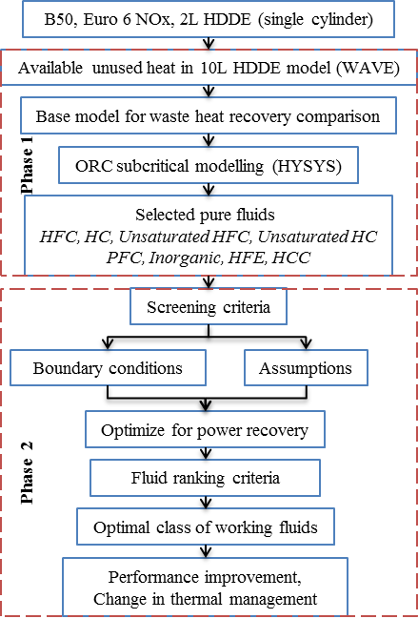
Figure 1- Method overview
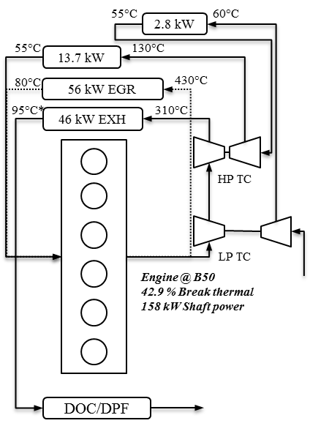
Figure 2- HDDE schematic, without NOx after-treatment (*for uninterrupted DPF operation exhaust temperatures should be above 230°C)

3.2 Waste heat recovery modelling and fluid ranking criteria
The basic configuration of the ORC (boiler, expander, condenser & pump) was analysed. While other researchers have added an internal heat exchanger [3] to recover heat from superheated post turbine vapour, this might not be a practical solution in the present case because of the consequence on the final dimensions of the ORC system and packaging constraints for mobile HDDE application. The basic configuration is therefore expected to result in relatively smaller heat transfer surfaces once the cycle is configured for minimal de-superheating.
The ORC was modelled and simulated using Aspen HYSYS V7.3 software package [8] (running in steady state), using appropriate fluid packages containing the physical property for the selected working fluids. Two sets of simulations were carried out: the first one recovering heat from the EGR circuit only and the second one considering EGR with partial top-up from EXH. All results presented are for dry expansion (i.e. based on the expansion of fluids starting from either dry saturated vapour or superheated vapour). More than 60 pure fluids with negligible Ozone Depletion Potential (ODP) were initially selected for screening [9-12]. The selected fluids included all 3 types of saturated vapour line and ranged from low critical temperature (e.g. ammonia, 132.5°C) to high critical temperatures (e.g. n-Butylbenzene, 373.9°C).
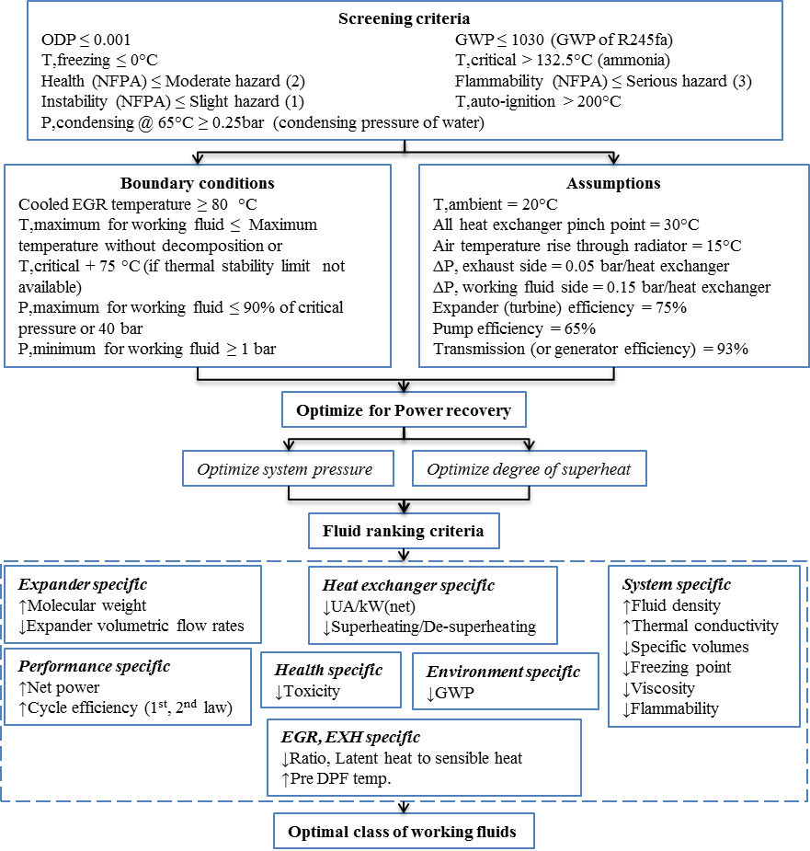
Figure 3- Developed methodology to identify optimal class of working fluids
For a process condition, the selection of a suitable working fluid for ORC is a crucial step in achieving high heat recovery and thermal efficiency. A systematic methodology involving detailed thermodynamic criterion was developed and employed to investigate the most suitable class of working fluids. The method of assessing the fluids through the screening criteria, constraining the cycle with boundary conditions and associated assumptions is detailed in figure 3. For an optimal design of a waste heat recovery system, the effect of each working fluid was investigated with regards to cycle temperature and pressure effect on the system efficiency and net power. All of the ORC simulations results yielded maximum output power with higher pressures and appropriate level of superheat. Therefore, in order to identify the most suitable class of working fluids, 15 ranking criteria related to the fluid but specific to the expander, heat exchanger, cooled EGR, post turbine exhaust, overall system, health, environment and performance were rated for maximum or minimum outputted values. The justifications of the selecting parameters shown in figure 3, with maximised or minimised values are summarised in table 1.

Table 1- Fluid ranking criteria
Maximise [Specific to ] | Reasoning
Molecular weight [Expander] | Reduces expander size, leakages (due to higher mass flow rate)
Thermal conductivity [Heat exchanger] | Increases heat transfer coefficient (reduces system size)
Pre DPF temp. [Exhaust] | Interruption free operation of DPF with temperatures over 200°C
Fluid density [System] | Reduces system size (increases mass flow rate)
Net power and efficiencies [Performance] | For maximum heat to power conversion potential
Minimise [Specific to ] | Reasoning
Expander volumetric flow rates [Expander] | Results in compact expander with high efficiency
Post expansion temp. [Heat exchanger] | Reduces the level of de-superheating needed
Condensing pressure [Heat exchanger] | While keeping super-atmospheric values to eliminates infiltration gases
Boiler pressure [Heat exchanger] | To allow light weight construction, safety implications
UA/kW(net) [Heat exchanger] | To reduce heat exchanger size
Ratio, Latent heat to sensible heat [EGR] | Able to provide highly cooled EGR (less heat is required in evaporator resulting in high heat recovery efficiency); Volume of vapour produced per unit mass is low compared to that of the liquid entering the boiler
Specific volumes [System] | Reduces system size (related to cost and packaging)
Freezing point [System] | To avoid anti-freeze or heating coils is ultra-cold environment
Viscosity [System] | Increases turbulence, heat transfer; reduces friction, pressure drop, power consumption
Flammability [System] | Combination of min. flammability risk and max. power recovery
GWP [Environment] | Environmental impact
Toxicity [Health] | Combination of min. health risk and max. power recovery

4 RESULTS AND DISCUSSION

4.1 Ideal bottoming cycle
This section provides an insight into the maximum theoretical efficiency attained using the EGR stream for an ideal bottoming cycle. Analysis of heat transfer from a finite source and sink must be based on steadily decreasing waste heat source temperature and increasing coolant temperatures, rather than Carnot’s assumption of heat source/sink at a constant temperature. It has been shown that the ideal bottoming cycle for heat to power conversion under these conditions is a sequence of infinitesimal Carnot cycles, each operating with a decreasing temperature difference between the heat source and sink [13] [14]. Hence, the ideal bottoming cycle for power recovery can be considered as not that of Carnot, but rather ideal quadrilateral concept as illustrated in figure 4.
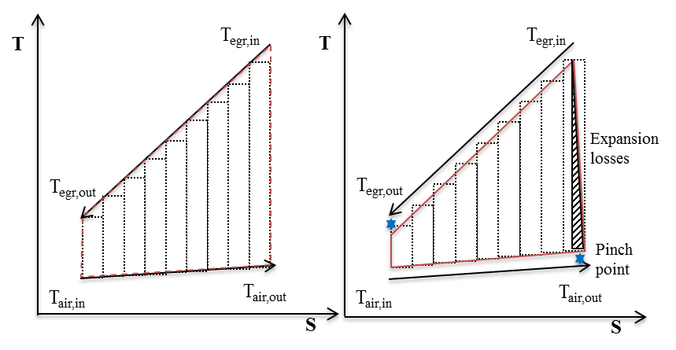
The ideal quadrilateral concept in figure 4 assumes isentropic pump and expander efficiencies of 100%. It also assumes perfect heat transfer, resulting in the same working fluid temperatures as that of the EGR stream and air. Due to these impractical assumptions it is impossible to approximate a real bottoming cycle performance with the ideal quadrilateral cycle. The performance of an optimised real quadrilateral cycle (illustrated in figure 5) was used to serve as an ideal case for comparison of bottoming cycles with different working fluids. With an assumed 15°C overall pinch point (minimum approach temperature) and 90% efficiency for the expander, the maximum power produced by the bottoming cycle with a sensible waste heat source (EGR at B50, cooled down from 430°C to 80°C), was estimated as 18.2 kW. This corresponds to 11.5% of engine shaft power. The maximum thermal efficiency of the optimised real quadrilateral cycle provided an estimated practical upper thermodynamic cycle efficiency limit of 32.3%, rather than 58.3% as deduced from the Carnot cycle.
Figure 5- Optimized real quadrilateral cycle
Figure 4- Ideal quadrilateral cycle

4.2 Waste heat recovery optimization
From the cycle durability standpoint, the maximum temperature and pressure were restricted to 400°C (or maximum stable thermal temperature) and 40 bars (or 90% of critical pressure, if critical pressure is lower than 44 bars). Using ambient air at 20°C, the air temperature rise through the radiator was restricted to 15 °C, and a minimum pinch temperature of 30°C was assumed. Thus, the working fluid minimum condensing temperature of 65°C (or the lowest temperature above 65°C for super-atmospheric condensation) was chosen.

Without any single working fluid being optimal for all criteria, the following sections discuss the trade-offs amongst a selection of working fluids investigated. Out of the 60 working fluids originally assessed, the discussion has been narrowed down to 6 optimal performing fluids. These include fluorobenzene, R1130t (Trans-1,2-Dichloroethylene), Ethanol, Methanol, R30 (Dichloromethane) and acetone. As a mean of comparison, water and R245fa (1,1,1,3,3-Pentafluoropropane) are also in the discussion.

Table 2- Fluid ranking for EGR and EGR with EXH top-up
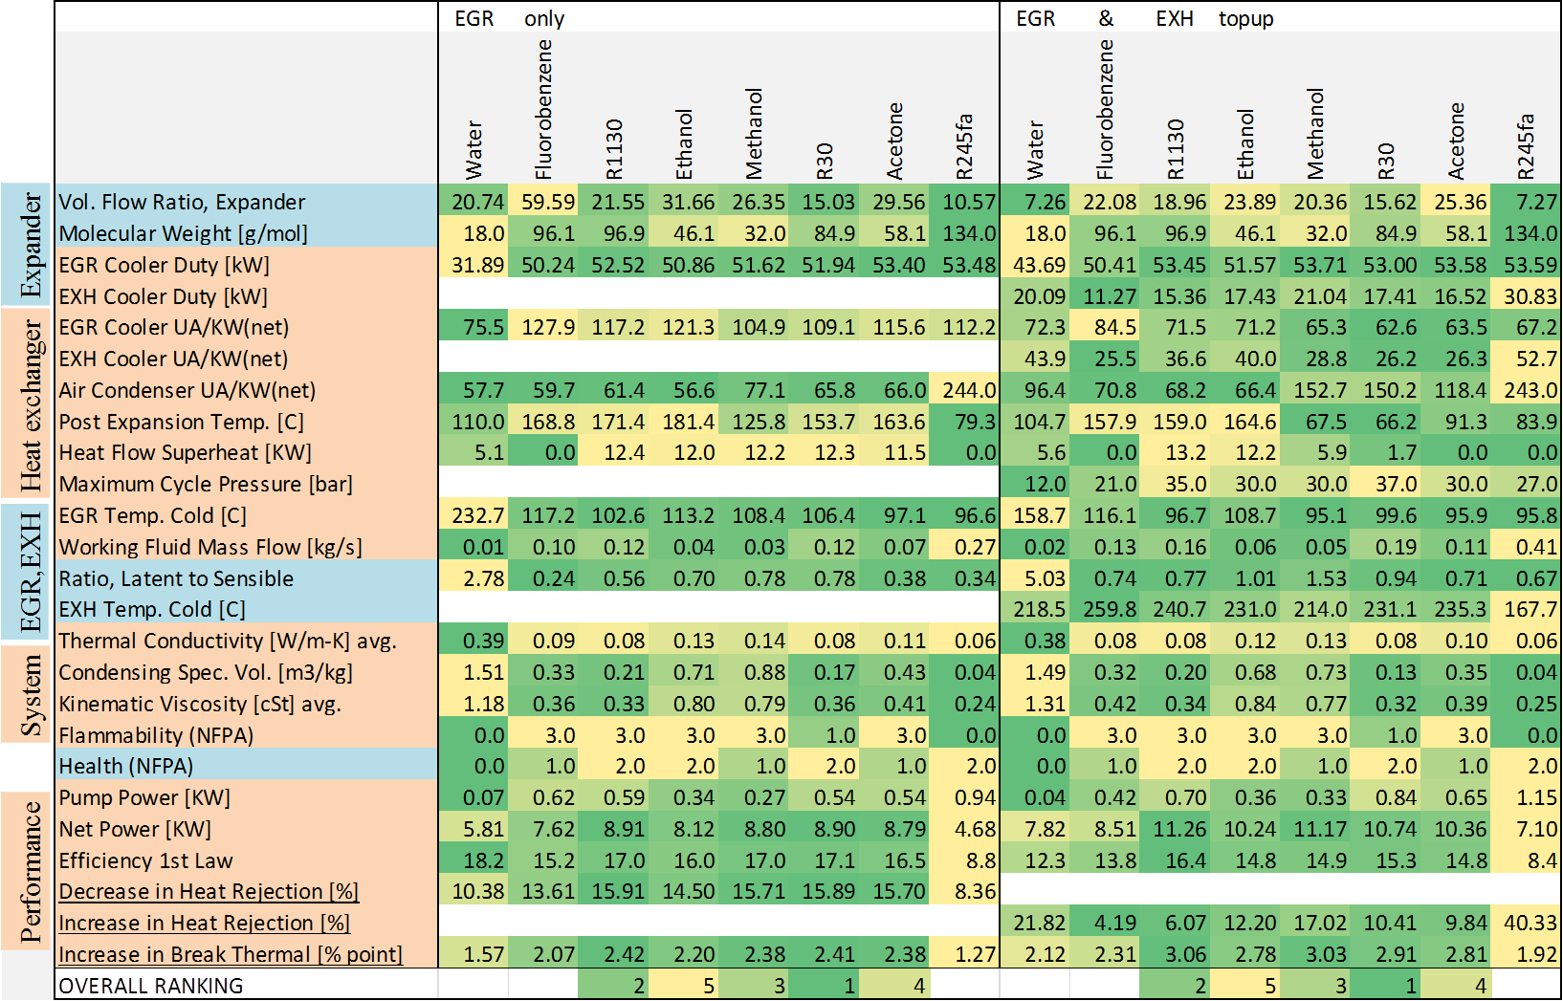

Table 2 presents the comparative performance of the considered 8 fluids with regards to the 15 fluid ranking criteria. The left set of values relate to EGR only case, whereas the right set of values are for EGR topped up with EXH. In table 2, the more frequent the occurrence of dark green cells for a particular fluid, the better suited the fluid is with respect to the ranking criteria. The last 3 rows in the table show the change in vehicle thermal load and efficiency.

The degree of superheating and pressure at the expander inlet was optimised for maximum power recovery. This optimisation makes it possible to decide if it is better to have saturated vapour or superheated vapour at the expander inlet, for a working fluid with a particular shape of saturated vapour line. For wet fluids (e.g. water) the efficiency linearly increased with increased superheat levels. For the EGR only ORC system the calculated efficiency was over 18% at a system pressure of 40 bars, but it rapidly decreased when the superheat level was reduced below the maximum temperature of 400°C. However, for dry and saturated fluids high levels of superheat also increases the de-superheating needed, the added cost for the de-superheater or an additional internal heat exchanger would have to be justified.

Considering dry fluids (e.g. R245fa), with increasing pressure, the efficiency reached its maximum (8.8%) and then gradually decreased if superheat was added. The effect of superheating was negative on dry fluids as the rate at which the temperature of heat addition increased was lower than the rate at which heat rejection temperature increased. This reduced the efficiency gains obtained from better temperature matching with the waste heat stream when super-heated.

4.3 Bottoming cycle heat transfer losses
The main thermodynamic irreversibility in the ORC system is due to the losses from irreversible heat transfer from the EGR stream and to the ambient air. T−H diagrams are presented as a visual aid in judging the suitability of a working fluid and comparing it with the ideal fluid used in the optimised real quadrilateral cycle. The solid lines bound between the source and sink in figure 6 indicate the expansion process. In figure 6, the temperature difference between EGR stream and ORC using R245fa is larger (greater irreversibility) and the area enclosed is less, indicating lower work output. Hence, R245fa achieved a relatively low efficiency (8.75%). Conversely, R30 produced higher net power (8.9 kW) and higher efficiency (17.1%) with less heat exchanger irreversibility. Despite this, R30’s efficiency still only corresponds to around half of that derived from the optimised real quadrilateral cycle as described in section 4.2.
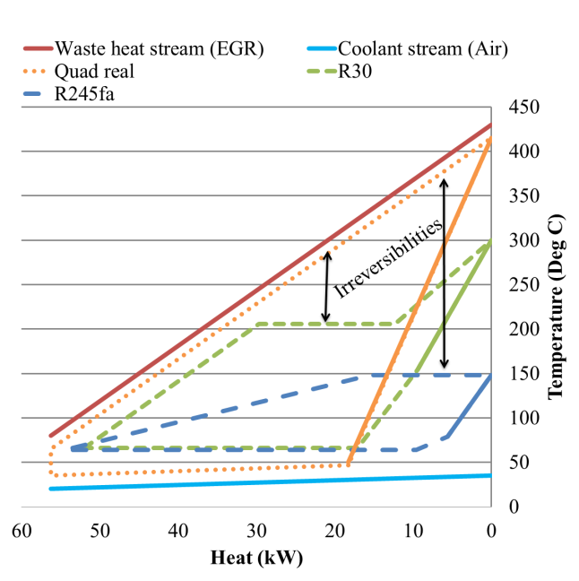
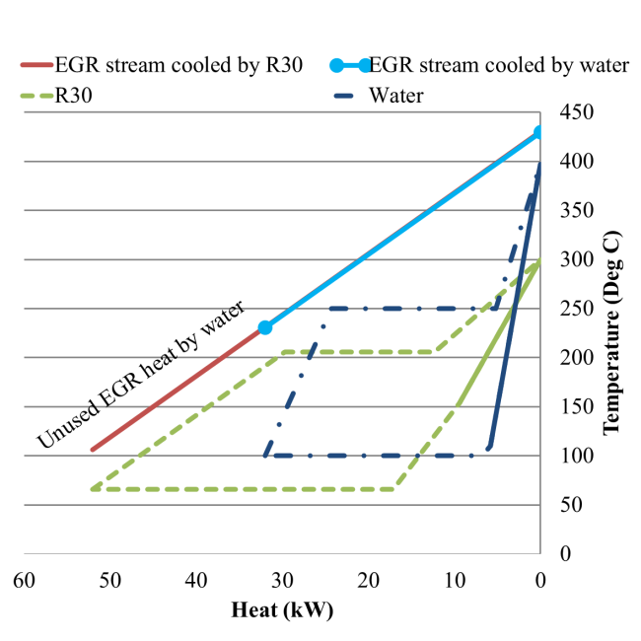
Figure 7- Effect of ratio of latent to sensible heating on cooled EGR, when comparing R30 and water
Figure 6- T-H diagram comparing R30 and R245fa with optimized real quadrilateral cycle

In figure 6, R245fa is shown to transfer nearly the same amount of heat in the EGR cooler as R30 but over a relatively small temperature range. Therefore, the required mass flow rate of R245fa is larger (0.27kg/s) when compared to R30 (0.12kg/s). This results in almost twice the pump power consumption by R245fa. When comparing R30 with other high net power output working fluids like methanol (8.8 kW), the only drawback observed is its marginally lower thermal conductivity in vapour state. This corresponds to a negligible increase in EGR heat exchangers area/kW power output for R30. Although the considered Hydro-Chloro-Carbon (HCC) group of fluids i.e. R30, R1130t and n-alcohols i.e. ethanol, methanol produced nearly the same net power output (8.12-8.91 kW) for the EGR only case. HCCs are the preferred candidates while considering system size as they have almost twice the expander inlet densities and one-third the de-superheating condenser volumes. They will also induce lower friction losses as they have lower liquid and vapour viscosities compared to n-alcohols.

4.4 Heat recovery efficiency
The EGR stream temperature drop is an indicator of how effectively heat is being delivered to the ORC. When using water for waste heat streams below 600°C, it is important to consider the implications of latent heat of vaporisation and sensible heating. R30 and water differ significantly with regard to latent heat and sensible heating. Cooled EGR limitations associated with water relate to its high ratio of latent heat to sensible heating. The system considered in figure 7, with R30 to recover 52 kW from EGR at 430°C will have a contribution for latent heat of vaporisation of 17 kW and sensible heating of 23 kW. This will cool the EGR stream to 105°C, compared to water which will only cool EGR to 230°C, thus contributing 20 kW in latent heat of vaporisation and only 7 kW in sensible heating. In this comparison, 35% of the incoming EGR enthalpy remains unused while using water. Therefore, more heat can be extracted from the EGR and converted to power while using R30. Also, the larger ratios seen with water imply that the volume of vapour produced per unit mass is very large compared to that of the liquid entering the boiler.

4.5 Post turbine exhaust temperatures
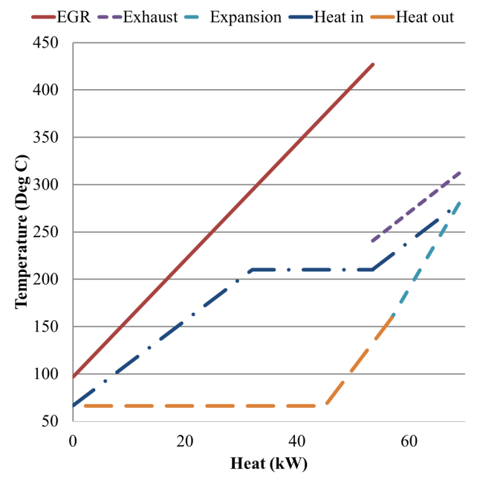
The use of EXH heat in addition to the EGR heat was also considered. An additional parameter considered while ranking fluids for EGR topped up with EXH was the cooled post turbine exhaust temperatures. As post turbine exhaust temperatures are generally lower than EGR temperatures, to obtain a higher thermal efficiency, the exhaust stream should be used for pre-heating and partial evaporation and the EGR stream should be used for evaporating and superheating. The approach used here involved EGR for preheating and partial evaporation and exhaust for evaporating and superheating. This approach resulted in slightly lower cycle efficiencies but was nonetheless able to provide the required EGR cooler outlet temperatures without an additional cooler stage. Figure 8 shows the case of an ORC using R30, cooling EGR to 100°C and receiving 53kW of heat and cooling EXH to 230°C by topping up with 17 kW of post turbine heat. Once again HCC’s were found to be the preferred class of working fluids as their optimal cycles did not lower the post turbine exhaust temperatures below 230°C (Required for uninterrupted Diesel particulate filter (DPF) operation)
Figure 8- T-H diagram of R30 using EGR topped up with EXH

4.6 Comparing HCC to water and R245fa
As demonstrated in table 2, the selection of a working fluid depends on a number of factors. However, general guidelines can be drawn to highlight the limiting factors while using a working fluid for a particular waste heat stream. To demonstrate this, HCCs are compared with water and R245fa below.

4.6.1 Comparing HCC to water
For waste heat streams below 600°C, water is usually regarded as unsuitable for bottoming cycles. The low vapour density of steam requires bulkier equipment with increased size of the turbine. Additionally, a low temperature waste heat streams may not be able to provide sufficient energy for superheating, an essential requirement for preventing turbine damage due to steam condensation. Water has extremely high critical pressures (220.6 bars) with high specific enthalpy in the vapour phase. The expansion of low molecular weight (18 g/mol) vapours is associated with large specific enthalpy drops and hence high fluid velocities [14]. Another disadvantage includes sub-atmospheric pressure at ordinary condensing temperatures.

Fluids with a lower boiling point (such as HCCs) would, on the other hand enable higher heat recovery efficiencies from heat streams of lower temperatures (below 600°C). Their intrinsic condensing and molecular weight properties would also lead to smaller sized air cooled condensers and lower turbine speed (hence higher efficiency). Their lower freezing point compared to water would increase cold weather performance in vehicle applications.

4.6.2 Comparing HCC to R245fa
With a high critical pressure (36.4 bars) for a relatively low critical temperature (154°C), a system utilizing R245fa operates at high super-atmospheric condensing pressures. This implies a denser vapour with relatively compact expander and heat exchangers. R245fa is more suited to heat sources below 300°C, allowing good temperature matching between the cooling heat stream and the working fluid, since a high percentage of the heat is transferred by sensible heating. Because of its much higher molecular mass (134 g/mol), the specific enthalpy drop in expansion is relatively small. Hence, by default the feed pump work is relatively large, thus negating the systems thermodynamic advantage gained due to better temperature matching in the boiler.

R1130t has a high critical pressure (55.1 bars) and temperature (243°C), while it’s molecular mass is lower (96.9 g/mol). Accordingly it is better suited to higher temperature cycles, with better source/sink match. Under such conditions the pump work will be relatively low. Because of its high critical temperature, the condensing pressure will be slightly above atmospheric with lesser dense vapour. However, as R1130t will best operate at temperatures above 300°C as in this case, its cycle efficiency will be much higher than that of an ORC with R245fa and therefore the power generated per unit of heat absorbed will be considerably large.

4.7 Performance improvement and change in thermal management
For a fixed condensing condition, a higher expander pressure ratio yields higher efficiency. Following this, fluorobenzene and R30 resulted in high expander pressure ratio (37-39). However, ORC with fluorobenzene resulted in very large volumetric flow ratio (59.59) compared to R30 (15.03). Thus, fluorobenzene would require a larger expander and is therefore considered inappropriate for this study, despite its low ratio of latent to sensible heat (0.24) and a relatively high molecular weight (96.1 g/mol).

Referring to table 2, with high net power and thermal efficiency the presented HCCs appear to be the most suitable working fluids from the initial 60 selected. With the most suitable brake thermal improvement for the EGR only waste heat recovery configuration, the bottoming cycle with R1130t was found to increase the engine efficiency by 2.42% point and reduced the condenser load by 15.9%. When using EGR partially topped up with EXH, R1130t was found to increase the brake thermal efficiency to over 3% point while increasing the heat rejection by only 6%. With the first law efficiency above 16%, an ORC with R1130t has sufficiently high temperatures in the exhaust for uninterrupted DPF operation. The only drawback of R1130t when compared to R30 is its high flammability. The thermal efficiency improvement results are in agreement with other authors [2, 3]. However, the results shown in this paper are based on much more realistic component efficiencies and condensing conditions.

5 CONCLUSION AND FUTURE WORK

A detailed systematic approach for the selection of optimum working fluids for ORC systems has been developed and applied to a vehicle application. Fluids were ranked using 15 criteria to enable the assessment of different options in terms of both performance and application suitability. The methodology was applied to a HDDE application using a high EGR emissions control strategy running at Euro 6 emission levels.

Fluorinated refrigerants such as R245fa were found to be unsuitable due to poor temperature match with EGR temperatures. HCC non-ozone-depleting chlorinated solvents (R1130t, R30) were identified as the new optimal class of fluids for this application, followed by n-alcohols (methanol, ethanol) and acetone. These fluids also comply with directive 2006/40/EC (Global Warming Potential < 150). Fluids with super-atmospheric saturation pressure at 65°C include R1130t, methanol, R30 and Acetone. However, methanol has the highest condensing specific volume of the four. Conversely, working fluids with normal boiling point between 35-70°C are considered most suitable. None of the working fluids presented are considered a serious health hazard and can therefore be considered for a transport application. Some fluids such as R1130t, acetone have higher flammability but offers saturated expansion with minimum superheat.

There is a trade-off between selected HCC fluids, R30 offering lower flammability with slightly reduced cycle performance compared to R1130t. An ORC system operating with R30 is considered to be the most suitable overall in the considered application, with the potential to increase the overall thermal efficiency of the engine by 2.4% points and up-to 2.9% point when using EGR and EGR topped up with EXH respectively.

Themes of future investigation will include, low temperature heat recovery from engine, assessing different cycle arrangements (reheat, regenerator, supercritical etc.) and addressing the heat exchanger’s irreversibility issues by using Azeotropes and Zeotropic blends. Finally after assessing heat recovery at different key points, the optimal system packaging and costing implications will be investigated.

6 REFERENCES

1. Dec, J.E., Advanced compression-ignition engines—understanding the in-cylinder processes. Proceedings of the Combustion Institute, 2009. 32(2): p. 2727-2742.
2. Park, T., et al., A Rankine Cycle System for Recovering Waste Heat from HD Diesel Engines - Experimental Results. SAE Technical Paper 2011-01-1337, 2011, doi:10.4271/2011-01-1337.
3. Nelson, C.R., Exhaust Energy Recovery, in FY 2009 Annual Progress Report, Advanced Combustion Engine Research and Development 2009, U.S. Department of Energy.
4. Hountalas, D.T. and G.C. Mavropoulos, Potential for Improving HD Diesel Truck Engine Fuel Consumption Using Exhaust Heat Recovery Techniques, New Trends in Technologies: Devices, Computer, Communication and Industrial Systems ISBN 978-953-307-212-8, 2010.
5. BCS Incorporated, Waste Heat Recovery: Technology and Opportunities in U.S. Industry, 2008, U.S. Department of Energy; Industrial Techonologies Program.
6. Schock, H., Thermoelectric Conversion of Waste Heat to Electricity in an Internal Combustion Engine Vehicle, in FY 2009 Annual Progress Report, Advanced Combustion Engine Research and Development 2009, U.S. Department of Energy.
7. Ricardo Software, WAVE Version 8.1, 2008.
8. Aspen Technology Software, HYSYS Version 7.3, 2011.
9. Calm, J.M., Air-Conditioning and Refrigeration Technology Institute Refrigerant Database,. Data Summaries Single-compound Refrigerants DOE/CE/23810-105 (JMC/ARTI-9909D - RDB9932)1999.
10. Green, D.W. and R.H. Perry, Perry's Chemical Engineers' Handbook, Eighth Edition,2007: McGraw-Hill.
11. US Environmental Protection Agency. Ozone Layer Protection. [28/09/2012]; Available from: http://www.epa.gov/ozone/strathome.html.
12. US National Fire Protection Association. Codes & Standards 704. [28/09/2012]; Available from: http://www.nfpa.org/faq.asp?categoryID=928.
13. Smith, I.K., Development of the Trilateral Flash Cycle System: Part 1: Fundamental Considerations. Proceedings of the Institution of Mechanical Engineers, Part A: Journal of Power and Energy, 1993. 207(3): p. 179-194.
14. Smith, I.K., Power Plant Thermodynamics [Monograph], 2009.

