2013-24-0089

An assessment of the bottoming cycle operating conditions for a high EGR rate engine at Euro VI NOx emissions

Copyright © 2012 SAE International
ABSTRACT
This paper investigates the application of a Bottoming Cycle (BC) applied to a 10-litre (L) heavy duty Diesel engine for potential improvements in fuel efficiency. With the main thermodynamic irreversibility in the BC due to the temperature difference between the heat source and the working fluid, a proper selection of the working fluid and its operating condition for a given waste heat is the key in achieving high overall conversion efficiency. The paper reviews a fluid selection methodology based on thermodynamic/thermo-physical and environmental/safety properties. Results are presented using seven pure, dry, isentropic and wet working fluids (synthetic, organic and inorganic) operating with expansion starting from the saturated vapour, superheated vapour, supercritical phase, saturated liquid, and two-phase.
Efficiency improvements by recovering Charge Air Coolers (CAC) and Exhaust Gas Recirculation (EGR) cooler heat on two engine platforms were calculated. The first platform operating at Euro 6 engine out NOx emissions levels and the second platform operating with Euro 5 engine out NOx emissions coupled with a 80% efficient selective catalytic reduction system. Performance and heat rejection data for the 10L platforms were derived from experimental measurements on an advanced 2L single cylinder research engine which was used to determine the trade-off between thermal efficiency and regulated/unregulated emissions. Results indicate a potential improvement of 5.1% and 6.3% in engine power for a cruise (B50) and high load (C100) condition, with a technically feasible BC operating at subcritical mode with minimum superheat.
INTRODUCTION
The impact of increasing fuel prices, regulated emissions, and CO₂ emissions have all increased the significance of exhaust Waste Heat Recovery (WHR) to improve engine Break Specific Fuel Consumption (BSFC). One method for WHR is the adoption of fluid driven Bottoming Cycles (BC). For WHR applied to Heavy Duty Diesel Engine (HDDE) major manufacturers and powertrain developers including Cummins, AVL, Volvo and Ricardo are exploring BCs. For maximum improvement, Cummins [1] and AVL [2] both initially conducted a case study showing an additional 15.3% and 20% of engine shaft power recovered through the BC, respectively. More recently, Cummins has applied its first generation recuperated R245fa Organic Rankine Cycle (ORC) to a US 2010 Cummins ISX (15L, 6-cylinder) HDDE. Using the heat from Exhaust Gas Recirculation (EGR) and the exhaust streams, a 7.4% fuel efficiency improvement across the Heavy Duty Corporate Composite operating cycle was demonstrated [3]. AVL has applied a superheated recuperated ORC demonstration unit to 10.8L HDDE operating with ethanol as the working fluid. The results of EGR and exhaust heat recovery at high load (C100) generated 9.12 kW, resulting in a fuel consumption improvement of only 3% [4]. The reason for reduced BSFC improvements was due to the low operating pressure ratio of the modified GT-25 turbocharger (used as expansion device) and low EGR flow rates (10%). Volvo has also selected ethanol as the working fluid and are intending to use a piston expander. They simulated a parallel EGR and exhaust WHR topology, resulting in 9.9 kW at the B50 (7% of engine power) and 24.5 kW at the C100 (8.5% of engine power) condition [5]. Southwest Research Institute modelled a Rankine cycle, first using exhaust heat and then high temperature EGR heat. With 25-30% EGR flow and condensing temperature of 40°C, an 8% fuel consumption improvement was calculated [6].
BCs are by no means the only technology for WHR. The development of thermo-electric generators for units under 1 kW has accelerated performance considerably over the last 5 years. Maximum module efficiency of 10% (ΔT=480°C) and 11% (ΔT=385°C) are reported by LaGrandeur et al. [7] and Schock et al. [8], respectively. Mechanical-Turbo-Compounding (MTC) is already established in HDDEs [9] and simulation results have shown BSFC improvements between 2.4% and 4% [6, 10]. Also, Electrical-Turbo-Compounding (ETC) is in demonstration phase and has been partially tested. The independent control of turbine and engine speed makes ETC more efficient compared to MTC, with BSFC improvements between 4% and 10% [11, 12]. However, the above studies show that BCs provides the largest BSFC

Table 1 Applied NOx strategy for EGR only and EGR focused platforms to meet Euro 6 emissions, and the resulting waste heat quantity and quality for the 10L engine models.
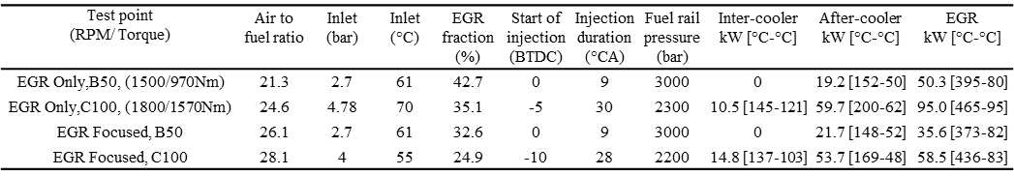

improvement, they are less sensitive to vehicle load, and cost considerations ($/kW) show them to be competitive [6, 13].
Efficiency of all the waste heat to power conversion technologies mentioned are limited by the flow rate and temperature levels of the heat streams. They face certain common interrelated barriers: payback periods, temperature limits of recovery equipment, thermal cycling, reliability, and performance. They will also include advanced controls to minimise the disadvantage linked to the varied driving conditions. Despite their success in stationary application, BCs face some technology specific barriers which are impeding their wider adoption and installation when applied to road transport application. These include: cost (economies of scale), chemical (corrosion/fouling, working fluid toxicity and flammability, potential of exhaust and working fluid mixing), physical (complexity, packaging, weight, crash safety) and performance (variable turbine/expander speed).
NOx solution layouts
The advances in EGR, Diesel Particulate Filter (DPF), Turbo-Charger (T/C) and fuel injection equipment technology, have allowed the possibility to explore Euro 6 and US 2010 NOx limits without after-treatment. The use of high EGR rate and the delayed combustion to meet Euro 6 engine-out NOx emission avoid additional after-treatment but inherit the drawback of increasing engine BSFC. For US 2010 emissions it is estimated that an EGR only engine shows a 5-7% fuel penalty when compared to a Selective Catalytic Reduction (SCR) focused platform [14]. However, when urea consumption is included the projected BSFC penalty for a SCR focused (Euro 4 engine out NOx + 90% SCR) engine reduces to 4% for Euro 6 conditions [15].
The adoption of EGR only approach compromises on specific power output and fuel economy. With elevated boost, in-cylinder and rail pressures, a stronger mechanical design of the engine will be required. Mixing of EGR and Charge Air Cooler (CAC) stream, protection against fouling/corrosion and avoiding DPF filter plugging, all have to be ensured. To reduce start of combustion temperatures, considerable amount of waste heat has to be rejected from the inter-cooler and after-cooler. Furthermore, the increased exhaust gases cooled and diverted back to the intake will increase the complexity, volume, weight and cost of the engine’s cooling module. However, there are some advantages of an EGR only engine when compared to a combined platform, including no urea requirement, lower operating cost, less maintenance and lower vehicle weight [16]. The estimated weight and cost for an additional low temperature EGR cooler, which will cool the EGR to 100°C is estimated to be only around 18 kg and $750 respectively (on top of the standard EGR cooler) [6]. The after-treatment package (DPF+EGR+SCR) represents a cost of around $17,100 for US 2010 emissions, which is not far below the cost of an HDDE engine [17], signifies the importance of exploring cost effective integrated solutions.
To investigate this, the addition of WHR on an EGR only engine was conducted by a simulation study. Also included are results for an EGR focused (Euro 5 engine out NOx + 80% SCR) engine. To generate waste heat quantities and qualities typical of long haul engine, two 10L (EGR only and EGR focused) engine simulation models were developed in Ricardo WAVE 8.1 [18] running with the available test data from an experimental 2L single cylinder, Ricardo Proteus, HDDE [19]. The 2L engine is configured as a direct injection Diesel engine with a low swirl. A common rail single injection fuelling equipment with injection pressures up to 3000 bar was employed to partly compensate for the increase in particulate matter emission. As the exhaust temperature profoundly influence the WHR, the high temperatures along the exhaust line for the 10L models were matched within 20°C of the experimental values. The applied NOx strategy for the two 10L engine platforms at a typical cruise (B50) and high load (C100) conditions along with the heat available in CAC and EGR heat exchangers with hot and cold temperatures are given in table 1.
Methodology
The temperature levels seen in the EGR cooler (370-470°C, table 1), cannot be simultaneously used to maximise engine BSFC while providing highly cooled EGR temperatures using the conventional superheated Rankine cycle method. This is due to water’s largest ratio of latent heat to sensible heat. In this context, research on how to convert this temperature level heat source efficiently into power is of great significance. Organic and synthetic fluids can be selected with the necessary trade-offs between, thermodynamic, thermo-physical, chemical, environmental, and safety properties to maximise the power conversion with an economically viable system.

Table 3 Thermodynamic/thermo-physical and environmental/safety properties of the seven fluids discussed.
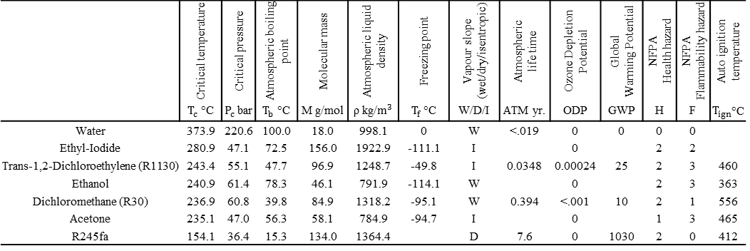

A detailed selection study to identify potential working fluids for EGR WHR has already been conducted by the authors [20]. With multiple fluid screening criteria, common BC boundary conditions, and similar equipment performance assumptions, the study highlighted the system and performance benefits when using non-ozone depleting chlorinated fluids (R1130 and R30), acetone and ethyl iodide. When benchmarked for fixed evaporator pressures the selected fluids also showed advantages over R245fa, ethanol and water, the preferred options for automotive application in present literature.
Due to limitations associated with the EGR quality, quantity, and variability the influence of the selected working fluid and the corresponding operating condition can be vital. However, detailed studies on the selected operating condition and trade-offs compared to the wide range of other operating modes are rarely published. Most of the investigations mentioned in the introduction section have been focused using recuperated ORC configuration, this ignores the overall conversion efficiency advantages that can be gained by exploring different operating modes with appropriate working fluids. There is still a great deal to learn about improving the performance and bringing down the costs for BC units for automotive application. To address this, the paper discusses extensive analyses and comparisons among different BC working conditions using pure fluids. The closed loop, single expansion derivative of the traditional BC is conducted to obtain conclusions in theory, with the results providing directions for practical implementation of BC units. To detail the influence of turbine inlet pressure, temperature, and vapour fraction on the BC performance and system, simulations were conducted at C100 quality and quantity values for the EGR only engine with the above seven fluids using Aspen HYSYS V7.3 software package [21]. The boundary conditions and assumptions used for BC simulations are detailed in table 2.
BC parameters present a multi-dimensional surface on which an optimum condition can be found within prescribed constraints. The work described in this paper uses overall conversion efficiency (product of thermal and heat recovery) as the objective function. The main objective of this study is focused on optimisation of turbine/expander inlet conditions to find the combination of working fluid and cycle operating condition that could show the best performance and system (size and cost) trade-off to achieve a better integration within a HDDE.
Table 2 BC equipment performance and boundary conditions used for simulations.
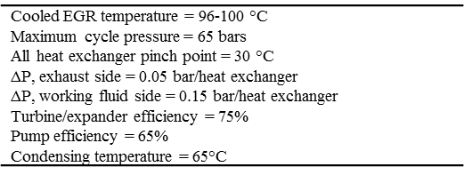

Working fluids and cycle operating conditions
The thermodynamic properties of a fluid are interrelated and largely dependent on critical point properties, normal boiling point, molecular makeup and structure [22]. Table 3 covers thirteen necessary properties of the seven fluids used in this study. Within organic fluids it is observed that the ratio of normal boiling point at atmospheric pressure to critical temperature (i.e. reduced temperature) is in the range of 0.6-0.7. They show an approximate behaviour between the reduced vapour pressure and the corresponding reduced saturation temperature i.e., organic fluids with a lower boiling points have a higher vapour pressure at normal condensing temperatures and vice versa. A significant variable that affects the fluid applicability and the arrangement of associated equipment is its saturation vapour curve. Figure 1a and 1b show the temperature-entropy diagram of the fluids used by other authors and the fluids proposed in this study, respectively. The saturated vapour curve is shown to be roughly dependent on molecular weight or molecular

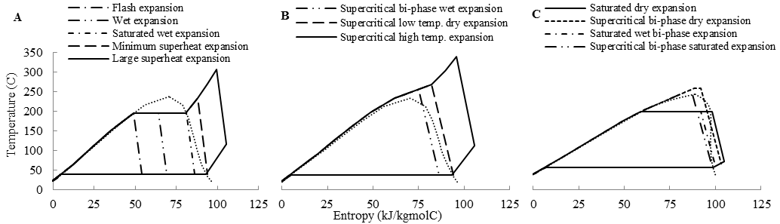
Figure 2 Twelve cycle operating modes using pure fluids for single expansion (a) subcritical operating modes (b) supercritical operating modes (c) operating modes specific to dry and isentropic fluids.

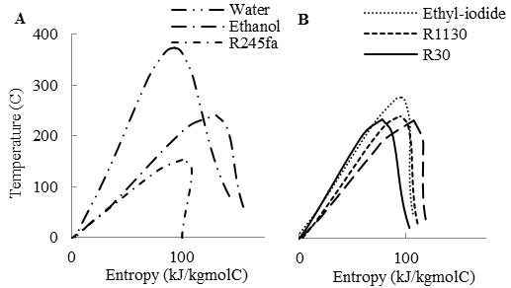
Figure 1 Temperature-entropy diagram of the seven fluids, (a) mentioned in published automotive literature, (b) proposed alternatives used in this study.
complexity (number of atoms in the molecule) of the substance. With increase in the number of bonded atoms, the molar heat capacity, and consequently the slope of the saturation boundary has been shown to increase. With pressures slightly below critical pressure, the working fluids can be divided according to the slope of their vapour saturation curve (dT/dS). Fluids like water, ethanol and R30 for which the entropy of the saturated vapour decreases with increasing temperatures are called wet fluids (dT/dS<0). Wet fluids require superheating in order to avoid the formation of liquid droplets which may cause blade erosion at the turbine exit. Although, it is possible to expand dry saturated vapour using special materials for leading edges to allow some wetness (≈10%) at exit, this sacrifices the turbine efficiency. Fluids like R245fa (figure 1a) where the entropy of the saturated vapour increases with increasing temperature are called dry fluids (dT/dS>0). During expansion, they do not condense since the degree of superheat increases as expansion takes place. However, if the fluid is too dry, the expanded vapour will exit with substantial superheat, increasing the condenser load. An ideal fluid would be one that would neither require superheating (wet) or de-superheating (dry), as large heat exchanger surface area are required for vapour heat transfer. The third classification, organic molecules with 5-10 atoms, are called isentropic fluids, with near quasi-vertical saturated vapour curves (dT/dS≈ ∞) they includes fluids like acetone, R1130 and ethyl iodide (figure 1b).
The expansion/power generation unit is a critical component of the BC hardware. The two widely proposed solutions for automotive application include either the use of a high speed turbine-generator unit for electrical output, or the use of a positive displacement expander coupled to the drive shaft for mechanical output. For a high speed turbine-generator unit various turbine technologies can be adapted from the stationary BCs. These include: axial flow turbines, radial inflow turbines, radial outflow turbine, variable phase turbines etc [23]. For automotive WHR, Cummins had selected a high speed (50,000 rpm) fixed-nozzle, axial inflow turbine generator with maximum working fluid temperature of 260°C [1]. Positive displacement type expanders (scroll, screw, reciprocating etc.) have speeds roughly one order of magnitude less than those of turbines and permit some condensation during the expansion. For two-phase expansion, screw expanders have recently been proposed [24]. However, scroll and screw expanders usually have expansion pressure ratios below 8:1. For HDDEs the reciprocating expander is being considered as a valid alternative as they work even at high expansion ratios. The wide variety of turbine and positive displacement expanders along with high EGR temperatures has made it possible to consider the start the working fluid expansion from saturated vapour, superheated vapour, supercritical, and even saturated liquid or two phase mixtures. When considering turbine/expander inlet temperature, pressure, and vapour fraction a total of twelve BC operating conditions exists with pure dry, wet and isentropic fluids as detailed in figure 2a, 2b and 2c.
Results and discussion
Dry saturated subcritical cycles
To examine the effect of turbine inlet parameters on BC performance, simulations were conducted for varying turbine inlet pressures and temperatures using the seven fluids. Figure 3a shows the variation in the first law efficiency with increasing turbine inlet pressures for EGR WHR. The cycle operating conditions were that of saturated dry expansion for dry fluids (figure 2c) and minimum superheat expansion for wet fluids (figure 2a). Figure 3a demonstrates that the first law efficiency increases with the increment in the turbine inlet pressure. The results are consistent for all the fluids, with fluids with a high boiling point being more efficient. This can be understood with reference to figure 4a which refers to ethyl iodide, where by increasing the evaporator pressure from 20 bar to 45 bar, the temperature difference between the working fluid and the EGR stream reduces. This results in greater cycle area and hence improved efficiencies. Also, from figure 3a, it can be seen that the rate of efficiency improvement reduces with the increasing maximum pressure. Working fluids show maximum values while approaching their respective critical point conditions (given in table 2).
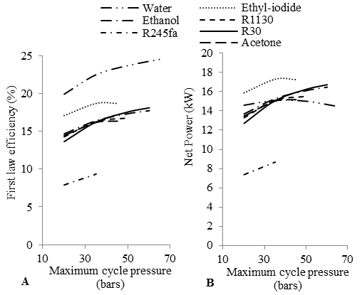
Figure 3 Effect of turbine inlet pressure on, (a) first law efficiency, (b) net power output.
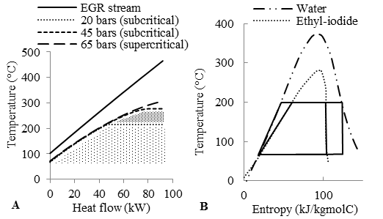
Figure 4 (a) Ethyl iodide and EGR stream thermal matches with subcritical and supercritical pressures, (b) Influence of working fluid latent heat on first law efficiency.
From figure 3a it can be seen that water provides the highest first law efficiency of 24.5%. This is due to water’s large latent heat and its influence is illustrated in figure 4b, which shows water and ethyl iodide, with evaporator and condenser temperature of 200 and 65°C, respectively. The length of the horizontal line segment at 200°C is proportional to the latent heat of the working fluids. Under similar temperature limits in the evaporator and the condenser, water with larger latent heat will produce greater unit work output as the area formed by the cycle which indicates the turbine output will be larger. Hence, for defined temperature limits, working fluids with high latent heat will give higher net power output per unit heat absorbed.
Working fluids like water with low molecular weight (18 g/mol) have large enthalpy of vaporisation, and hence, high specific enthalpy in vapour state. This high specific energy of steam implies that the pump power consumed in pressurising the working fluid is one order of magnitude less than other fluids (figure 5a). As a consequence of this, the expansion of steam vapours shows a one order of magnitude larger specific enthalpy drop (figure 5b). This results in higher velocities during expansion and around twice the turbine speed seen with other fluids, indicated by the speed of sound (figure 5c).
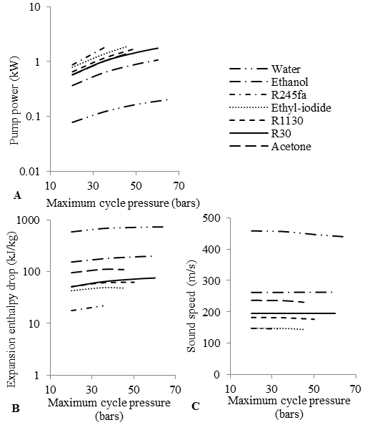
Figure 5 Calculated, (a) pump power consumption, (b) expansion enthalpy drop, (c) speed of sound, with increasing turbine inlet pressure.
The potential advantage of a working fluid for EGR WHR does not only depend on first law efficiency but also on the heat recovery efficiency and hence the overall conversion efficiency. Figure 3b shows the net power produced using the seven considered working fluids. The maximum power produced was shown to be when using ethyl iodide (17.3 kW) for a 35 bar evaporator pressure. With the exception of ethyl iodide and R245fa, all other working fluids at 35 bar evaporator pressure provide similar net power (15.2 kW).
Increasing the evaporator pressure for water from 35 bar to 65 bar increases the first law efficiency (from 22.4 to 24.5 %, figure 3a) but reduces the net power (from 15.1 to 14.4 kW, figure 3b). Due to water’s high latent heat, the largest portion of heat is needed to evaporate water. With increasing boiler pressure, less quantity but high quality heat is being exchanged in the EGR cooler. Hence, increasing the boiler pressure beyond 35 bar has a negative effect on the net power produced. For other working fluids greater net power is achieved above 35 bar, nevertheless with a decreased cycle efficiency compared to water. This is due to the additional power being derived from a stream of steadily decreasing EGR temperature. Therefore, working fluids should be selected to provide lower cooled EGR temperatures, resulting in higher overall conversion efficiency and higher net power.
The above thermodynamic analysis must also be completed with some considerations regarding the size and costs of the BC unit. Two criteria used to evaluate the relative size and costs of these BCs are expansion Volume Flow Ratios (VFR, figure 6a) and the ratio of average heat exchangers surface area to net power (UA/kW, figure 6b). A fluid with lower expansion VFR will result in a compact expansion machine, and when using turbines, will avoid supersonic flow problems. Lower VFR also implies higher super atmospheric condensing pressures with denser vapours, reducing the system size. From figure 3b and 6a, it is evident that R30 provides a best combination of maximum net power and lowest VFR.
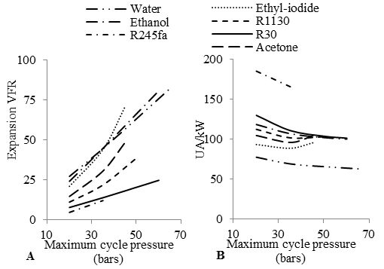
Figure 6 Relative indicators for BC system (size and cost), (a) expansion volume flow ratios, (b) heat exchanger area / net power.
When comparing R30 with ethanol between 35 and 50 bar evaporating pressures, they both give similar net power (15.2-16.3 kW, figure 3a). However, R30 gives lower pressure ratios (14.4:1-20.6:1 vs. 45.4:1-64.9:1) and volume flow ratios (13.7:1-20.2:1 vs. 44.6:1-66:1, figure 6a). This makes R30 more suitable for piston expanders under the considered pressure limits. To estimate the relative EGR cooler and air condenser size the UA/kW values shown in figure 6b can be used. For a maximum cycle pressure of 40 bar all fluids show similar values, with the exception of water showing better and R245fa showing worse values.
It must be highlighted that system safety and risk control must be a primary concern when using fluids like ethanol. When the temperature of the EGR cooler surface in contact with ethanol is much higher, there is a risk of fire and/or explosion in the event of any rupture in the heat exchanger surface due to the much lower auto ignition temperature (given in table 3) compared to R30 (363 vs. 556°C). The other proposed fluids, R1130 and acetone also display higher auto ignition temperatures of 460 and 465°C, respectively.
Subcritical superheated cycles
Due to the critical temperatures of the working fluids being much lower than the maximum EGR temperatures, superheating beyond what is required to prevent turbine damage can also be implemented (figure 2a, large superheat expansion). Figure 7a shows the variation in first law efficiency with fixed evaporator pressure with increasing superheat. To generate this, the boiler pressure was fixed at 25 bar for water and R245fa; 45 bar for ethyl iodide and acetone and; 50 bar for Ethanol, R1130 and R30. The heat flow in the superheater and hence the temperature range for each fluid used was less than 100°C above the critical temperature. Figure 7a illustrates that the thermal efficiency of the cycle slightly increases with increasing turbine inlet temperature for all fluids with the exception of R245fa.
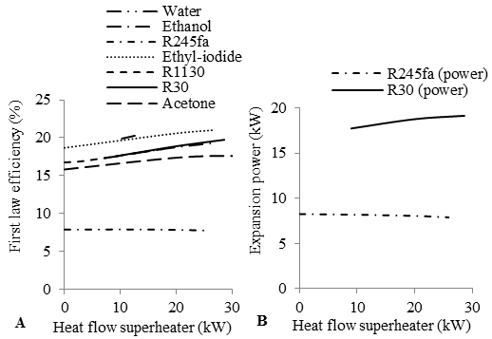Figure 7 Effect of superheating at fixed evaporator pressure on, (a) first law efficiency, (b) expansion power.
Comparing R30 (a wet fluid) and R245fa (a dry fluid) with reduction in working fluid flow rate to facilitate an addition of 20 kW of heat in the superheater. The first law efficiency (figure 7a) of R30 will increase from 17.5 to 19.7 % from the reference minimum superheat cycle, whereas the efficiency will decrease from 7.9 to 7.7 % for R245fa, from the reference saturated vapour cycle. This can be understood with figure 8a, where the rate at which the constant isobars lines diverge determines the impact of superheating on expansion power. For Dry fluids like R245fa the pressure lines converge in superheating zone, contrary to wet fluids where they diverge. Figure 7b shows expansion power for R30 and R245fa. For R245fa, superheating reduces the expander power (from 8.2 to 8 kW). Dry superheated cycles result in increased higher temperature de-superheating at the end of expansion, this reduces the thermal efficiency gains obtained from better temperature match with the EGR stream. Hence, figure 7a and 7b shows that the best case scenario is obtained when the dry fluids are operated at saturated conditions before the turbine, since this produces higher net power with higher thermal efficiencies than operating under superheated conditions.
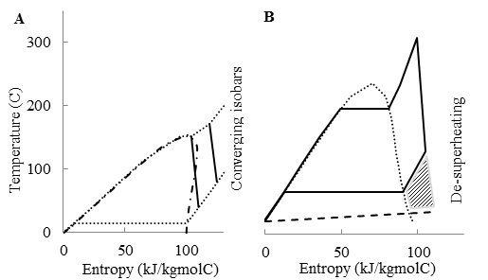
Figure 8 Effect of superheating on dry and wet fluids, (a) converging isobars of dry fluids in superheated region, (b) large de-superheating due to improved net power on wet fluids.
For wet fluids, superheat is mostly necessary to avoid blade erosions in conventional turbines. From figure 7a and 7b, for optimum theoretical operation conditions, increasing the turbine inlet temperature increases the turbine power output and improves the thermal performance of BC for wet fluids like R30. Figure 8b shows R30 with a boiler pressure of 35 bar and 20 kW of superheating (9 kW for dry expansion and additional 11 kW for superheating). This has the effect of increasing the expansion power from 17.7 kW to 18.7 kW (figure 7b). However, in reality the big superheating as shown in the diagram 8b would not be practical from sizing considerations due to the high EGR cooler surface area needed because of the low thermal conductivity associated with the gaseous phase. Furthermore the de-superheating of the working fluid will also require a larger heat transfer surface than what would be required for condensing. From a cost/benefit ($/kW) consideration, the ability to operate with minimum superheat at the expander inlet with a reduction of only 6% in expansion power clearly improves the economic viability of the system.
A means to avoid de-superheating is to use a recuperator. Recuperated cycles produce higher first law efficiency with a lower irreversibility due to higher average heat addition temperatures. Since the highest power output is not achieved with increasing the thermal efficiency, recuperated cycles do not improve the net power of the BC. Recuperated cycles also increase the cooled EGR temperatures, resulting in EGR enthalpy loss. For recuperative cycles, an additional low temperature EGR cooler is also needed. Other modifications that can increase thermal efficiency include turbine bleeding and reheat. However, none of these modifications increase the net shaft work. Finally, it may be noted that the capital cost, size and the overall complexity of the system will increase due to integration of such modifications for the same net power.
Supercritical low temperature cycles
A limitation of a pure working fluid is the isothermal boiling when operating in subcritical mode. Figure 4a shows the different thermal matches for ethyl iodide for subcritical (20 bar) and supercritical cycle (65 bar). To reduce EGR cooler irreversibilities, working fluids with low critical temperatures than EGR levels and pressures under 50 bar can be directly compressed and heated beyond their critical point. With the boundary conditions from table 2 limiting the maximum cycle pressure to 65 bar, the reduced critical pressures of below 1.08 P_{c} may lead to instability of the supercritical BC system. As literature indicates optimal pressures of around 1.2 P_{c} for supercritical cycles [25], the supercritical analysis was only conducted on R245fa, ethyl iodide and acetone. For these fluids the supercritical pressures could be reached relatively easily compared to the other fluids considered in the study.
The operating mode of the supercritical cycle greatly influences the turbine performance and cycle arrangement [26]. In supercritical bi-phase wet expansion (figure 2b) the fluid first subcools and then nucleates to become a two-phase mixture. The formation and behaviour of the liquid in the turbine create problems that would lower the performance of the turbine. Hence, wet fluids need higher turbine inlet temperature (supercritical low temp. dry expansion, figure 2b) to avoid two-phase region, therefore providing less concern about de-superheating after the expansion. If supercritical bi-phase dry expansion (figure 2c) is carried out for dry fluids to avoid the two-phase region, the fluid may leave the turbine with substantial amount of superheat, adding condensation load. This can be avoided by the use of supercritical bi-phase saturated expansion (figure 2c). Under such expansion conditions it is observed that only extremely fine droplets (fog) will form in the two-phase region and without any liquid that may damage the turbine before it starts drying during the expansion. Hence, the investigation of supercritical fluid parameters in a supercritical bi-phase saturated expansion cycle was conducted to determine whether it leads to a more suitable cycle operating condition.
Figure 9 shows the net power for the subcritical and supercritical cycle results. Considering the the two proposed fluids, ethyl iodide and acetone, it can be noticed that the peak net power is not reached at a critical operating condition, but at values around 0.9-0.95 P_{c}. This can be better understood with figure 4a, considering the 45 bar subcritical and the 65 bar supercritical conditions. For all working fluids the temperature difference between isobars in the temperature-entropy dome reduces at a higher rate when approaching the critical point conditions. For example, difference between 10 and 20, 20 and 30, 30 and 40 bar is 42.6, 28.7, 22.2°C, respectively for ethyl iodide. As the net power output is analogue to the enthalpy difference in the expansion and compression stages. The pump power consumed to pressurise ethyl iodide from 45 bar to 65 bar increases from 1.8 to 2.1 kW, whereas the expansion power due to higher enthalpy at the inlet increases from 19.1 kW to only 19.2 kW. As a consequence of a further increase of 20 bar from the optimal 45 bar cycle pressure no net power output benefit is achieved by low temperature supercritical cycles. The important dependence of increasing the maximum cycle pressure on increasing heat exchanger costs and weight, increasing expansion pressure ratios, and volume flow ratios also highlights the advantages of using the BC where optimised maximum pressure are lower than the critical pressure. Hence, the low temperature supercritical cycles which may also lead to difficulties in operation and safety concern, may not be able to ensure an optimum thermo-economic BC.
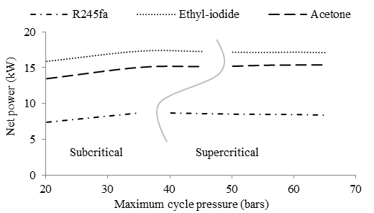
Figure 9 Net power comparisons for subcritical dry saturated and supercritical bi-phase saturated expansion.
The published thermal stability literature is sparse, mainly in the temperature range for EGR WHR. Nevertheless, most synthetic and organic fluids exhibit the behaviour of low fluid stability, high flammability and corrosiveness near or above critical point conditions [27]. This limit influences the BC design since the performance has to be tailored to the temperature and pressure ranges where the fluid is chemically stable. The highest fluid temperature is found in the boundary layer of the fluid close to the tube walls, the stagnation conditions with hot spots will contribute to the decomposition of the working fluid at such points. Furthermore, the expansion inlet temperatures above the fluid critical temperature will compound this degradation effect.
The alteration of the working fluid flow rate in supercritical cycles to increase average heat addition temperature can compensate for the net power drawbacks of a low temperature supercritical cycle. However, given the high pressure, large vapour phase heat transfer (de-superheating) and high temperature drawbacks for BCs already discussed, high temperature supercritical cycles (figure 2b) are therefore the least practical option.
Flash expansion cycles
An alternative approach for providing an almost constant temperature difference between the EGR stream and the working fluid with lower pressures than the supercritical cycles was explored by the use of Trilateral Flash Cycles (TFC). In TFC the working fluid enters the expander as saturated liquid and exits at condensing pressure with some vapour content (figure 2a). The heat recovery efficiency for TFC does not depend on the selected working fluid but depends on the cycle operating condition. As a result all of the selected working fluids provide nearly equal heat recovery efficiency of 96.5-97.5% and hence cool the EGR from 465 to 95-98°C. Figure 10a shows the overall conversion efficiency for TFC with different working fluids.
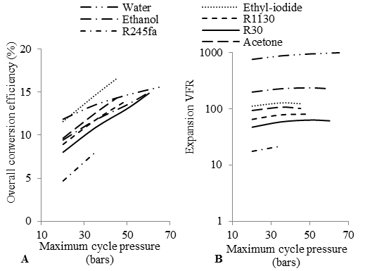
Figure 10 Effect of increasing expander inlet pressure on, (a) overall conversion efficiency, (b) expansion volume flow ratios, for flash expansion cycles.
For the near constant temperature difference across the greater segment of the EGR cooler and higher net power, the selected fluid should have a higher critical temperature, like ethyl iodide. The shape of the saturated cycles in T-Q diagrams near critical point conditions approximate close to that of the TFC since lesser heat is being needed to evaporate the working fluid. Nonetheless, TFC always demonstrate lower net power compared to saturated cycles. This can be explained by considering ethyl iodide for pressurisation up-to 45 bar for saturated and TFC (figure 10a vs. 3b). It is seen that more power is recoverable from expanding dry vapour (19.1 kW) than from expansion through the two phase region (18 kW). As the specific enthalpy change in the expansion is larger for dry vapour expansion (48.3 kJ/kg) than TFC (39.4 kJ/kg), under the same pressure limits the pump power is greater for TFC (2.2 kW) than that of the subcritical cycle (1.8 kW). Hence, TFC values for overall conversion efficiency are lesser than those calculated for dry saturated expansion condition. At 0.95 P_{c} evaporator pressure, TFC ethyl iodide provides a maximum overall conversion efficiency of 16.6% compared to 18% for dry saturated expansion.
When using positive displacement machines proposed for TFC, the overall expansion VFR of the fluid is many times greater than the machine built in VFR [28]. This is due to the density of the working fluid being higher at the expansion inlet compared to dry saturated cycles. The suction (high pressure port) process is accompanied by a comparatively large pressure drop which contributes significantly to the overall expansion. However, irrespective of this advantage over dry saturated expansion, the VFRs seen in TFC make them impractical. Figure 10b shows the VFRs associated with TFC. Comparing with figure 6a it can be observed that the VFRs of expansion from the liquid phase are much higher than those associated with the expansion of dry vapours.
Comparing water and R30, it can be noticed that at 35 bar, the cycle with minimum superheated water (figure 6a) has a VFR of 44.4:1 which increases to 863.8:1 for a TFC, an increase by a factor of 19.45. These large VFRs with water as working fluid for 65°C condensing temperature are unrealistic to handle in real BCs. Furthermore, TFC expander efficiencies decrease as the difference between the heat source and heat sink increases. This is due to the need for a higher built-in VFR to permit complete expansion across increasing pressure differences and, associated with this, reduced fluid throughput and higher leakage losses [28]. Neither radial inflow turbines nor positive displacement expanders can maintain high efficiencies when VFR exceeds approximately 25:1.
The large VFRs with water as working fluid are caused by the low vapour pressure (0.25 bar) at the selected condensing temperature. Water with TFC operating condition is mainly recommended for combined heat and power plants or in the upper stages in cascade systems which have higher values of condensing temperature. The VFR can be decreased by using working fluids with higher vapour pressures. Using R30 the VFR could be reduced by a factor of around 15. Under the same maximum pressure, minimum superheated R30 gives a VFR of 13.7:1 and increases to 58:1 for TFC, an increase by a factor of 4.23 (figure 6a vs. 10b).
Wet expansion cycles
Due to the large heat required to vaporise water and further heat needed to superheat steam when using conventional turbines, the EGR stream is not cooled down to the temperature values as demonstrated by TFC. Figure 11a shows the EGR stream only being cooled to 200°C in a minimum superheat cycle with an evaporator pressure of 35 bar. For such a cycle operating condition, 25 kW of the 95 kW heat in the EGR cooler remains unused and is exhausted, requiring an additional low temperature EGR cooler. The complete isothermal evaporation, which reduces heat recovery efficiency, can be avoided by the application of a wet expansion cycle (figure 2a). For wet expansion, depending on the saturated vapour line of the working fluid and the two phase mixture content at the expander inlet, it is possible to carry out expansion where the working fluid leaves as two phase, dry or even superheated vapour. The two-phase expansion machines are considered technically the most challenging component. Advancements in turbines have resulted in efficient operation when the working fluid enters in the pure liquid phase; however, they are unsuitable for the admission of two-phase mixtures. Recent progress has been made with screw expanders and equivalent positive displacement machines which may provide a solution [24].
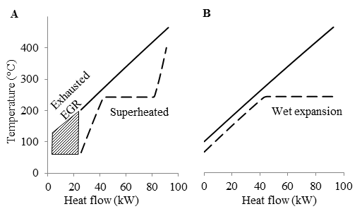
Figure 11 Heat recovered and cooled EGR temperature for, (a) Minimum superheat expansion, (b) Wet expansion.
To determine the effect of a wet expansion cycle on the heat recovery efficiency and net power, simulations were conducted with varying expander inlet wetness conditions for all fluids at a boiler pressure of 35 bar. With the exception of water, figure 12a shows net power produced by all the working fluids increases as the wetness at expander inlet decreases. This indicates that these fluids are better suited when operating at dry saturated or minimum superheated conditions. However, when using water the the peak overall conversion efficiency and hence the maximum net power is observed at an expander inlet dryness fraction of 0.45-0.5. The optimised wet expansion cycle in which water enters with a dryness fraction of the order of 0.5 is shown in figure 11b. This operating condition gives similar heat recovery efficiency (97.4%) as seen with TFC but with higher net power output (17.8 vs. 13 kW). Additionally, when compared with the minimum superheat cycle from figure 3b for the same pressure limits wet expansion cycle will give higher net power output (17.8 vs. 15.1 kW). With low temperature heat recovery the UA/kW for wet expansion cycle with water will be higher than the values shown in figure 6b and will be similar to the values calculated by the proposed working fluids at 35 bar. The higher heat transfer coefficients associated with water (two-phase) may in fact result in smaller total heat exchanger surface area.
However, wet expanders face some application specific challenges. For the selected 35 bar boiler pressure the evaporation temperature is 242.5°C. Such high temperatures may lead to thermal distortion of the casing and the rotors when using screw machines. To avoid this, boiler pressure has to be reduced to 25 bar; this will result in reduced net power from 17.8 to 16.8 kW. Furthermore, as screw machines cannot operate at such high pressure ratios (87.5:1), the condensing pressure has to be raised to 100°C. This will further decrease the net power produced to 12.8 kW. Even at this reduced pressure limits, two stages of screw expansion will be required, resulting in bulkier equipment. The problem of utilising wet steam is also evident by the VFR shown in figure 12b. Comparing water TFC and optimised wet expansion cycle at 35 bar (figure 10b vs. 12b), the VFR reduces form 863.8:1 to 76:1 with increasing the vapour fraction at inlet. Nonetheless, the VFR of wet expansion cycle is twice the values of minimum superheat expansion (figure 12b vs. 6a). This may result in larger footprint of screw expanders to expand water to low condensing temperatures.
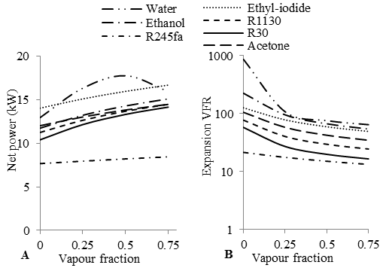
Figure 12 Effect of expander vapour fraction on, (a) net power, (b) expansion volume flow ratios, for wet expansion cycles.
An important problem encountered with BCs is the highly transient conditions of the source/sink in an automotive application. Suitable control and monitoring systems are thus required to keep the temperature, pressure and vapour conditions within acceptable ranges. Flash and Wet expansion will be very challenging to control in practice, since the information about the enthalpy would be required to exactly define the vapour quality at expansion inlet. In contrast, the minimum superheated condition upstream of the expansion is clearly defined by pressure and temperature. Furthermore, expanders designed for flash and two phase expansion are slightly inefficient than dry vapour turbines. From the analysis conducted by varying turbine/expander inlet parameters, it can be concluded that the most suitable cycle operating mode is that of a subcritical cycle with maximum pressure of 0.9-0.95 P_{c}, with dry saturated expansion for the proposed isentropic fluids and minimum superheat expansion for the wet fluid.
EGR and CAC WHR
Waste heat can be obtained from four sources which include, engine cooling, CAC’s (inter and after-cooler), EGR cooler and exhaust gas stream. The engine cooling carries a large percentage of fuel energy but due to the low quality its potential for power conversion is low. Similar results are seen with inter-cooler. Furthermore, inter-cooler is extremely sensitive to engine speed and load, and at typical cruise condition, the low pressure T/C is bypassed. The after-cooler is a slightly more favourable source, though not very effective over the drive cycle, the higher temperatures seen at high loads and even at low loads allows the possibility of partial WHR. The exhaust gas flow taken downstream of the DPF is comparable in quantity but lower in quality than EGR during normal operating conditions. For an EGR only engine, the frequent DPF regenerations will boost the exhaust temperature to 600°C, increasing the quality of the stream significantly. However, the use of an exhaust heat exchanger will lead to added pumping losses and significant increase in engine cooling load. EGR flows taken before the T/C offer the highest quality. The 35-45% flow rates make it a source of high overall conversion efficiency, leading to over 15% reduction in total heat rejected by the EGR condenser. Hence, for a systems approach, the recovery of EGR and partial high temperature after-cooler was conducted. With such a recovery layout, the available components in the cooling circuit are used without added back pressure for BSFC improvements and reduced engine heat rejection.
The maximum cycle pressure was limited to 45 bar and the cycle operating condition was that of minimum superheat for wet fluids and dry saturated expansion for isentropic fluids. For the low temperature and high temperature radiators in the cooling module of the high EGR rate engine, the lowest temperatures are 65 °C and 85 °C, respectively. The BC condenser is considered as a replacement of the low temperature radiator. The condensing temperature was fixed at 65°C. The minimum cycle pressures must be maintained at low levels, yet super-atmospheric, in order to prevent air or moisture ingress. Hence, the potential WHR benefits were only assessed using acetone, R30 and R1130 (condensing pressures 1.33, 2.28, 1.69 bars, respectively). Even though ethyl iodide gives condensing pressure ≈ 1 bar, it was excluded from this analysis. With the three selected fluids, reducing condensing temperatures further while remaining at super-atmospheric pressures will also improve their cold weather performance.
Table 4 shows the results for the two engine platforms. Also included are results for ethanol condensed at 65 °C. From table 4 it can be seen that the proposed fluids provide similar or improved BSFC compared to ethanol for EGR only (10.25-10.01 vs. 10.1%; 13.83-12.41 vs. 12.56 %) and EGR focused (6.76-6.6 vs. 6.67%; 6.98-6.64 vs. 6.72%) engine at B50 and C100, respectively. For maximum performance improvement, the analysis favours acetone, with approximately 7% increase in engine power for an EGR only engine at C100. The higher efficiency with acetone is owed to the better heat transfer performance in the CAC as a result of its lower latent heat. A fluid with a low latent heat and high density will absorb more energy from the source in the preheating phase rather than evaporation and will thus increase the working fluid mass flow rate, maintain turbine efficiency, and provide higher overall conversion efficiency.

Table 4 Efficiency improvements by recovering CAC and EGR heat on EGR only and EGR focused engine.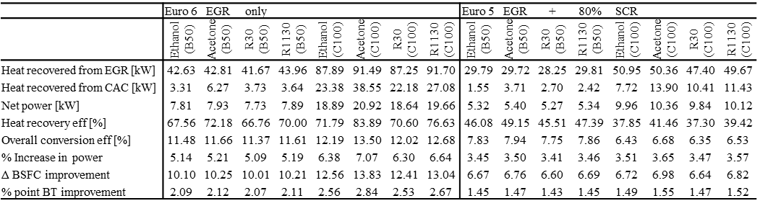
The recommendation of fluid with low latent heat is contrary to the discussion conducted using figure 4b. As the objective for WHR applied to a high EGR rate engine is not only to provide high thermal efficiency but is also to cool the EGR stream for highest overall conversion efficiency, fluids with low latent heat are more preferable.
The temperature and pressure limits considered in this analysis are least favourable for ethanol. Comparing ethanol and R30, it was found that ethanol operates at sub-atmospheric condensing pressures (0.77 bar). This implies reduced density of vapour and relatively higher condensing specific volumes (0.7845 vs. 0.1296 m³/kg). Also, the higher pressure ratios (58.4:1 vs. 18.5:1) calculated does not allow the possibility of using a positive displacement expander. Furthermore, if the condensing temperature is increased to that seen in the high temperature radiator (85°C) the suitability of R30 is even more profound over ethanol, for nearly the same net power (±3%) pressure ratio and volume flow ratios are 9.7:1 vs. 26.2:1 and 10.7:1 vs. 29.7:1.
ConclusionS
The main challenges of the BC design and performance are the choice of an appropriate working fluid and the associated operating mode which impacts its practicality. With higher condensing pressures, higher auto-ignition temperatures, lower expansion VFRs and lower speed of sound than ethanol, the study highlighted the desirable characteristics of isentropic fluids (R1130 and acetone) and a wet fluid (R30) which are proposed as alternatives.
Multiple sub and supercritical BC operating conditions with varying turbine/expander inlet parameters were analysed. For organic fluids, a higher turbine inlet pressure increases the ratio of net work to heat absorbed, leading to improved thermal and overall conversion efficiencies. Net output of the BC systems is significantly increased by using maximum pressure levels of 0.9-0.95P_{c} for the proposed fluids.
Superheating plays a negative role on the thermal efficiency of dry fluids, as it reduces the net power produced compared to the reference saturated dry expansion. Minimum superheating is necessary for wet fluids when used with conventional turbines, however, the economic feasibility of the proposed wet fluid (R30) can be increased by avoiding large superheat with a reduction of only 6% in expansion power.
The investigation of supercritical bi-phase saturated expansion on isentropic and dry fluids did not bring any favourable results concerning the net power produced. Drawbacks associated with the high pressures, compounded fluid decomposition and large de-superheating makes high temperature supercritical cycle operating mode impractical.
Flash expansion using dense organic fluids like R30 can reduce the expansion VFR by a factor of 15 when compared to water. Nonetheless, the VFR will still be 4 times of those seen with minimum superheated expansion using R30. To address the drawback of water’s large latent heat on overall conversion efficiency, wet expansion was considered. With an optimum inlet dryness fraction of the order of 0.45-0.5, the cycle resulted in approximately 18% higher net power when the fluid enters the expander as superheated vapour in a minimum superheat cycle. However, flash and wet expansion mode implies that the expansions VFR in the expander are very large, resulting in big and expensive machines and expander design problems.
Dry saturated expansion (for R1130 and acetone) and minimum superheat expansion (for R30) with slightly subcritical evaporator pressure limits were found to be optimal when considering performance and system trade-off to achieve a better integration with a HDDE. For EGR and CAC heat recovery, acetone showed the maximum BSFC improvement potential of 13.83% for an EGR only engine at C100. With low pressure ratios and volume flow ratios, R30 may allow the use of a piston expander. An R30 BC with a maximum cycle pressure of 45 bar provided BSFC improvements of 10.01 and 12.41%, 6.66 and 6.64% for EGR only and EGR focused engine at B50 and C100, respectively.
References
1. Nelson, C., R. Gravel, and C. Maronde, “Heavy-Duty Truck Engine Program”, in FY 2006 Annual Progress Report, Advanced Combustion Engine Research and Development 2006.
2. Teng, H., G. Regner, and C. Cowland, “Achieving High Engine Efficiency for Heavy-Duty Diesel Engines by Waste Heat Recovery Using Supercritical Organic-Fluid Rankine Cycle”. SAE International 2006-01-3522, 2006, doi:10.4271/2006-01-3522.
3. Nelson, C., R. Gravel, and C. Maronde, “Exhaust Energy Recovery”, in Advanced Combustion Engine Research and Development 2009.
4. Park, T., et al., “A Rankine Cycle System for Recovering Waste Heat from HD Diesel Engines - Experimental Results”. SAE Technical Paper 2011-01-1337, 2011, doi:10.4271/2011-01-1337.
5. Tai, C., et al., “Very High Fuel Economy, Heavy-Duty, Narrow-Speed Truck Engine Utilizing Biofuels and Hybrid Vehicle Technologies”, in FY Annual Progress Report, Advanced Combustion Engine Research and Development 2010, 2009.
6. Cooper, C., et al., “Reducing Heavy-Duty Long Haul Combination Truck Fuel Consumption and CO₂ Emissions”, P. Miller, Editor 2009, NESCCAF; ICCT; SwRI; TIAX, LLC.
7. LaGrandeur, J., et al., “High-Efficiency Thermoelectric Waste Energy Recovery System for Passenger Vehicle Applications”, in FY Annual Progress Report, Advanced Combustion Engine Technologies 2008, 2007.
8. Schock, H., et al., “Thermoelectric Conversion of Waste Heat to Electricity in an Internal Combustion Engine Vehicle”, in FY Annual Progress Report, Advanced Combustion Engine Technologies 2008, 2006, 2005.
9. Green Car Congress. “Daimler Trucks Introduces New Heavy-Duty Engine Platform for North America: DD15 Improves Fuel Economy by 5%” ; 2012.
10. Hountalas, D.T. and G.C. Mavropoulos, “Potential for Improving HD Diesel Truck Engine Fuel Consumption Using Exhaust Heat Recovery Techniques”, New Trends in Technologies: Devices, Computer, Communication and Industrial Systems ISBN 978-953-307-212-8, 2010.
11. Kruiswyk, R., J. Fairbanks, and C. Maronde, “An Engine System Approach to Exhaust Waste Heat Recovery”, in FY 2009 Annual Progress Report, Advanced Combustion Engine Research and Development 2009.
12. Vuk, C.T., J. Fairbanks, and R. Nine, “Electrically Coupled Exhaust Energy Recovery System Using a Series Power Turbine Approach”, in FY Annual Progress Report, Advanced Combustion Engine Research and Development 2007, 2006.
13. Schock, H., et al., “Thermoelectric Conversion of Waste Heat to Electricity in an Internal Combustion Engine Vehicle”, in FY Annual Progress Report, Advanced Combustion Engine Research and Development 2010, 2009.
14. Stanton, D., R. Gravel, and C. Maronde, “Advanced Diesel Engine Technology Development for High Efficiency, Clean Combustion”, in FY 2009 Annual Progress Report, Advanced Combustion Engine Research and Development 2009.
15. Cloudt, R., et al., “SCR-only concept for heavy-duty Euro-VI applications”, 2009: MTZ 09I2009 Vol 70
16. U.S. Department of Energy, “Advanced Combustion Engine Research and Development”, 2011, Energy Efficiency and Renewable Energy Vehicle Technologies Program.
17. National Academy of Sciences, Committee to Assess Fuel Economy Technologies for Medium and Heavy Duty Vehicles; National Research Council; Transportation Research Board, “Technologies and Approaches to Reducing the Fuel Consumption of Medium- and Heavy-Duty Vehicles”. ISBN: 0-309-14983-5, 2010.
18. Ricardo Software, WAVE Version 8.1, 2008.
19. SHRL. GREEN 3, Centre for Automotive Engineering, University of Brighton. 2012; Available from: http://www.brighton.ac.uk/shrl/projects/index.php.
20. Panesar, A.S., et al., “An investigation of bottoming cycle fluid selection on the potential efficiency improvements of a Euro 6 heavy duty Diesel engine”, in Vehicle Thermal Management Systems 11, 2013.
21. Aspen Technology Software, HYSYS Version 7.3, 2011.
22. Calm, J.M. and D.A. Didion, “Trade-offs in refrigerant selections: past, present, and future”. International Journal of Refrigeration, 1998. 21(4): p. 308-321, doi:10.1016/s0140-7007(97)00089-3.
23. Welch, P. and P. Boyle, “New Turbines To Enable Efficient Geothermal Power Plants”, Presented at the Geothermal Resources Council, Annual Meeting, 4-7th October 2009, Reno, Nevada.
24. Smith, I.K. and N. Stosic. “Steam as the Working Fluid for Power Recovery from Medium Temperature Heat Sources Using Positive Displacement Expanders”. Available from: Centre for Positive Displacement Compressor Technology, http://www.staff.city.ac.uk/~sj376.
25. Shengjun, Z., W. Huaixin, and G. Tao, “Performance comparison and parametric optimization of subcritical Organic Rankine Cycle (ORC) and transcritical power cycle system for low-temperature geothermal power generation”. Applied Energy, 2011. 88(8): p. 2740-2754, doi:10.1016/j.apenergy.2011.02.034.
26. Chen, H., D.Y. Goswami, and E.K. Stefanakos, “A review of thermodynamic cycles and working fluids for the conversion of low-grade heat”. Renewable and Sustainable Energy Reviews, 2010. 14(9): p. 3059-3067, doi:10.1016/j.rser.2010.07.006.
27. Gu, Z. and H. Sato, “Performance of supercritical cycles for geothermal binary design”. Energy Conversion and Management, 2002. 43(7): p. 961-971, doi:10.1016/s0196-8904(01)00082-6.
28. Smith, I.K., N. Stosic, and A. Kovacevic. “Power Recovery From Low Cost Two-Phase Expanders”, in Geothermal Research Council Annual Meeting, August 2001, San Diego, CA.

DefinitionS/AbbreviationS
BC | Bottoming Cycle
BSFC | Break Specific Fuel Consumption
P_{c} | Critical pressure
CAC | Charge Air Cooler
R30 | Dichloromethane
DPF | Diesel Particulate Filter
ETC | Electrical-Turbo-Compounding
EGR | Exhaust Gas Recirculation cooler
HDDE | Heavy Duty Diesel Engine
L | litre
MTC | Mechanical-Turbo-Compounding
ORC | Organic Rankine Cycle
SCR | Selective Catalytic Reduction
R1130 | Trans-1,2-Dichloroethylene
TFC | Trilateral Flash Cycle
T/C | Turbo-Charger
VFR | Volume Flow Ratio
WHR | Waste Heat Recovery

