Practicing Presence: Drawing Near and Far.

  - Duncan Bullen, University of Brighton. D.Bullen@Brighton.ac.uk

ª [Affiliation of each author linked via a, b, c etc superscript prefix]
[Email of corresponding author (1 only)]

Abstract:
This paper takes the experience of drawing within two sites in states of transition, as a starting point to explore the changing nature of place as a catalyst for lived experience. Working from phenomenological perspective, I propose an alignment of manual drawing practice with meditation (mindful awareness), to ask how the act of drawing ‘… the state, or the being that is in question cannot be detached entirely from the sense of gesture, movement or becoming.’ (Nancy 2013). Through a discussion of a non-representational drawing practice and mindful awareness (counting the breath), I will argue that drawing as process enables an experiential and intimate engagement with the world as ‘grounded in availability and access’ enabling ‘presence’ (Noë 2012). One that allows us to experience the physicality of spaces and the living body not as separate realities, but as entities that are thoroughly and deeply entwined, in which there is no separation of self, other and the lived environment. Dwelling (being present) and touch (making present) are key factors in this, as a means of understanding experience of the embodied self in relation to artistic expression and resulting knowledge.

[Keywords:
Drawing, Mindfulness, Presence, Dwelling, Phenomenology.

‘The world shows up for us in experience only insofar as we know how to make contact with it' (Noë 2012, p. 2).
Introduction:
This paper aims through a first-person investigation, to contribute and build upon discussions that position drawing as phenomenology (Rosand 2002, Harty 2012). A Phenomenological approach in this instance asks how the act of drawing ‘… the state, or the being that is in question cannot be detached entirely from the sense of gesture, movement or becoming.’ (Nancy 2013, p. 1). I propose to do this by focusing on a series of works titled Breath Drawings (2015 - 2019). These drawings emerged as a result of a project to explore what the particular value of drawing might be as an investigative practice, concerning the Circus Street site adjacent to the main Grand Parade Campus of the University of Brighton. This area was earmarked for demolition and redevelopment. Making drawings on site challenged me in ways I wasn't anticipating and led to an artist in residence opportunity at Gordon House, Margate where I would continue to develop these drawings.
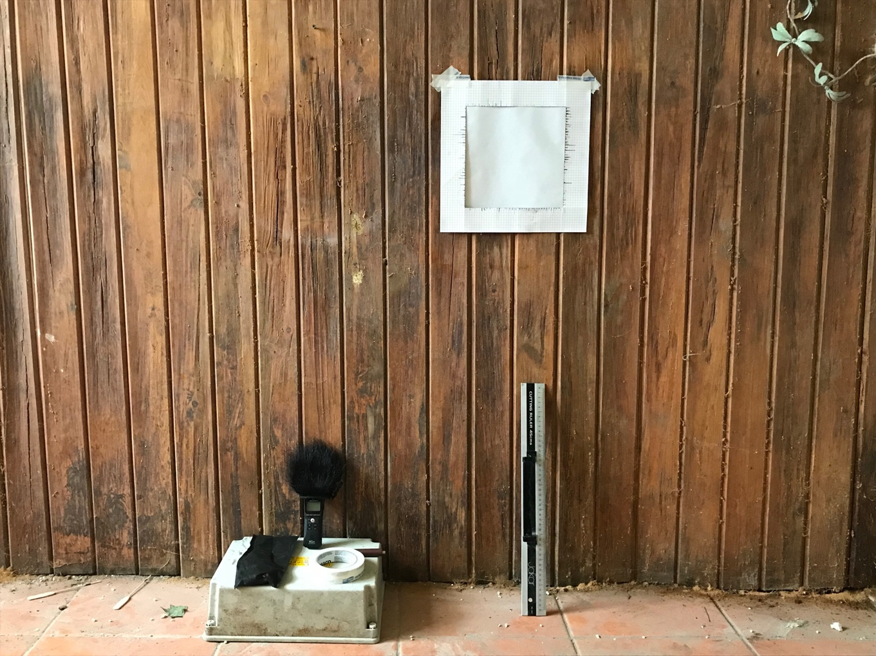
Figure 1: Gordon House, Margate, 19th July 2018. Photo: Duncan Bullen
I intend to document and reflect on the what, how and why of this specific series of drawings, to open up an idea of presence described by the contemporary philosopher Alva Noë as something that ‘is manifestly fragile' (Noë 2012, p. 1). In order to discover presence Noë suggests we need to ‘give up the idea that the world shows up as remote contemplation' (Noë 2012, p. 3), rather, we need to find strategies to let the body come to the foreground. He states that ‘If we are to hope to bring this pervasive feature of our lives, of ourselves, into focus, then we need … somehow to let the body itself crowd into the space of our attention and let itself be felt… Perhaps, it is one of the aims of practices such as meditation and yoga to enhance the kind of sense of self that arises out of a withdrawal from our worldly engagements'. (Noë 2012, p. 12).
Throughout the paper I attempt to weave together different discourses, through an experience-based methodology that is essentially phenomenological in approach, blended with Eastern philosophies, notably Zen Buddhism (Kasulis 1985), Japanese aesthetics (Lomas 2017, Blaser 1963) and mindfulness practices (Kabat-Zinn 1994, Varela, Thompson and Rosch 1993/2016) as they have been interpreted in the West. I situate this thinking alongside Western philosophy (Dewey 1934/2005, Noë 2012, Johnson 2007) and positive psychology (Lomas 2016, 2017), as well as thinking about drawing in particular and creative practice in general (Hughes 2014, Fisher and Fortnum 2013).
Experience, presence and mindful drawing:
In Art as Experience (1934/2005), John Dewey contends that art resides in our experience, rather than in the object or performance itself. Dewey, states that ‘in conception the work of art, is often identified with building, book, painting, statue, or in its existence apart from human experience. Since the actual work of art is what the product does with and in experience' (Dewey 2005, p. 1). Mark Johnson suggests that ‘the basis for Dewey's idea of experience is an account of an organism continually interacting with its surroundings … and knowing is a matter of cultivating appropriate habits of intelligent inquiry that allow us to more or less satisfactorily reconfigure our experience … ' (Johnson 2010, p. 146).
Central to Noë's argument is that presence is something we earn, and may achieve through experience and engagement, that ‘is grounded in availability and access' (Noë 2012, p.33). My conceit in this paper is to align repetitive, reductive and non-representational manual drawing, with the practice of mindfulness meditation, as a means to trace the physicality and presence of particular spaces and places. Johnson argues that it is how ‘we are in touch with our world at a visceral level, and it is that quality of "being in touch" that importantly defines what our world is like and who we are' (Johnson 2007, pp. 19-20). Correspondingly, I aim to explore how space and place provide a situation for integrated lived experience, in which mental and bodily experiences are imminent, entwined and transactional with our surroundings.
For me, mindfulness meditation and mindfully drawing act as a means of accessing a clearing through the seemingly endless distractions of daily living to focus attention on present moment experience. In the Embodied Mind, Francisco Verela, Evan Thompson and Eleanor Rosch collectively suggest that ‘mindfulness techniques are designed to lead the mind back from its theories and preoccupations, back from the abstract attitude, to the situation of one's experience itself' (Varela et al 2016, p. 22). In the introduction to the revised edition of Embodied Mind (2016), Eleanor Rosch suggests that mindfulness originating from Buddhist practices teaches us to experience our bodies as grounded, in touch with the immediacy of experience. Rosch proposes that ‘the lived body, lived mind, and lived environment are all thus part of the same process, the process by which one enacts one's world (in phenomenology speak, "brings forth a world") (Rosch 2016, pp. xxxviii-xxix).
In this context, I see practices such as sitting meditation and drawing with repetitive mark making as ways of consciously investing in and enacting well-being and well-doing. In this practice, making is an embodied act in which one is engaged with instructional and habitual practices as ‘continuous acts of doing' (Jacob 2004, p. 166). Paradoxically, mindfulness has been described as a practice of ‘non-doing' (Kabat-Zinn 1994). One sits and counts the breath, stares at a wall, and watches thoughts come and go. In my case, I align mindfulness with the drawing of horizontal lines or circling points one after the other in sequence as a strategy that oscillates between contraries. By this I mean adopting a methodology that is both near and far, that allows for mind-body attunement, and that asks how do we get close to an event, while simultaneously getting the self out of the way in order to let presence be felt? In these drawings the author's hand is present, yet the act of mark making is subjugated to rule based instruction and calculation, as a foil ‘between touch and measured distance' (Malone 2012, p.9).
Background:
Before discussing the Breath Drawings, I would first like to mention, what I would regard, as my primary drawing practice. I want to do this because there are core concerns that are relevant to a drawing practice that emphasises the simple act of making the same mark, one after another in predetermined sequences. In Chromatic Fields (2010), Gatherings (2011 - 2016) and Constructed Drawings (2017-present) the drawing process is a balance between pre-determined ‘planned procedure and intuitive response’ (Bullen 2012, p.11) in which mark-making is reduced to a set of point-to-point connectors, through which I activate the picture plane via a slow and patient marking of the surface of the paper (Figure 2a, 2b, 2c). These marks operate on thresholds and explore boundaries between visible and barely visible and as such, they have a clear hierarchical preference toward the visual and illusory pictorial space, where the white of the paper, the spaces between the drawn are activated (Bullen 2013). David Rosand sees drawing in terms of phenomenology and as a ‘fundamental pictorial act’ in which ‘to make a mark or trace a single line upon a surface immediately transforms that surface, energizes its neutrality; the graphic imposition turns the flatness of the ground into virtual space, translates its material reality …’ (2002 p. 1). The psychologist Richard L. Gregory in his influential book The Intelligent Eye stated that ‘Pictures have a double reality', they are simultaneously object’s in their own right, ‘patterns on a flat sheet' and depictions, representations, symbols, emblems of something else: ‘they are seen both as themselves and as some other things … Pictures are paradoxes.' He goes on to suggest that 'Pictures are perhaps the first step away from immediate reality' (Gregory 1970, p. 32).
Figure 2a: Constructed Drawing: Circling no 2:17, pencil on paper 50x50cm 2017. Figure 2b: Drawing no 33, Chromatic Fields, Colour pencil on paper, 40x40cm 2010. Figure 2c: Drawing no 28, Gathering, 40x40cm, 2011. Photos Lorry Eason.
Gregory's writings on visual perception have contributed to our understanding of the eye and brain, in terms of how seeing happens in the brain and in particular how seeing is an active, not passive, process. Noë takes an enactivist position and questions whether seeing is something that happens in our brain, that happens to us, or whether ‘it is something we do, or make or achieve.' (Noë 2015, p. xi-xii). Building on the work of Dewey, Noë claims that art is experience, and that ‘seeing (and all kinds of perception) is the organised activity of achieving access to the world around us' (Noë 2015, p. 10). Experience for Dewey, and likewise, Noë, is not a ‘series of sensations, in haphazard sequences' but rather ‘structured and integral … we make them. We don't just have them. We manage them' (Noë 2015, p. 204).
Mindfulness:
As someone whose mind is prone to wander and drift easily, I initially began to explore meditation as an aid to concentration and a means of cultivating stillness, awareness and attention. I have found the writings by Jon Kabat-Zinn (2013,1994), the founder and director of the Stress Reduction Clinic at the University of Massachusetts Medical Centre a particularly helpful guide to developing a personal practice. He describes mindfulness succinctly as discovery through a ‘paying attention in a particular way: on purpose, in the present moment, non-judgmentally (Kabat-Zin 1994, p. 4). In Full Catastrophe Living, Kabat-Zinn provides straightforward, practical techniques as a guide to develop a formal foundational practice. In exercise no. 1 Kabat-Zinn outlines seven basic instructions for mindfulness of breathing. It asks us to sit, relax the eyes, feel the breath rise and fall and that we focus on the sensations of the in breath and out breath. When the mind wanders the guidance is to bring it back to the breath, to keep bringing the mind back to the breath and to do this for fifteen minutes each day, whether you want to or not (Kabat-Zin 2013, pp. 52-53). Realising how difficult it is to do this every day, let alone follow the seemingly simple instruction to stay with the breath, I became increasingly interested in ‘how the flightiness, the nonpresence of mind can be worked with' (Varela, Thompson, Rosch 2016, p. 24). I began to see how my interest in reductive yet visceral approaches to drawing could be supported and nurtured by exercises for mindfulness practice, as expounded by Kabat-Zinn. These exercises were not just an aid to concentration but formed through a procedural and instructional method in which I would draw in keeping with my breath.
It seems no coincidence that Dewey, whose Art as Experience has informed this text directly and indirectly (through Noë and Johnson in particular), studied and practiced the Alexander Technique and wrote the ‘forward to three of F. Matthias Alexanders books ‘(Jackson 1998, p. 137). While the Alexander Technique is not mindfulness meditation, Philip W. Jackson writes that ‘Dewey was no stranger to the kind of advice that Kabat-Zinn offers. He knew what it was like to focus on the act of breathing and on the posture of the body as a means of breaking old habits and establishing new ones' (Jackson 1998, pp. 137-138).
Dewey's influence is also profoundly present in publications by Jacquelynn Baas (2005) and Baas and Mary Jane Jacob (2004, 2009) in which they explore perspectives of pedagogy, contemporary art, and Buddhism. Dewey's writings do not mention Buddhism, yet, Baas claims that ‘the roots of American Zen [Buddhism] are … tangled with those of American pragmatism ...' (2005, p. 58 – my italics). She notes that ‘Buddhism is essentially experiential' and that Dewey's conception of art ‘is a distillation of experience', in which Dewey resolved the ontological divide between mind-body ‘by understanding the mind as a product of natural processes and the web of interactive relationships between human beings and the world (Baas 2005, p. 58).
In her essay, The Space of Art (Jacob 2004) Jacob draws interesting parallels between the practice of art, the method of meditation and the mental space they inhabit. She interestingly asserts that both require not just practice but ‘assuming a practice' (Jacob 2004, p. 166). She asserts ‘that the space artists depend on to make their art … is … a transition space, a place of pause, a place of wait, to test and then move beyond… it's open… In the space of art dwells the "mind of don't know." Jacob equates this with the Buddhist idea of Emptiness in which she claims the ‘Empty Mind or Unknowing Mind' is also the ‘Creative Mind' (Jacob 2004, p. 166). The artist Anne Hamilton supports this and suggests ‘Not knowing is a permissive and rigorous willingness to trust, leaving knowing in suspension, trusting in possibility without result, regarding as possible all manner of response' (Hamilton 2010, p. 68).
What Jacob describes as ‘Empty Mind or Unknowing Mind' are terms which are close to the terminology of ‘not knowing' valued by many creative practitioners (Fisher and Fortnum 2013). My view is in accord with the one offered by Dean Hughes (2014), who claims that ‘not knowing while illuminating and necessary to creativity, subjugates a key element of its rhetoric.' Because of this, Hughes, advocates a space within ‘not knowing" for an attitude that is concerned with dwelling and being resident' and argues that an appropriate schema in which this practice takes place is through repetition and stasis, one that imposes ‘restriction and limitation' and dwells within a ‘fixed parameter' (Hughes 2014, p. 74).
The artist Wendy Smith ‘sees no contradiction between intentionality and not knowing' and suggests ‘that when one is seriously in the dark, there is little choice but to be methodical' (Smith 2015, p. 42). After a visit to Japan, where Smith spent time copying the Heart Sutra, she was led to reflect in an interview with Ben Gooding ‘that ritualising a practice might be a way of ensuring that however often it is performed … the operation commands one's full attention'. She goes onto say ‘As one painstakingly traces the characters of the sutra, one could scarcely be more aware that this is not an exercise in self-expression: this is not about me; the world is not about me. The curious thing about this is that it is not as self-denying or self-effacing as it perhaps sounds. It opens one to the amazingness of everything that isn't oneself, but of which one is somehow apart. In a way, the challenge is to be the best possible nobody that only you yourself can be' (Smith 2015).
This view seems to be in accord with an outlook expressed by Mark Epstein, a therapist influenced by Eastern philosophy, who writes; ‘The ability to be present while getting the self out of the way is the great discovery that meditation makes possible … Meditation teaches us how to put ourselves aside, and it shows us that when we achieve this we do not disappear, but we open to a more creative relationship with our minds, our feelings, and the world'. (Epstein 2010, p. 48).
Circus Street (April – June 2015):
Circus Street, adjacent to the main Grand Parade campus of the University of Brighton at the time of making the drawings, was a site soon to be demolished to make way for new educational development. The project involving staff and students asked two questions:
What can drawing offer as a method to explore changing urban spaces? Does drawing offer a valuable means of investigating and recording not only the function but the presence and impact of buildings that are about to be demolished?
When I first went into the space with a group of students to draw, my response was that I could not possibly document the entirety of the building to meet the proposition. So, while the students walked around and chose places to sit and draw, I found myself wandering around and just sitting. This initial sensing of location outside of my regular drawing board studio was a challenge to my customised practice. I remember in discussions leading up to this project saying that I felt no emotional attachment to Circus Street, however, what I was not prepared for were the feelings that this physical space would produce in me.
I felt a sense of not knowing what to do or how to approach the project and a feeling that I needed to be fully present in my body, in the moment-to-moment of the embodied experience of the environment in which I had placed myself. In short, I felt, as it were, ‘out of touch.' This sense of longing and unknowing was initially unsettling and disconcerting. What I had not anticipated was the way being in the space provoked and collided with my emotional state. This empty shell of a building, which was once a thriving marketplace, somehow resonated with my particular circumstances. I need to explain; just previous to this project I experienced the death of my father, followed shortly by the death of my mother, as well as being reunited with my long-lost, but not forgotten sister. At the outset of the project I had no intention of speaking about this, and I am struggling as I write as to whether to include such personal material. I have thought long and hard whether to disclose this information and to speak about this in a more detached sense. It seems necessary to reveal this to capture the early phases of a project that was to lead onto a new body of drawings (Figure 3a, 3b).

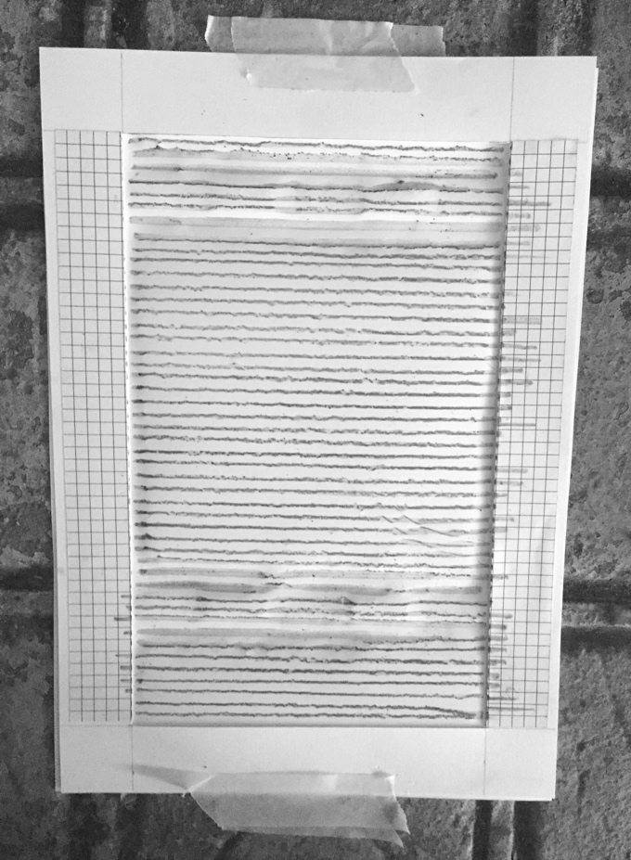
Figure 3a: Breath Drawing no 16, pencil on paper, 21x29cm, Circus Street, Brighton May 2015. Figure 3b: Breath Drawing no 16, in situ. Photo’s Lorry Eason.
Dwelling, being present in the space, just sitting and being still was a small but significant part of how I began to approach the project. This setting allowed me to connect to the space and the space to communicate to me. It allowed me to be exactly where I was in this moment in time, both my physical and emotional state (Bullen, Fox, Lyon 2017, p. 133).
My notes at the time asked questions about whether these feelings could be communicated. Was I interested in attempting to share them? Is it even possible to fully share a subjective experience? What was it about this place/space at this precise moment in time that triggered such an instinctive response? I remember feeling inadequate, having a sense that my intellectual faculties trailed behind. There were questions, but I kept returning to a perception and that there seemed to be no separation between being, doing and my lived experience and that I wanted to carry out an inquiry that ‘does not assume the separation of subject and object and does not observe a distance between the researcher and the practice of art (Borgdorff 2007, p. 5).
My first attempts at drawing were graphite rubbings the frottage of surfaces to create a record of the process, topographical translations of place and archival documentation. The results of these, while visually appealing, and capturing something of a sense of place, did not seem wholly appropriate. An interest in reductive and rule-based approaches led to a simple system, predicated on ‘touch,' ‘receptivity' and a ‘balance of agency and surrender' (Bullen, Fox, and Lyon, 2017, p. 130). Using this system, I made a drawing by placing paper onto uneven surfaces, upon which I attempted to draw a straight line from left to right with the aid of a pencil and ruler. To draw a ‘straight' line was rarely in my grasp because of the resistance and disruption caused by the surface on which the paper was placed. Consequently, each line became a record of the moment of its making, determined by factors that sent the line in directions beyond my control. This act left a visible line but also a physical embossing and occasional rupture to the surface of the paper. With the drawings made at Circus Street I became particularly concerned with the necessity of a direct and physical process - the relationship between the hand, the drawing material, the straight edge and paper; how my body was positioned in the space as I knelt, stood or sat. ‘While lines demarcate and define objects’, wrote Dewey, ‘they also assemble and connect … Lines express the ways in which things act upon one another and upon us' (Dewey 2005, pp. 104-105). Importantly, I began to draw with a rhythm that was concurrent with my breathing. I drew each line on the in-breath, as one might count the breath in mindfulness meditation.
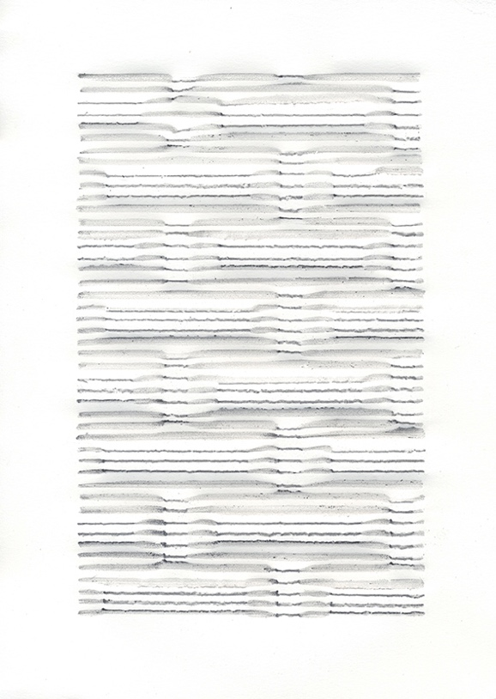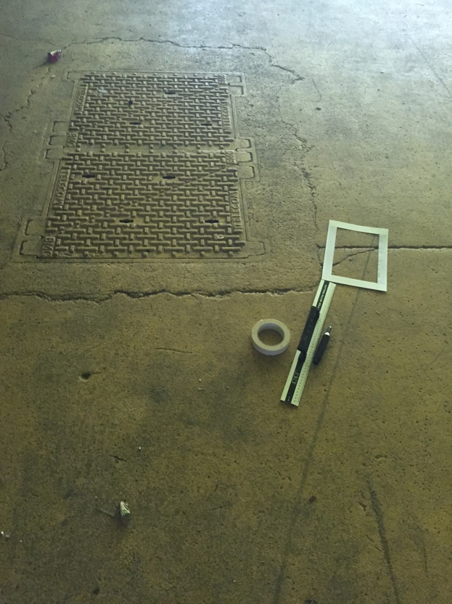
Figure 4a: Breath Drawing no 17, pencil on paper, 21x29cm. Figure 4b Circus Street, Brighton May 2015: Photo’s Lorry Eason.

Shortly after making the Circus Street drawings my thinking was extended and challenged by a research project Touching the World Lightly. I began to utilise the structures I had created for a set of drawings called Gatherings (2011 - 2016) and to formulate these as laser cut constructions in wood and card, upon which I placed paper and drew. Primarily, I was looking for a means to continue to explore ideas of drawing, touch, and breath, by contriving my surfaces which directed composition. In these drawings, I used a variety of different sizes and grades of graphite, from soft blunt chunky sticks, a flat Carpenters pencil (sometimes with a notch carved into the lead to produce parallel lines), to finely sharpened points. I used different rulers, from a standard straight edge to a French curve, to a ruler with a serrated edge designed for tearing decal edges on paper. I tested different papers and found 45gsm layout paper was robust enough to hold the pencil line, while being fragile enough, allowing for the surface to be broken. Making these drawings enabled me to build upon the drawings made in Circus Street, while simultaneously testing material possibilities through handling of a variety of tools (Figure: 5a, 5b).

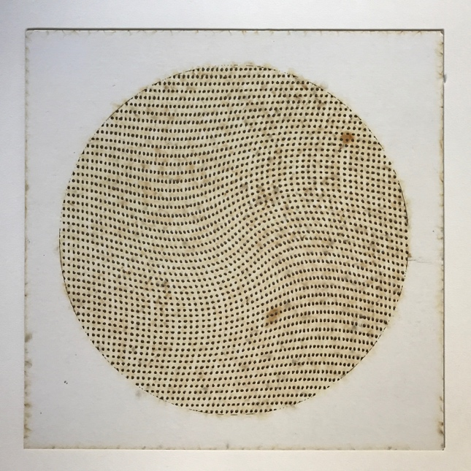
Figure 5a, Laser cut stencil, Figure 5b, Breath Drawing 22.06.16, pencil on paper, 30x30cm. Photo’s Lorry Eason.
Gordon House (May-August 2018):
The main body of work in which the changing nature of a place, manual drawing and mindfulness are fully aligned is through a set of drawings which are the result of two residencies at Gordon House, Margate. These were made possible by invitation from Lucy Lyons who suggested ‘I examine, excavate and dissect the real and fictional hidden within the fabric of the interior' of the soon to be renovated Grade II listed Georgian building. The house is a five-story assortment of surfaces, a medley of original architectural features and modifications that are particular to previous inhabitants’ tastes.
Here I decided to limit, restrict and work further within a ‘fixed parameter' as a means to inhabit and stay close to the physicality of the surfaces of both the environment and the paper. I was also attempting to reside in the background, so to speak, to allow things to occur, to bring forth something into appearance, through co-emergence with materials, tools, and environment (Figure: 6a, 6b).

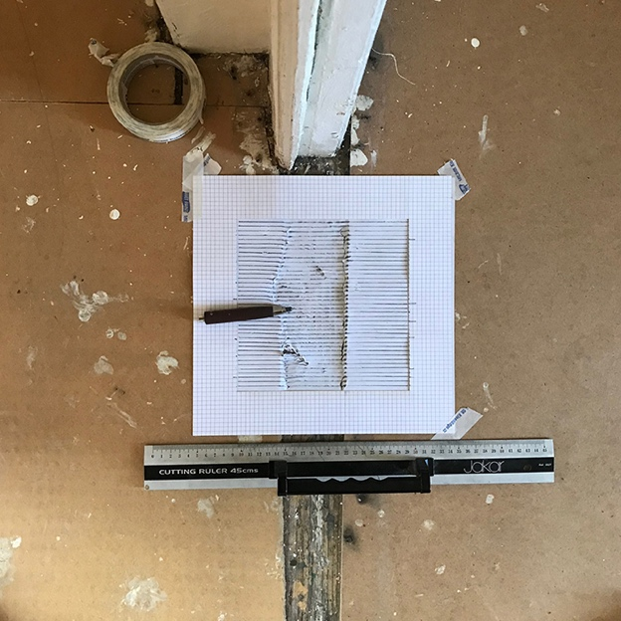
Figure 6a, Breath Drawing no 16 pencil on paper, 30x30cm. Photo Lorry Eason. Figure 6b,
As in previous work, the drawings were made by placing layout paper cut to 30x30cm onto the uneven surfaces. For these drawings, I cut an isolating gridded window of 20x20cm. I chose a square to avoid choices of horizontal or vertical formats, thus leaving all compositional decisions to the subjective determination of where to place the paper. Drawing a line was aided by the use of the gridded window acting as a kind of viewfinder to frame and isolate a particular surface. For each drawing, I used the same pencil (an HB graphite stick, in a holder), the same ruler and the same size and weight of paper, and drawing each line on my in-breath, while trying to maintain an even pressure. It was this correlation between breath and the drawn line, each inhalation, and exhalation, each continuous action of finding and centering the tracing of the next line, that enabled me to feel fully present in moment-to-moment attention.
Each drawing is produced in the time it takes to draw 39 horizontal lines with a 0.5cm space between each. Every line takes approximately 3 seconds to draw, with an approximate gap of 6 seconds to reposition the ruler before the next line. Separately each drawing took about 6 minutes from the first drawn line to the last. The drawings were made by using the following surfaces: oak floorboards, plywood, hardboard, chipboard, carpet, underlay, plaster, brick, concrete, different wallpapers, Artex, tongue and groove panels, ceramic tiles and formed plastics.

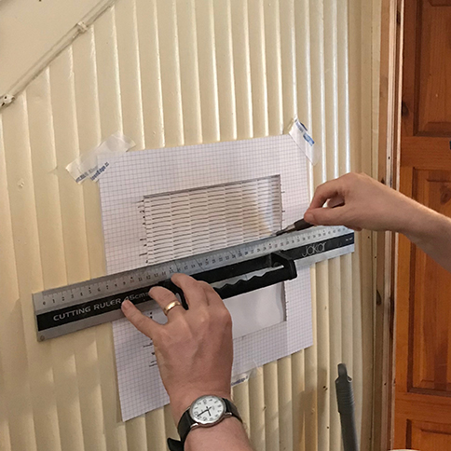
Figure 7a, Breath Drawing no 22 in process, Gordon House, photo Lucy Lyons. Figure 7b, Breath Drawing no 22, pencil on paper, 30x30cm, 2018, photo Lorry Eason.
Reading between the drawn lines, one notices that the 0.5cm gap is never an accurate measurement, nor is it negative space, instead, it is a fluctuating, pulsing, physical presence, actuated by the drawing process. In fact, in these drawings the whole of the paper is activated: the reverse of each drawing holds and reveals traces and indents, ruptures and inversions, vying for equal status to the front (Figure 6a,6b). Consequently, one can say that there is no back or front, left or right, up or down, and each drawing can be displayed and viewed, picked up and handled in whatever way one chooses in any given circumstance. Treating the drawing in such a way is not a case of being indecisive or relinquishing responsibility, but rather it is an acceptance of the outcome of the process. A process that involves the cultivation of receptiveness characteristic of meditation practice and trust in the results as they unfold. The drawings enable a suspension of judgment, recognising that there are different and multiple viewpoints for any given situation.

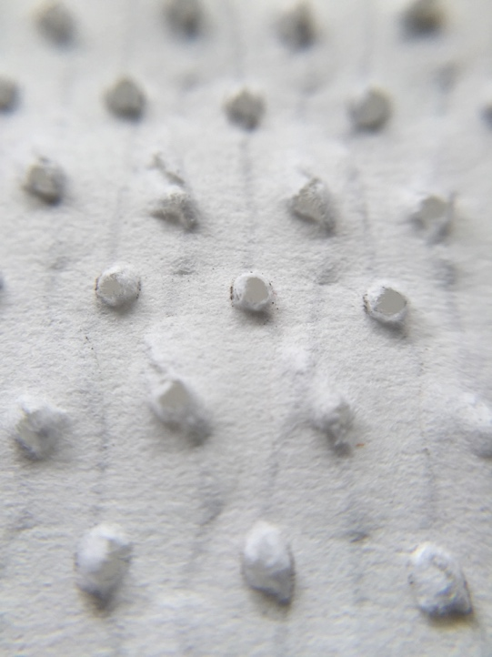

Figure 8a, Reverse detail of Breath Drawing 03.07.16. Figure 8b, Breath Drawing 03.07.16, pencil on paper, 30x30cm 2016. Photo’s Lorry Eason.
The drawing process is one of repetition, of doing the same action over and over, time and again, like a metronome, back and forth, back and forth. The consequence of these repeated actions is constant flux and change, where the uneven surfaces are revealed and affect the outcome. Each drawn line displays the textural nuances of the given surface and the inevitable variability of the hand. The contrast between surfaces, the peaks, and troughs, or the humidity and temperature, occasionally cause the paper to buckle and tear, or for lines to jolt and jar. Deborah Harty suggests that ‘repetitive processes are phenomenological… and have the potential to record both the drawer's mind and the drawing’s own making,' and such a process generates a ‘fluctuating' state of consciousness which fuses awareness between internal and external features (Harty 2012, p1). Harty discusses this in relation to Flow theory, and there are parallels between Western psychology (Flow) and Eastern philosophy (Mindfulness) that have been acknowledged by the leading scholar Mihaly Csikszentmihalyi (2002). Both Flow and Mindfulness are seen very much as positive states in which through an engaged practice, one may notice similar qualities of attention, leading one potentially to experience a state in which there is no separation between the self and the object made or action performed, and through which our conscious awareness of time can be altered (Csikszentmihalyi 2002, pp. 53-54).
Nevertheless, during the practice of mindfulness, ‘you might’ asks Kabat-Zin ‘wonder why it is that your mind is so quick to be bored with being with itself…you might wonder what is behind your impulses to fill each moment with something…what drives the body and mind to reject being still (2013:60)? Tim Lomas (2016, 2017) discusses mindfulness in relation to boredom and Zen aesthetics. Lomas (2016) re-evaluates boredom from one historically and commonly considered to be a negative mental state to one that when worked with, can be a potentially positive place from which to develop awareness, concentration, and creativity. He cites the example of ‘wall gazing’, which is a form of meditation as practiced in the Zen Soto School. This particular meditation involves the meditator sitting about a metre away from and facing a blank wall for the duration of the meditation. For Lomas, this is an example of how boredom is valued and something that one needs to hold and work with, rather than see as negative. In so doing ‘… experiential insights can potentially be liberating and transformative' (Lomas 2016, p. 9) and can enhance levels of ‘psychosomatic wellbeing' (Lomas 2017, p. 3).

John Cage, whose life and artistic practice was influenced by his exposure to Zen at Columbia University in the 1950s (Larson 2012) wrote of the need to stay with something over time: ‘if something is boring after two minutes, try it for four. If it is still boring, then eight. Then sixteen. Then thirty-two. Eventually one discovers that it is not boring at all' (Cage 2009, p. 93). Writing on Cage's interest in Zen, Peter Jaeger suggests that ‘boredom provides a welcome state for the development of concentration…'. He claims that boredom is accepted in ‘…all schools of Buddhist meditation, especially Zen as it is practiced in the West because Western culture is so heavily focused on the desire for excitement. The mindful awareness of boredom provides a strong antidote to that desire' (Jaeger 2013, p. 81).
Working with boredom in an experiential sense, as part of formal mindfulness practice, you may encounter how much of one's time is focused on desire, a quest for excitement and newness, or merely the ever-present ‘to-do’ list. In the context of habitual, procedural and repetitious drawing I can testify to a constant stream of thoughts arising. Should I vary the paper, draw to the edge of the paper, draw on a different scale, try a different pencil or a pen, use colour, draw lines vertically and right to left, rather than horizontally left to right, draw using a curved ruler or without a guiding ruler at all, draw diagonally, or draw directly onto the wall? Do anything but stay with and be present? Perhaps this is a legacy of my art school education which, as Hughes contends, ‘values overt difference in creative thought,' one in which ‘difference always looks to what is not present in a situation' (Hughes 2014, p. 74).
Final Remarks:
I do not wish to dismiss the values of artistic experimentation. There was a period during the making of this body of work, where I tested various materials and technologies, albeit within a limited frame. My emphasis here, though, after Hughes is a space for ‘dwelling', which for me is achieved through alignment of mindfulness and methodical drawing. So, if mindfulness is ‘Knowing what you are doing, while you are doing it' (Kabat-Zin 2013, p. 16), then the idea of dwelling, and being methodical, means paying attention to what you are doing without distraction. When certain thoughts arise, just to let them come and go. I would contend that by staying close to an event, by being ‘the best possible nobody that only you can be' (Smith 2015) you allow for a close engagement with the world by being in the middle of it, grappling with tools and materials, spaces and places, emotions and ideas and theories and discourses. I have found that drawing mindfully and reflecting on mindfulness practice allows me to be fully present with my senses so that I can come to inhabit the world and orientate myself through an experiential and practical engagement that is transactional, transformative and experiential. Nevertheless, Varela et al ask ‘if the results of mindfulness/awareness practice are to bring one closer to one’s ordinary experience, rather than further from it, what can be the role of reflection’ (Varela, et al 2016, p. 27).
For Dewey, art is experience, and in a neat linguistic turn, Noë says after Dewey, that ‘…it's about the work of art' (Noë 2015, p. 133). Noë means that it is the work art does in transforming experience that allows us to shape meanings. Experiences may take place continuously. However, Dewey points out that it is not every experience, but one that ‘… occurs when the material experienced runs its course to fulfilment', which Dewey maintains ‘is constituted by a single quality that pervades the entire experience in spite of the variation of its constituent parts (2005, pp. 37-38). In a recent paper in ‘Contemporary Pragmatism,' John Russon (2015), provides useful commentary on ‘artistic experience' as ‘a way of establishing our intimate engagement with the world.' Russon draws upon Dewey and suggests that; ‘Experience is an ongoing process in and through which one gradually comes to "inhabit" one's world, comes to dwell in it as one's home rather than encountering it as alien.' Russon proposes that it is precisely through the development of a connection with the world that allows us to experience not separate realities, but entities that are thoroughly and deeply entwined. (Russon 2015, pp. 40-41). Consequently, it may follow that reflection is not just on experience, reflection is itself an experience - and that reflective form of experience can be performed with mindfulness/awareness’ (Varela, Thompson, Rosch 2016:27). Susan Kozel argues that ‘Phenomenological reflection is a form of contemplation’ and likens this to ‘a moving meditation’ which ‘requires deep levels of focus and the ability to pursue a train of thought or physical impulse as it unfolds and transforms’ She suggests that ‘contemplation is a form of immersion, of dwelling in a system’ (Kozel 2011, p. 213).
What I am proposing is that through a conscious choice to engage in repetitious processes of drawing within particular environments, the ‘just sitting’ of formal mindfulness, and theoretical reflection on experience makes possible a particular engagement with the world. In this practice, making present and being present align and are two different aspects of the same situation, in which I claim ‘presence is…achieved in full understanding of its manifest fragility' (Noë 2012, p. 3). I conclude by saying that we need methods for attuning to our practices as a means to access awareness ‘in which the mind is neither absorbed nor separated but simply present and available' (Rosch 2016, p. XI).

Baas, J., 2005 Smile of the Buddha: Eastern Philosophy and Western Art, University of California Press, Berkeley.
Blaser, Werner., 1963 Structure and Form in Japan, Verlag fur Architektur, Zurich
Borgdorff, H., 2007 ‘The debate on research in the arts’, Dutch Journal of Music Theory, 12(1) pp. 1-17. Online: http://upers.kuleuven.be/en/tvm_archive12 [Accessed 26.5.16].
Bullen, D., 2012 ‘Drawing Light, Journal of the International Colour Association, (2012):6-13.
Bullen, D., 2013 ‘Drawing Colour: Between the Line and the Field’, in Wingham, I., ed., The Mobility of the Line, Birkhauser Verlag, Basel.
Bullen, D., Fox, J., Lyon, P., 2017 ‘Practice-infused drawing research: being present and making present’, Drawing: Research, Theory, Practice 2 (1) pp.129-142, Intellect Limited.
Cage, J., 2009 Silence: Lectures and Writings, Marion Boyars Publishers Ltd London.
Cocker, E., 2013 ‘Tactics for Not Knowing: preparing for the Unexpected’ in Fisher, E., and Fortnum, R., eds., On Not Knowing How Artists Think, Black Dog Publishing, London.
Csikszentmihalyi, M., 2002 Flow, Random House, London.
Dewey, J., 2005 Art as Experience, Penguin, New York.
Epstein, J., 2010 ‘Meditation as art/art as meditation’, in Jacob, MJ. and Bass, J. eds., Learning Mind: Experience into Art, University of California Press, Berkeley.
Fisher, E., and Fortnum, R., 2013 On Not Knowing How Artists Think, Black Dog Publishing, London.
Gregory, R L., 1970 The Intelligent Eye, Weidenfeld and Nicolsons, London.
Hannula, M., 2009 ‘Teaching Discourse: Reflection Strong, Not Theory Light’ in Jacob, MJ. and Bass, J. eds., Learning Mind: Experience into Art, University of California Press, Berkeley.
Harty, D., 2012 ‘Drawing/Phenomenology/Drawing: an exploration of the phenomenological potential of repetitive processes’, Tracey Journal online at
http://www.lboro.ac.uk/microsites/sota/tracey/journal/proc/harty.html [Accessed on 09.08.18].
Hughes, D., 2014 ‘Dwelling as an approach to creative pedagogy’, Art, Design, and Communication in Higher Education, 13 (1). Intellect Books
Jackson, P.W 1998 John Dewey and the Lessons of Art, Yale University Press, New Haven and London.
Jacob, MJ., 2004 ‘The Space of Art’ in Jacob, MJ. and Bass, J. eds., Buddha Mind in Contemporary Art, University of California Press, Berkeley.
Johnson, M., 2007 The Meaning of the Body: Aesthetics of Human Understanding, University of Chicago Press Chicago and London.
Kabat-Zinn, J., 2005 Coming to our Senses: Healing ourselves and the world through mindfulness, Hyperion Books, New York City.
Kabat-Zinn, J., 2013 Full Catastrophe Living: How to cope with stress, pain and illness using mindfulness meditation, Piatkus, Little, Brown Book Group, London.
Kabat-Zinn, J., 1994 Wherever You Go, There You Are, London: Piatkus, Little, Brown Book Group, London.
Kasulis, Thomas, P., 1985 Zen Action, Zen Person, University of Hawaii Press, Honolulu.
Kozel, S., 2011 ‘The Virtual and the Physical: a phenomenological approach to performance research’ in Biggs, M and Karlsson, H., eds., The Routledge Companion to Research in the Arts, Routledge, London and New York.
Lomas, T., 2017 ‘A Meditation on Boredom: Re-appraising its value through introspective phenomenology’, Qualitative Research in Psychology Vol 14 NO 1,1-22
Lomas, T., 2016 The Positive Power of Negative Emotions, Piatkus, Little, Brown Book Group, London.
Lomas, T., Etcoff, N., Van Gordon,W., Shonin, E., 2017 Zen and the Art of Living Mindfully: The Healing Power of Zen Aesthetics, J Relig Health 56: 1720-1739.
Malone, M., 2012. The Porous Practice of Drawing: System, Seriality and the Handmade Mark in Minimal and Conceptual Art, online at http://notations.aboutdrawing.org/essay/ [Accessed 01.09.2018].
Nancy, J L., 2013 The Pleasure in Drawing, translated by Philip Armstrong, Fordham University Press, New York.
Noë, A., 2015 Strange Tools: Art and Human Nature, Hill and Wang, New York.
Noë, A., 2012 Varieties of Presence. Harvard University Press Cambridge, Massachusetts.
Rosand, David., 2002 Drawing Acts: Studies in Graphic Expression and Representation, Cambridge University Press.
Rosch, E., 2016 ‘Introduction to the Revised Edition’, Varela, F, Thompson, E, Rosch, E., eds., The Embodied Mind: cognitive science and human experience, MIT Press, Cambridge, Massachusetts.
Russon, J., 2015 Expressing Dwelling: Dewey and Hegel on Art as Cultural Self-Articulation. Contemporary Pragmatism; Leiden Vol. 12, Issue 1, pp. 38-58.
Smith, W., 2015 ‘Interview with Ben Gooding’, Saturation Point, the online editorial and curatorial project journal for systems, non-objective and reductive artists working in the UK at http://www.saturationpoint.org.uk/wendy_smith.html [Accessed on 01.09.2018].
Varela, F, Thompson, E, Rosch, E., 2016 The Embodied Mind: cognitive science and human experience, MIT Press, Cambridge, Massachusetts.

Gordon House is the home of Dr Lucy Lyons, and a setting in which artists, writers and performers can make, test and share ideas. https://gordonhousemargate.blogspot.com
Touching the World Lightly is a project based in the School of Art, University of Brighton, which asks: how we can understand the pivotal value of touch and how do we articulate the generative nature of drawing practice-based research? http://blogs.brighton.ac.uk/ttwl/

