THE WASTE ZONE at FutureBuild 2019
Curated by Duncan Baker-Brown Senior Lecturer University of Brighton, Co-Founder BBM Sustainable Design

INTRODUCTION THE PROGRAMME

The Waste Zone will return for the third time at FutureBuild in 2019. It has been curated once again by architect, academic, and author, Duncan Baker-Brown. This year’s event will include an exhibition showing how waste can be a valuable resource for the construction industry. Another new feature this year is The Circular Economy Hub where invited suppliers will get the opportunity to show their innovative closed loop products. As before, there will be the central seminar space where over 40 speakers will be invited to discuss the challenges and opportunities the Circular Economy presents.

Duncan says “In the last ten years the construction industry has nearly halved the amount of construction and demolition waste it creates, and it is also exceeding EU waste reduction targets. This is great news. In 2017 London Waste and Recycling Board (LWARB) identified that by 2036 a Circular Economy could provide London with net benefits of up to £7bn per annum, with up to 12,000 new jobs. I feel that the construction industry is very well placed to take advantage of this, and with over with over 50% of the World’s population now residing in cities, they are now the main driver for economic growth and have the potential to power a successful Circular Economy. So I have invited as many designers, consultants, constructors, thought leaders, and suppliers as I can think of to share their knowledge and hopefully inspire visitors to Futurebuild 2019 take advantage of the financial and employment benefits a Circular Economy will provide.”

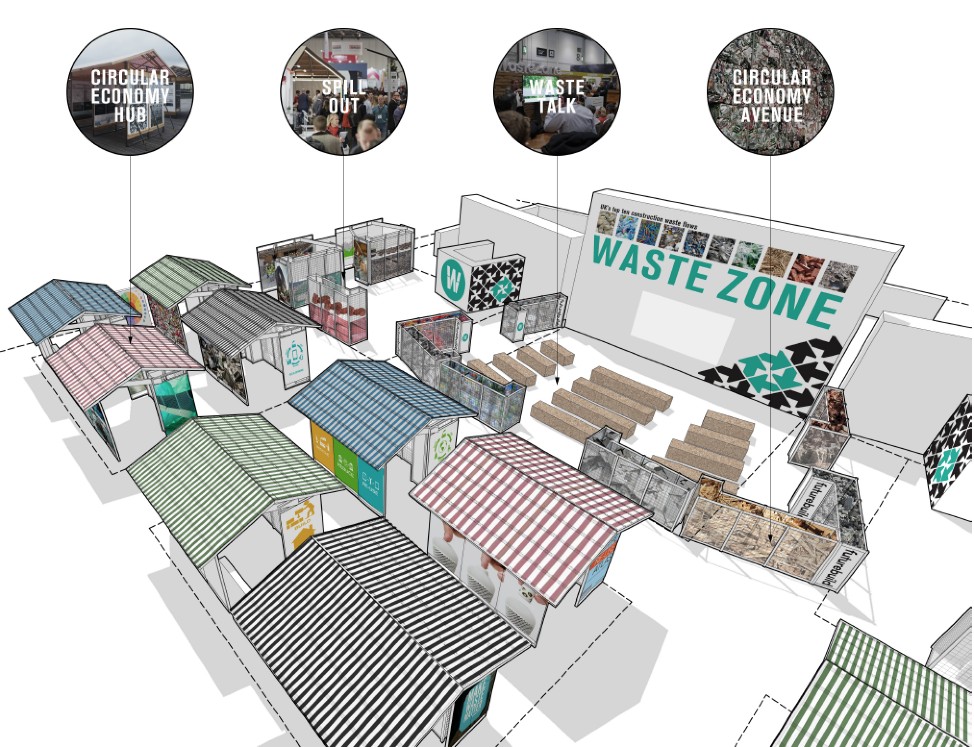

Image: 3D visualisation of The Waste Zone at FutureBuild 2019.

DAY 1 Tuesday March 5th 2019: Waste Zone Content
FINAL DRAFT 4th March 2019

Time of Session | Chair/ Speaker/ Speakers | Format of session/ Themes
Session No.1  10.30-11.40 | Introduction to The Waste Zone by Duncan Baker-Brown University of Brighton 5mins  Cat Fletcher (Chair & Speaker) Co-Founder of FREEGLE + Brighton & Hove City Resource Manager  Timothee Duret Technology & Organics Director VEOLIA  Ian Humphreys, Director of Operations International Synergies  Dr. David Greenfield MD SOENECS & Circular Economy Club Europe External Affairs  Dr. Adam Read External Affairs Director SUEZ | DISCUSSION/ DEBATE  The problem with waste? …..There’s no such thing as waste! Five expert speakers from the world of waste/ resource management. Each speaker will make a 10minute presentation. This is followed by a Q&A Session
Session No.2  12.00-13.10 | Duncan Baker-Brown (Chair) University of Brighton  Dr. Jo Williams Director of Circular Cities Research Hub, Associate Professor in Sustainable Urbanism, UCL  Maja Johannessen Research Analyst The Ellen MacArthur Foundation Eveline Johkoff Strategic Advisor for Sustainability & the Circular Economy, Municipality of Amsterdam Cécile van Oppen Consultant Copper8 Davide Stronati Global Sustainability Leader Mott MacDonald Prof.Dr.ir. Arjan van Timmeren Chair, Environmental Technology & Design, Dept of Urbanism, TU Delft | DISCUSSION/ DEBATE  What is a Circular City? Six expert speakers discuss the huge potentials and challenges presented by this concept. Each speaker will make a 7 minute presentation. This is followed by a Q&A Session.
Session No.3  13.30 -14.40 | Dr. David Greenfield (Chair) MD SOENECS & Circular Economy Club Europe External Affairs  Atta Ajayebi University of Exeter Business School  Petran van Heel ABN AMBRO Sector Advisory & Sustainability  Gilli Hobbs Director Building Performance Group BRE  Nick Ribbons Sector Manager Construction Zero Waste Scotland  Anna Surgenor Senior Sustainability Advisor UKGBC | DISCUSSION/ DEBATE  Making a Circular City? Five expert speakers discuss some of the processes and systems that support a Circular Economy. Each speaker will make a 7 minute presentation. This is followed by a Q&A Session
Session No.4  15.00-16.10 | Duncan Baker-Brown (Chair) University of Brighton & BBM  Pablo van den Bosch Madaster Foundation  Dan Epstein Director of Sustainability Useful Projects  Casper Østergaard Christensen Architect 3XN / GXN  Dr. Michaël Ghyoot Rotor DC Niklas Nolsøe Project Architect Lendager Group Gerard Roemers Senior Sustainability Consultant Metabolic | DISCUSSION/ DEBATE  Systems & Case Studies. Six expert speakers discuss a variety of exemplar case studies that test the real potentials of a Circular City. Each speaker will make a 7 minute presentation. This is followed by a Q&A Session.
Session No.5  16.30-17.40 | Rob Holdway (Chair) Brunel University & Giraffe Innovation  Miguel Reynolds CEO of Corkbrick Europe Jasper Brommet Founder StoneCycling Dr. Zoe Laughlin Co-Founder Institute of Making UCL Christian van Maaren Co-Founder Excess Materials Exchange Ehab Sayed Founder & Director of Innovation BIOHM Kresse Wesling MBE Founder Elvis & Kresse | DISCUSSION/ DEBATE  Future material resources. Six expert speakers discuss low carbon material options for the construction industry. Each speaker will make a 7 minute presentation. This is followed by a Q&A Session.
DAY 1 Ends
DAY 2 Wednesday March 6th 2019: Waste Zone Content
FINAL DRAFT 4th March 2019

Time of Session | Chair/ Speaker/ Speakers | Themes/ Format of session
Session No.1  10.30-11.40 | Introduction to The Waste Zone by Duncan Baker-Brown University of Brighton 5mins  Cat Fletcher (Chair) Co-Founder of FREEGLE + Brighton & Hove City Resource Manager  Marthijn Pool Founding Partner Space and Matter Architects Niklas Nolsøe Project Architect Lendager Group  Marieke Rietbergen Founder Design Innovation Group Ehab Sayed Founder & Director of Innovation BIOHM Jeremy Sumeray Senior Manager, Sustainability, Armstrong World Industries Ltd.  Prof. Andre Viljoen Deputy Head, Research & Enterprise School of Architecture & Design University of Brighton | DISCUSSION/ DEBATE  Reconsidering waste. When to recycle, re-use, avoid or grow? Six expert speakers discuss exemplar projects from the worlds of architecture, design, and the Circular Economy supply chain. Each speaker will make a 7 minute presentation.
Session No.2  12.00-13.10 | Duncan Baker-Brown (Chair) University of Brighton  Pablo van den Bosch Madaster Foundation  Richard Boyd Senior Engineer, Advanced Technology + Research, ARUP  Petran van Heel ABN AMBRO Sector Advisory & Sustainability  Bridget Jackson Chief Sustainability Officer, PwC  Aleksandra Smith-Kozlowska, Senior Consultant - Upstream Sustainability Services, JLL  Cécile van Oppen Consultant Copper8 | DISCUSSION/ DEBATE  Circular Cities: the potential for employment and wealth while drastically reducing resource consumption. Six expert speakers discussed exemplar projects from a more corporate perspective. Each speaker will make a 7 minute presentation.
Session No.3  13.30 -14.40 | Nick Gant (Chair & Speaker) Founder Community 21, University of Brighton  Dr. David Greenfield MD SOENECS & Circular Economy Club Europe External Affairs  Dr Jonathan Mitchell Project Engineer Nextek  Tom Meades Co-Founder Gomi Design  Ian Morgan Business DeDirector, Block London Ltd Mark Miodownik Prof. Materials & Society Director Institute of Making UCL | DISCUSSION/ DEBATE  The miracle of plastic. Six expert speakers discuss why plastic is such an amazing material. Each speaker will make a 7 minute presentation.
Session No.4  15.00-16.10 | Keynote Presentation by Prof. Dr. Michael Braungart, professor at the Leuphana University Lüneburg and founder of EPEA (Environmental Protection Encouragement Agency) & co-author of the significant book ‘Cradle to Cradle Remaking the Way We Make Things’. 45 minute talk plus Q&A session hosted by Duncan. | KEYNOTE ADDRESS  Professor Braungart will deliver a keynote address considering the strategies that need to be put in place to support a truly circular economy.
Session No.5  16.30-17.40 | Gilli Hobbs (Chair) Director Building Performance Group BRE  Doug Simpson Principal Policy and Programme Officer, GLA Dr. Teresa Domenech Course Director Institute for Sustainable Resources UCL  Simon Sturgis RIBA Founder Targeting Zero LLP  Alex Wandl Project Leader REPAiR Project TU Delft Faculty of Architecture | Making a Circular City? (2) Four expert speakers discuss some of the processes and systems that support a Circular Economy.  Each speaker will make a 10minute presentation. This is followed by a Q&A Session
DAY 2 Ends

DAY 3 Thursday March 7th 2019: Waste Zone Content
FINAL DRAFT 4th March 2019

Time of Session | Chair/ Speaker/ Speakers | Themes/ Format of session
Session No.1  10.30-11.40 | Introduction to The Waste Zone by Duncan Baker-Brown University of Brighton 5mins  Nick Gant (Chair) Founder Community 21, University of Brighton  Léa Brachet sustainable design engineer, ARTELIA  Dave Cheshire Regional Director Sustainability, Aecom  Phil Guthrie Collaboration Hub Project Officer LWARB  Christian van Maaren Co-Founder Excess Materials Exchange  Nick Ribbons Sector Manager Construction Zero Waste Scotland | DISCUSSION/ DEBATE  Making a Circular City? (3) Five expert speakers discuss some of the processes and systems that support a Circular Economy  Each speaker will make a 10minute presentation. This is followed by a Q&A Session
Session No.2  12.00-13.10 | Rob Holdway (Chair) Brunel University & Giraffe Innovation  Ann Beavis Head of Sustainability, Premier Sustain  Pablo van den Bosch Madaster Foundation  Nick Gant Founder Community 21, University of Brighton  Libby Sandbrook, Head of Circular Economy, BITC  Purva Tavri B.Sc, M.Sc, Kingston University | DISCUSSION/ DEBATE  Social circularity. Five expert speakers discuss some potential social benefits of a circular economy. Each speaker will make a 10minute presentation. This is followed by a Q&A Session
Session No.3 13.30-14.30 | Emma McKenna (Chair) Business Advisor LWARB  Ehab Sayed, Biohm  Angelique Belle, ECOR  Ann Beavis, Premier Sustain  Arthur Kay, Skyroom  Jason Harries, Adaptavate | DISCUSSION/ DEBATE  Circular Innovation in London  Join five start-ups from LWARB’s Advance London Advisory Programme to discuss how they’re working to drive circular economy innovation in the built environment sector.
Session No.4  14.50-15.50 | Duncan Baker-Brown (Chair) University of Brighton  Dr. Richard Bonser Dept. of Design (Biomimicry) Brunel University  Matthias Heinrich Environmental Design Engineer & Sustainable Design & Building TU Munich  Rob Holdway Brunel University & Giraffe Innovation  Gerard Roemers Senior Sustainability Consultant Metabolic  Becci Taylor Associate Director Arup  Zach Wilcox Senior Consultant City Economics Arup | DISCUSSION/ DEBATE  Circular Cities: the potential for employment and wealth while drastically reducing resource consumption. Six expert speakers discussed exemplar projects from a more corporate perspective. Each speaker will make a 7 minute presentation.

DAY 3 Ends

