Press Release
University of Brighton
February 2013

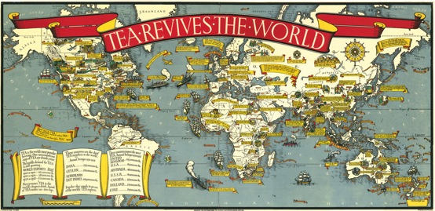

MacDonald Gill

From 28th March, a University of Brighton exhibition of large, decorative maps by MacDonald (Max) Gill (1884-1947), a remarkable, influential and multi-talented artist, designer and architect, will go on display at Kemistry Gallery in Shoreditch, London.

The younger brother of the sculptor and type designer Eric Gill, Max Gill was best known for pictorial maps, particularly his 1914 ‘Wonderground’ map of the London Underground system. This was hugely popular, selling in its thousands and inspiring a resurgence of pictorial and decorative map-making in Britain, the United States, Latin America and Australia.

His skills have been recognised in recent years by map lovers and lettering enthusiasts and his work has begun to gain a much wider audience following the major retrospective exhibition at the University of Brighton in 2011. Max initially pursued a career in architecture and then branched out into lettering, before concentrating on working as a ‘commerical artist’ carrying out commissions for decorative maps and graphics. Although Max was overtaken by Eric in fame, in his time he was hugely popular.

Max Gill’s talents and influence extended to many other areas. In 1917 he joined the Imperial War Graves Commission committee responsible for designing headstones and he also designed the lettering and regimental badges for the war graves that can be found in churchyards and cemeteries across Britain and around the world. He created hundreds of other works, including a huge map of the North Atlantic, which is still to be seen on the preserved liner Queen Mary in California.

The Kemistry exhibition will be showcasing Gill’s contribution to information design in the early part of the 20th century, particularly his ability to fuse elements of historical design with more modern approaches, making use of the latest colour lithographic techniques.

For more information on Max Gill and his work, go to:
http://arts.brighton.ac.uk/projects/macdonald-gill

