NAFAE symposium
Drawing: being present, making present

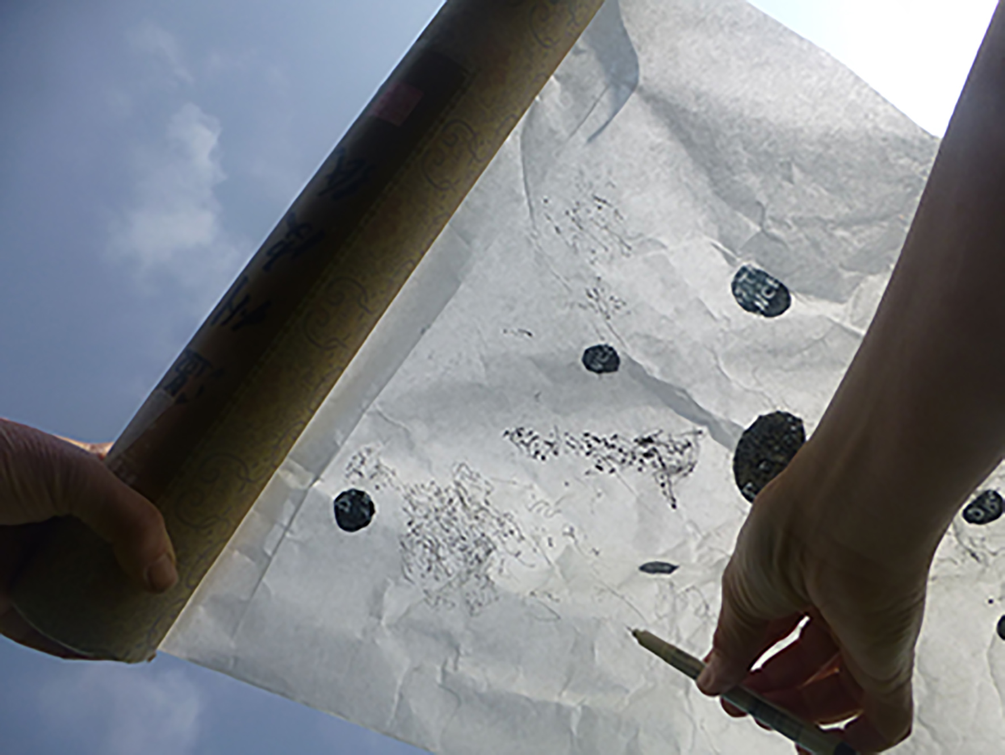
SLIDE 1

What is happening at the moment of making a drawing? How can we understand this?

We consider the precise placement and angle of the drawing implement on the surface, perhaps pencil on paper. We consider and control the weight applied through our hand and implement to a surface; the timing of this moment of contact.

This, perhaps, gives a sense of some of the mechanics of a drawing moment. But what else is taking place?

We select our material; in doing so we are making choices about what might be considered to be drawing material and how we will work with it. In doing this, we are aware of our relationship to the wider environment in which we draw – to what is available, as well as what forces and influences act upon us. What is around us, what affects us as we draw - physically, mentally, emotionally?

Of course, no one account of drawing can be universal. For many artists, drawing is focussed profoundly on the ocular; the notion of looking critically and from this, apprehending in depth; for others, drawing is generative of creative ideas, supportive of cognition as well as observation and for many it can involve several or many other elements.

The project I am talking to you about today, however, moves away from a concentration on the representational tradition of looking, on cognition or imagination as the wellsprings of drawing practice.

As Grisewood says, ‘the condition of ‘seeing’ is not a prerequisite: drawing exists with and without seeing.

So in this context, what shapes the drawing moment?

Breathing. Being. Touching. Presence.

Of the three members of the Touching the World Lightly team, two are practising artists and it is the specificity of their practice, and the processes involved, that have been the catalyst for this research.

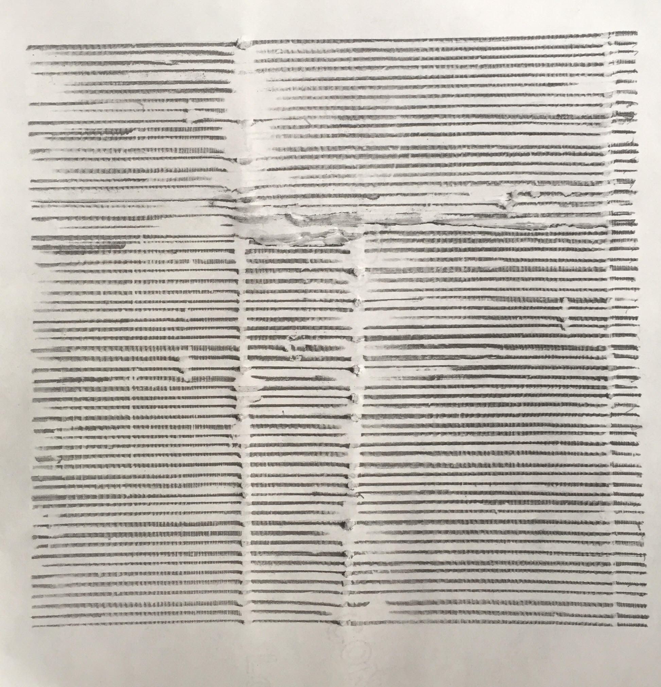
SLIDE 2
Duncan Bullen is an artist, academic and writer.

His research encompasses the meditative, durational and sensory possibilities of drawing and printmaking, both in terms of the activity of making and visual perception.

Duncan is interested in how, as makers, we not only shape the object made but also recognize how this shapes us, our world of work and the environment.

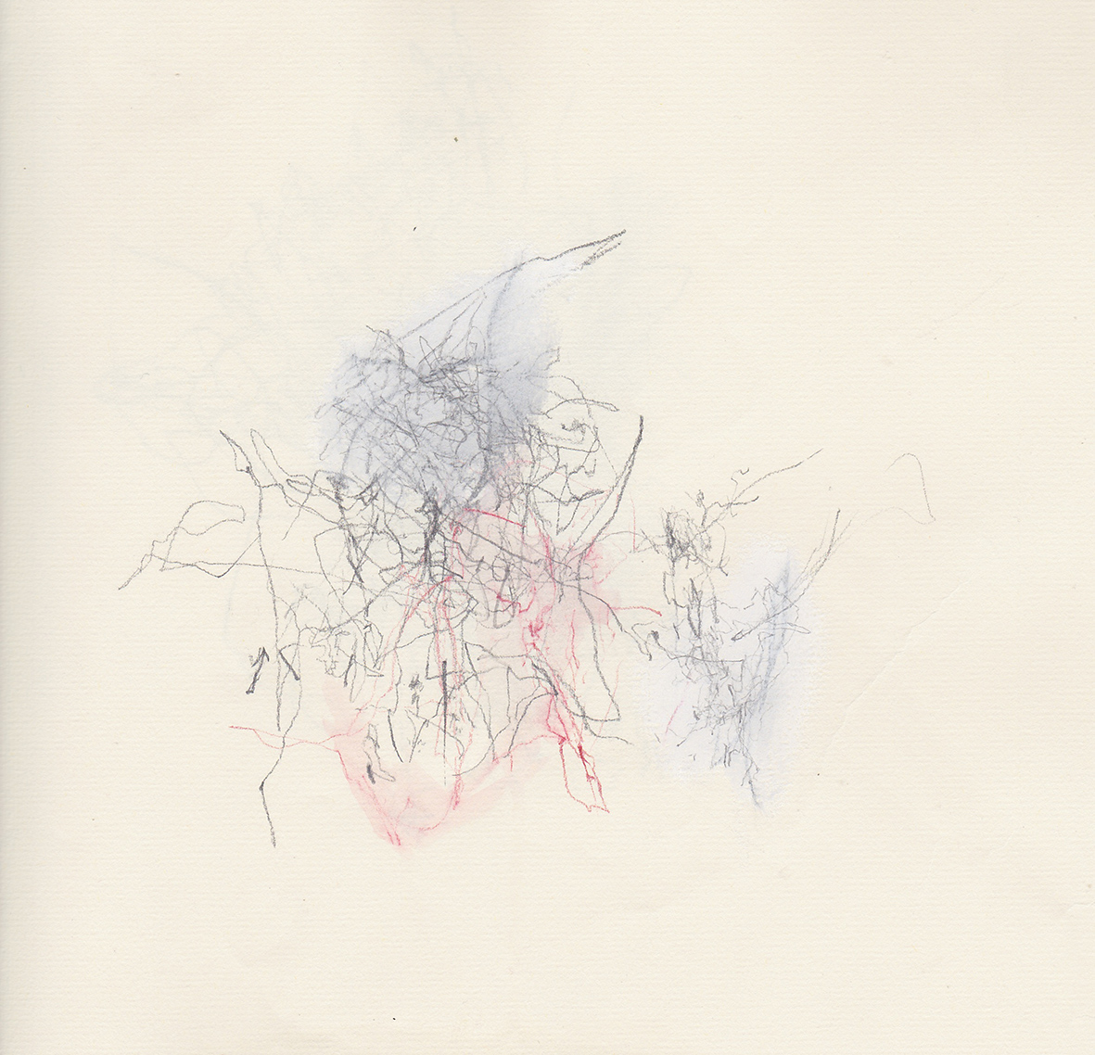
SLIDE 3

Jane Fox’s artistic output includes projected still and moving image, drawing and installation, using a diverse range of materials and processes.

Her practice embraces drawing, print, found matter, installation, and walking.

For Jane, processes of exchange and collaboration are central to her practice and her research.

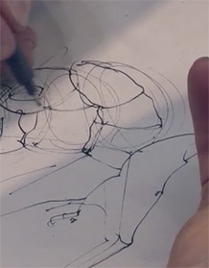
SLIDE 4

I have travelled from my original academic home in English Literature, via a period of employment in Allied Health Professions research, to the Art School, initially as a generic researcher but gradually shaping a commitment to the cross-disciplinary territory of drawing research.

Much of my previous research in drawing has focussed on applied drawing situations: how drawing impacts on professional learning and how drawing is used in routine health practice.

These ventures have been made from what might broadly be called ethnomethodological positions, or sometimes through a more psychological, phenomenological approach.

The reason I am mentioning this is that I have tended to hold myself at some distance from what I research, from the practice of drawing itself.

I have seen myself as the viewer/interpreter, sometimes even the skulking participant observer.

In forming this collaboration with Duncan and Jane, and in the three of us making the decision to, as Henk Borgdorff has put it, ‘inscribe’ ourselves within the research community together, my sense of what is involved in research is being remoulded.

The three of us coalesce around the concept of practice: drawing practice, writing practice and research practice, and their interrelationship.

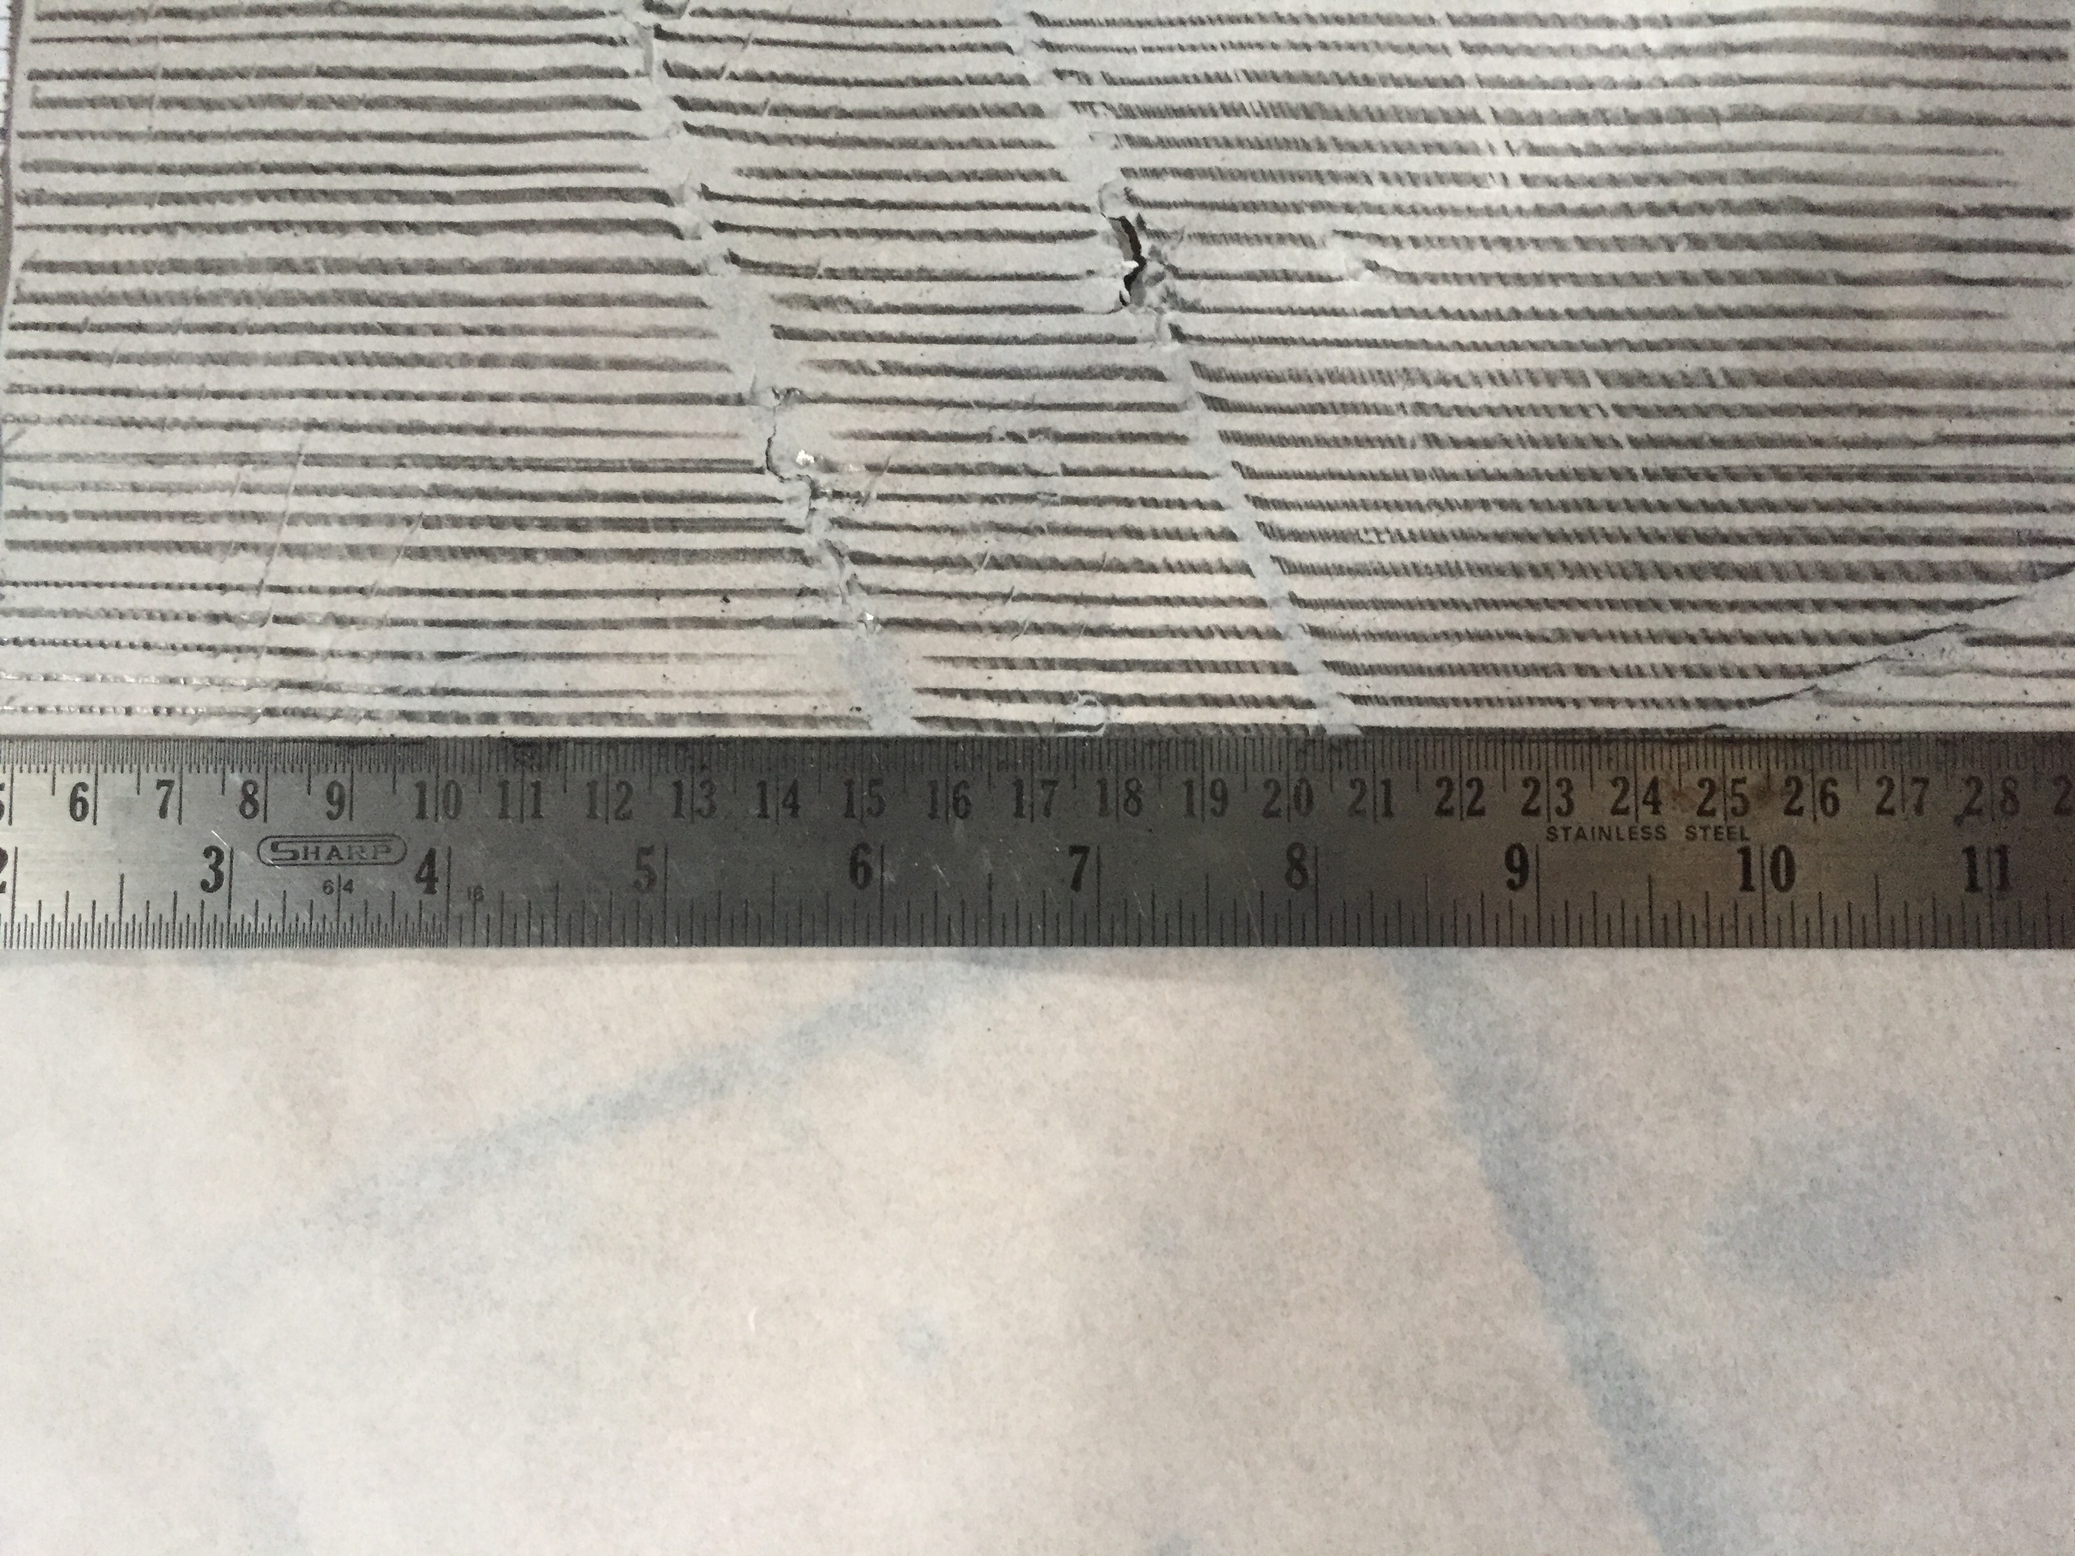
SLIDE 5

So what is this practice that has precipitated the research?

Duncan’s work explores the relationship between hand, breath and surface.

He places paper on a particular surface (found or created) and draws lines with a pencil and straight edge. The locations for his drawing are not limited by type and can be in or outside, urban or rural.

He has noted how, in making a decision to draw in a particular space, and spending time dwelling in that space with the aim to draw, that certain realisations have come to the fore.

This partly invokes the importance that Dean Hughes attaches to an ‘attitude that is concerned with dwelling and being resident’ in relation to creative pedagogy.

As he draws he becomes less concerned with the mimetic, with what the drawing ‘looks like’, and more with process. It is from this centring of attention on process that he feels a state of being in the world, or ‘being present’.

This type of understanding is not a purely intellectual one but an embodied, sensory state – in this approach to drawing, then, there is a particular focus on both surface and sense of touch. Kabat-Zinn talks about the significance of touch as a metaphor for all the senses – the notion that we are touched by the world through all our senses.

Lakoff and Johnson further point out that this idea of touch is linked to our dominant metaphorical idea of ourselves as containers with an inside and an outside, ‘bounded by surfaces’.

For Duncan, his drawing practice involves an awareness of how things are, rather than purely a striving towards what they might mean.

SLIDE 6

Jane’s practice involves the semi-resisted action of wind between paper and pencil.

Often using Japanese paper that is thin and translucent but also flexible and robust, Jane likens her drawing to sailing – another key metaphor within the project - in which the drawing paper flaps consistently when fully engaged.

The pencil makes and breaks contact with the paper, resulting in marks.

A balance is achieved between the movement of the paper and the way that the pencil is held.

There are many variables in this process, in which the wind’s force is unpredictable - the sensitivity and responsiveness of human touch interacts with all other elements.

By holding the pencil lightly, for example, a second layer of drawing appears in the creases and folds. This softens the surface and builds line.

As with Duncan’s practice, Jane’s wind drawing involves a concentration on the moment, and as part of this she adopts a state of very attentive listening and high level of awareness of the possibilities of touch that lead to a trace on the page.

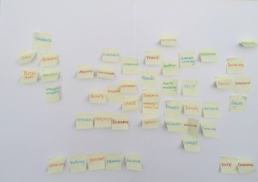
SLIDE 7

So how can the pivotal value of touch and collaboration within both artists’ drawing practice be understood as research?

In attempting to answer this question we are also developing and attempting to trace and articulate a set of generative and dialogic methods. The starting point for these methods is a set of agreements.

One agreement, already alluded to, is that both the drawing practice and research approach require a particular attention to how we are in the world, to ‘being in the world’.

A second is that drawing is understood as a bodily and experiential practice in which the artist’s relationship to the world is subjective, and objective, and collaborative.

A third is that the artist both holds and relinquishes agency in the act of drawing.

A fourth is that drawing, speaking and writing, particularly as types of practice, work dialogically with each other.

From these agreements emerge the proposition that through conscious and guided interaction between drawing and writing, together with discussion, new knowledge can be identified.

In more literal terms, this means that as a team we move between proliferation of ideas, a generative and accumulative process of which this post-it cluster map is one example -

- and a focussing down, in which patterns are identified and concepts articulated and honed.

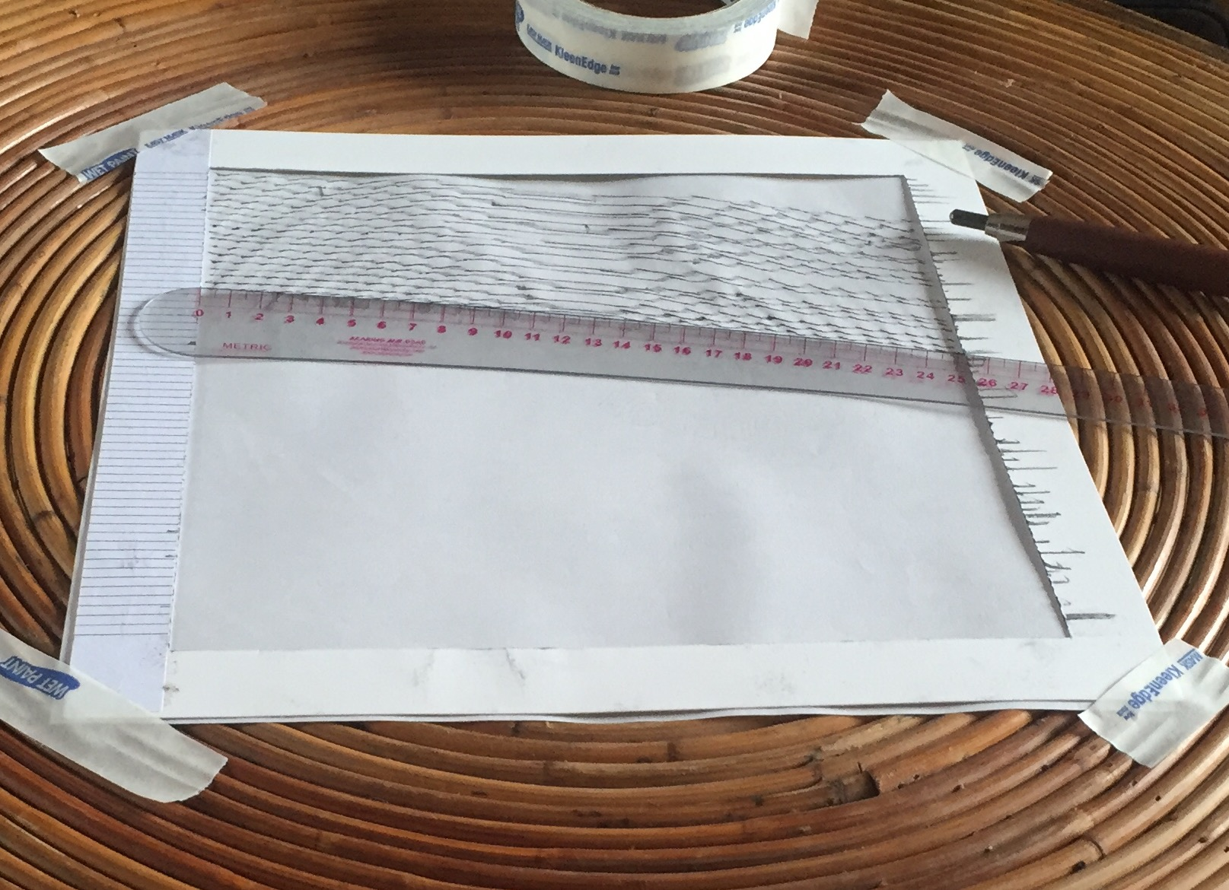
SLIDE 8

We have mentioned how for both artists, the notion of being in a reciprocal relationship with the world is crucial. Duncan has described this as a process by which he is not so much looking at the site or space within which he was drawing, but looking with it. This is a dynamic exchange in which consciousness is extended, and the space in which the drawing takes place becomes an empty site of possibility that is acting upon the artist. For both artists, drawing practice is not about depicting, imagining or expressing, but bringing out an inaccessible or intangible quality.

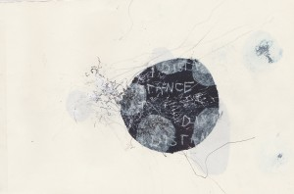
SLIDE 9

We have highlighted how, in Jane’s practice, wind becomes a kinetic agent, activating the site of drawing. What is equally important here is that wind is also understood, and used, as material. The expanded concept of the material world enables and facilitates the inclusion of phenomena at the fringes of experience. This concept implicitly argues that materiality does not have to be empirically tested and measured in the world. For Jane, her practice is a making visible or making present of the disregarded, overlooked, forgotten and invisible. For Duncan’s work, too, when he lays his paper onto a surface, drawing a straight line is rarely possible because of the resistance and disruption of the surface on which the paper is placed. Therefore lines become a record of the moment of their making, leaving not only a visible trace of the previously invisible or unregarded, but also an embossing and rupturing of the surface.

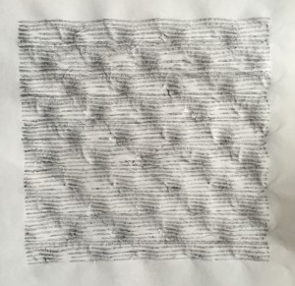
SLIDE 10 AND 11

For both Duncan and Jane there is an extremely important sense of touching a particular environment but also, being touched by a particular space. In this there is a kind of regaining of the sense of bodily experience itself. This enables and supports movements between rationality or agency on the one hand and a non-rational mode (though not necessarily irrational) and a surrendering of agency to chance. Through this openness and responsiveness, the practice and its ideas do not pin down but allow us to view the flux of lived experience. This includes the important and productive tensions between knowing and not knowing, between objective and subjective experience, and between external and internal stimuli. The same productive tensions shape our research processes and method.

SLIDE 11

Conclusion

