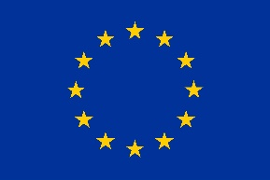

SB&WRC Project

Technical Fact Sheet :
Prototype 2 made from polyester

May 2019

Edited by: Karim TOUATI, Amel BOURGUIBA, Fouzia KHADRAOUI-MEHIR, Duncan BAKER-BROWN
Certified by: Nassim SEBAIBI + Duncan BAKER-BROWN

Abstract of the project
The SB&WRC (Sustainable Bio&Waste Resources for Construction) project, an undertaking of more than two years, aims to conceive, produce and test three innovative, low-carbon, thermal insulation materials from agricultural co-products and recycled waste. The project is supported by the development program Interreg VA France (Channel) England and its budget, estimated to be 1.8M€, is co-financed by the ERDF (European Regional Development Fund) for 69% (1.26M€ contribution).

This project, led by Nomadéis, is carried out by a cross-channel partnership which gathers academic research laboratories, private research and consulting companies, manufacturers and professional non-profit organisation of the building sector:
- Nomadéis;
- Veolia Propreté Nord Normandie;
- University of Bath;
- Ecole Supérieure d’Ingénieurs des Travaux de la Construction de Caen (ESITC Caen);
- Construction21;
- UniLaSalle;
- University of Brighton;
- Alliance for Sustainable Building Products.

ESITC Caen
1 Rue Pierre et Marie Curie
14610 Épron
http://www.esitc-caen.fr/

Project team:
Karim TOUATI, lecturer-researcher
Fouzia KHADRAOUI-MEHIR, lecturer-researcher
Aurélie GERAULT, Ingénieur R&D
Matthieu DUFEU, Chef de Projets R&D
Nassim SEBAIBI, Dr, Responsable scientifique

University of Brighton
Mithras House
Lewes Road
Brighton UK
https://www.brighton.ac.uk
Project team:
Duncan BAKER-BROWN, PI, Senior Lecturer
Siobhan O’DOWD, Project Manager
Nick GANT, Principle Lecturer
Dr. Ryan WOODARD, Waste Expert
Ben BOSENCE, Local Works Studio Specialist Supplier
Dr.Ryan SOUTHALL, Environmental Scientist, ARVEA Consultants

Nomadéis
120, boulevard Amiral Mouchez • 76600 Le Havre
4, rue Francisque Sarcey • 75116 Paris
Phone: +33 (0)1 45 24 31 44
www.nomadeis.com

Edition and diffusion:
Guillaume LAULAN, Project Manager
Adrien DUCHADEUIL, Analyst

© ESITC Caen, 2019
Copyrights
The text of this publication may be reproduced whole or in parts for educational and non-monetary purposes without prior consent of the copyright holder, to the condition that the source is mentioned. ESITC Caen and the partners of the SB&WRC project would be grateful to receive a copy of all the publications that have used the present as a source material. The present publication may not be reproduced, transmitted or used in any manner whatsoever for commercial uses without the prior written permission of the authors.

© University of Brighton, 2019
Copyrights
The text of this publication may be reproduced whole or in parts for educational and non-monetary purposes without prior consent of the copyright holder, to the condition that the source is mentioned. University of Brighton and the partners of the SB&WRC project would be grateful to receive a copy of all the publications that have used the present as a source material. The present publication may not be reproduced, transmitted or used in any manner whatsoever for commercial uses without the prior written permission of the authors.

Summary

The present report synthesises the experimental results obtained for prototype 2 made from recycled polyester within the SB&WRC project.
The choice of prototype 2 answers two main issues. It allows the recycling of duvets waste nowadays little or not reused and also allows to take advantage of the interesting thermal performance of the polyester component of this waste. Prototype 2 is a material intended for the building thermal insulation.
Experimental tests on this material have shown that it has potential and can be considered as a good thermal insulating. In fact, compared to standard building insulating materials such as glass wool or Rockwool, whose thermal conductivity is about 0.04 W /m.K., polyester is a good thermal insulator.

Table of Contents
1. From resource to prototype 7
2. Properties of the resource 9
2.1 Densities (apparent, true, porosity) 9
Experimental procedure 9
Bulk density 9
True density 9
Experimental results 10
Bulk density 10
True density 10
2.2 Moisture and hydric properties (sorption-desorption isotherms, moisture content etc.) 11
Experimental procedure 11
Water content 11
Water absorption 11
Experimental results 12
Water content 12
Water absorption 12
3. Hygrothermal properties of the prototype 13
3.1 Thermal conductivity and Thermal Resistance 13
Experimental procedure 13
Experimental results 14
4. General discussion 15
5. Summary of discussion on all Wall Prototype 2 tests (conducted by University of Brighton)………………………………………………………………
6. Final conclusions……………..

- From resource to prototype
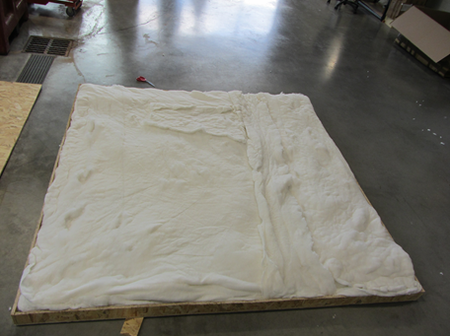
Picture of the full-size prototype
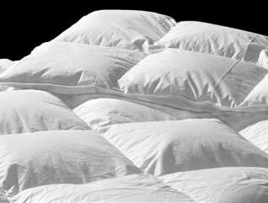
Picture of the ressource

Prototype 2 construction

After their reception, the recycled duvets were first cleaned and sanitized, then the polyester was taken out from the duvets and placed layer by layer inside the constructed OSB box.
The box constructed by the OSB wood has the following dimensions: 2 m height, 2 m large and 0.1 m for thickness. The weight of the polyester introduced in the box is approximately 8 kg.
The different steps of the prototype 2 construction are illustrated in the following pictures.
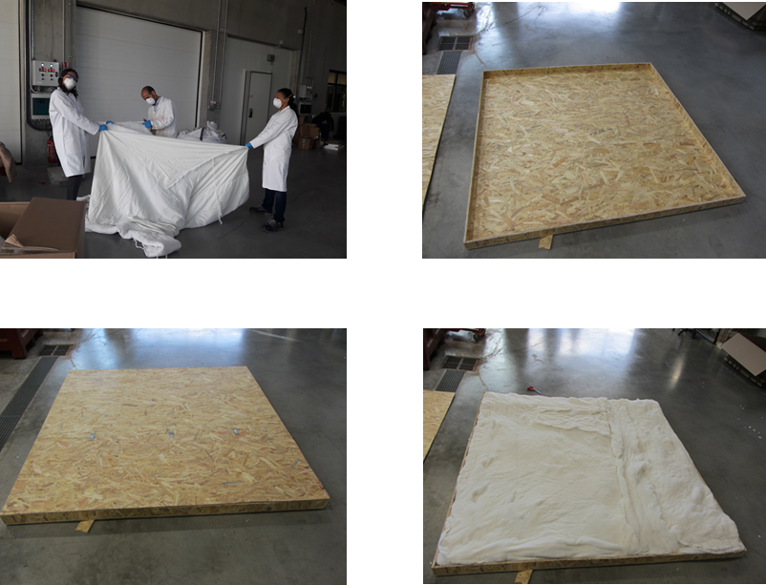
Illustration of the different steps of the prototype 2 construction.

- Properties of the resource

  - Densities (apparent, true, porosity)

Experimental procedure

Bulk density
Bulk density was determined by using helium pycnometer (AccuPyc 1330_ micromeritics). This method allows to obtain a precise measure of the sample volume. It consists in introducing helium into a reference chamber with a known pressure and then it is allowed to expand into the chamber containing the sample. Thus, the drop in pressure is measured.
The sample volume is determined according to Mariotte low:

$$V_{s}=V_{c}-\frac{P_{2}-P_{a}}{P_{1}-P_{a}} V_{2}$$
with:
- P₁ : gas pressure in the reference chamber (Pa) ;
- P₂ : gas pressure in the expansion chamber (which contains the sample) (Pa) ;
- P_{a} : atmospheric pressure (Pa) ;
- V₂ : expansion volume (cm³) ;
- V_{c} : chamber volume (cm³) ;
- V_{s} : sample volume (cm³).

Bulk density is then given by the following equation:

ρ_{b =}$\frac{m_{s}}{V_{s}}$
with:
- ρ_{b} : bulk density ;
- m_{s} : sample mass.

True density
True density is measured by means of a pycnometer with a countenance of 500 mL according to the procedure described below:
- Weigh the pycnometer filled with propanol to the mark: $M_{1}$
- Weigh the pycnometer filled with saturated sample and propanol to the mark: $M_{2}$
- Weigh the test sample in the dry state: $M_{d}$

True density is then given by the following equation:
$$ρ_{s}=\frac{M_{d}}{M_{d}-(M_{2}-M_{1})}ρ_{p}$$
with
- ρ_{p}: propanol density.
Propanol was selected as an immersion liquid because it is characterised by a density which is lower than that of water thus enabling the feasibility and the execution of the test.

Experimental results

Bulk density
The results of bulk density are given in the following table. Two samples of polyester are tested, and for each sample an average of 3 measurements is taken.

 | Polyester filling 1 (fabric) |  | Polyester filling 2 (balls)
 | Sample 1 | Sample 2 | Sample 1 | Sample 2
ρ_{b} | 1455.4 | 1466.9 | 1475.5 | 1472.5
ρ_{b mean} | 1461.15 |  | 1474
Table 1. Bulk density of the polyester waste [kg.m⁻³]

True density
The results of true density measurements are summarized in the following table.

 | Polyester filling 1 (fabric) |  | Polyester filling 2 (balls)
 | Sample 1 | Sample 2 | Sample 1 | Sample 2
ρ_{b} | 1283.13 | 1186.59 | 987.37 | 1108.88
ρ_{b mean} | 1234.86 |  | 1048.12
True density of the polyester waste [kg.m⁻³]

  - Moisture and hydric properties (sorption-desorption isotherms, moisture content etc.)

Experimental procedure

Water content
The test consists in drying the sample in a proofer at a temperature of 40 °C until the mass stabilizes. Water content corresponds to the registered loss of mass. It is calculated according to the following equation:
$$W\left(\%\right)=\frac{M_{w}-M_{d}}{M_{d}} . 100$$
with :
- M_{w} : mass at the wet state ;
- M_{d} : mass at the dried state.

Water absorption
This test is derived from an experimental protocol developed by RILEM TC 236-BBM group. The procedure used to measure the water absorption of the different materials is as follows:
- Dry the sample at 40 °C until a mass variation lower than 0.1% of is obtained in 24h;
- Immerse completely a plastic micro-perforated bag in water ;
- Place and attach the bag in a centrifuge and let it turn for 30 seconds at 500 trs.min⁻¹, then note the bag mass ;
- Weigh a mass (M₀) of the material and place it in the bag ;
- Immerse completely the bag filled with the material in water for 5 minutes ;
- Take the bag out of the water, place it in the centrifuge and let it turn for 30 seconds at 500 trs.min⁻¹ ;
- Weigh the spin-dried bag and note the mass M₁ (5 min);
- Repeat the steps 5, 6 and 7 for other samples for different immersion durations ;
- Calculate the water absorption according to the following equation :

$$M\left(t\right)=\frac{M_{t}-M_{0}}{M_{0}} . 100$$

Experimental results

Water content
The test was repeated three times for each sample. The results of water content are given in the following table.
 | Polyester filling 1 (fabric) |  |  | Polyester filling 2 (balls)
W | 1.0 | 0.8 | 0.7 | 1.2 | 0.9 | 2.1
W_{mean} | 0.8 |  |  | 1.4
Water content of the polyester waste [%]

Water absorption
The results of water absorption are given in the following Figure.

Figure 2. Water absorption of raw materials

- Hygrothermal properties of the prototype

  - Thermal conductivity and Thermal Resistance

Experimental procedure
To determine the thermal properties of a building material on a real scale, a Hot Box apparatus is often used. With this apparatus, a wall to be tested is positioned between two ambiences, one hot, and the other cold. Once the steady state is reached, measurement of the heat dissipated to keep a constant temperature gradient through the specimen wall is performed. Thanks to these data, dissipated power and temperature difference between the two atmospheres, thermal performance of the wall can be calculated. So, the prototype thermal resistance can be determined by using the following relationship:
$$R=\frac{A.(T_{h}-T_{c})}{Q}$$
Where:
R: prototype overall thermal resistance, m².K/W
A: metering box opening area, m²
$T_{h}$: Environmental temperature at the hot side (metering chamber), °C
$T_{c}$: Environmental temperature at the cold side (climatic chamber), °C
Q: rate of heat flow throw the prototype to be tested, W.

Once the prototype thermal resistance is known, an effective thermal conductivity can be calculated using the following relationship:
$$λ=\frac{L}{R}$$
λ: prototype effective thermal conductivity, W/(m.K)
L: prototype thickness, m

In this project, the thermal performance of the prototype 2 (OSB + polyester + OSB) were studied. To do this, a measuring system is developed by following the ASTM C1363-11 and NF EN ISO 8990 norms.
Our measuring system consists of two climatic chambers separated by a polyurethane wall. The separating wall contain a 2 m x 2 m opening where the sample to characterize should be placed. A metering chamber having an opening of 1.27 m x 1.46 m was built. A heating system was placed inside this metering chamber and powered by a DC power supply. Temperatures in both sides of the wall are measured by T type thermocouples which are linked to a data acquisition system. A LabVIEW program was created in a computer in order to perform temperature regulation, data acquisition and signal processing. In the following figure, an overview of the Hot Box apparatus is shown.
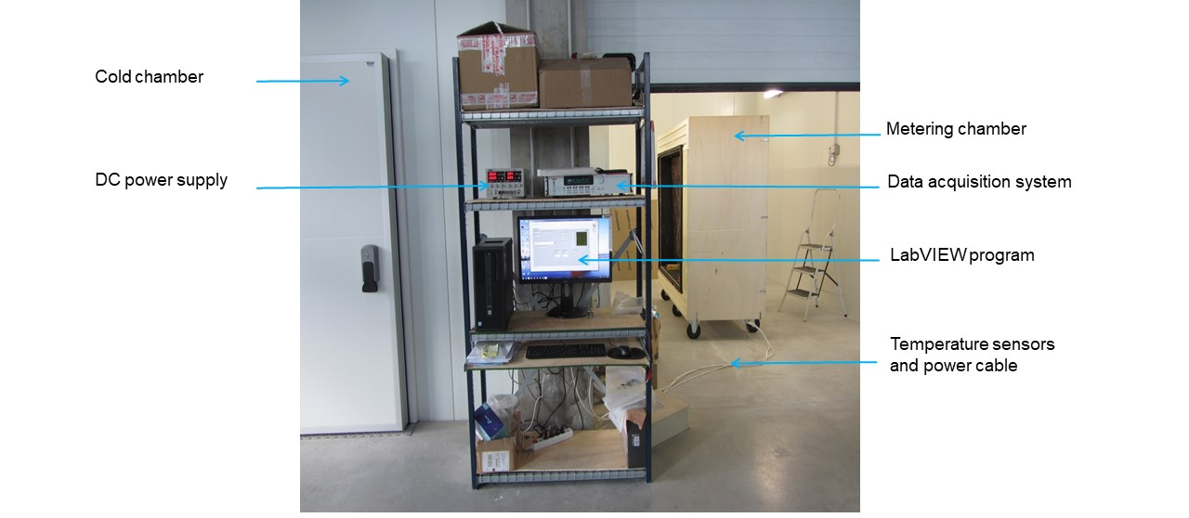
Overview of the experimental device used for thermal characterization of the prototype 2.

Experimental results

After the calibration of the developed Hot Box apparatus, the thermal properties of the prototype 2 were measured. The results are given in the following table:
Prototype | Dimensions  (cm) | Thermal conductivity  (W.m⁻¹.K⁻¹) | Thermal resistance  (m².K/W)
Prototype 2 | 200 x 200 x 10 | 0.0505 | 1.98

*The thermal properties represents an average of five measurements in the same environmental conditions.
From the performances reported in the above table, we can notice that the thermal conductivity of the prototype 2 is close to the one of the common thermal insulating materials already available in the market (as example, we can cite: Rockwool, glass wool or Polystyrene which have $λ≈0.04$ W.m⁻¹.K⁻¹). So, these results allow us to say that in the thermal point of view, the polyester can be considered as a good thermal insulating material.
- General discussion
As the raw material (recycled polyester) is a waste, it must present a very competitive price compared to the materials marketed today. As a limitation for the deployment of the prototype, we can cite the difficult implementation in buildings regarding to the fact the polyester cannot support its own weight in a vertical position. In this sense, a reflection must be made to find a way that would facilitate the implementation of polyester for thermal insulation in buildings. Also, before its deployment, more investigations should be performed, especially on the hydric behavior of the polyester and its durability.

- Summary discussion on all Wall Prototype 2 tests conducted by University of Brighton
  - Introduction
The following report summarises the methodologies and results of all wall prototype 2 tests conducted for the SB&WRC project. The wall prototype 2 employed reused duvets as the main insulative element. Lab tests were conducted at the Universities of Bath and Caen; in-situ tests were conducted at the Brighton WasteHouse by ARVEA Consultants for the University of Brighton.
  - ESITC CAEN Testing Methodologies

Caen Facility Presentation Sheet: Guarded Hot Box Appartus - University of Caen Installation Report: Guarded Hot Box Apparatus - University of Caen Technical Fact Sheet: Prototype 2 made from polyester - University of Caen R&D Protocol: Prototype 2 - University of Caen

Physical set-up
The used duvets were cleaned and the polyester fibre layers were removed from their coverings. The layers were then laid within a OSB box of external dimensions 2m by 2m by 0.1m; the 2m by 2m (standard double duvet size) dimension is assumed to conform to the size of the supplied duvets. The OSB board as 12mm in thickness giving an internal volume of 0.23m$​^{3}$. Approximately 8kg of fibres were placed within the specimen box resulting in an installed density of approximately 34kg/m$​^{3}$.

Monitoring set-up
The OSB box specimen was placed within the wall of a climate chamber held at 10$\text{°}$C. A heated monitoring chamber has placed over the specimen and maintained at 30$\ifmmode\begingroup\def\b@ld{bold} \text{\ifx\math@version\b@ld\bfseries\fi\textdegree}\endgroup\else\textdegree\fi$C. Heat flux through the wall appears to have been measured via the power required to maintain a steady state temperature within the monitoring chamber in accordance with ISO8890 and ASTM C1363-11. This power value combined with the temperatures within the climate chamber and monitoring chamber were used to derive the thermal conductivity of the specimen.

Results [subsec:Results]
The thermal conductivity of the entire sample is given as 0.0505W/m·K and the thermal resistance of this layer is reported as being 1.98m$​^{2}$K/W , a figure which excludes surface resistances. This results in a U-Value of 0.51W/m$​^{2}$K without surface resistances. Taking nominal values for surface resistances of 0.06 and 0.12W/m.K a total indicative U-Value of 0.46W/m$​^{2}$K is arrived at. Taking an accepted thermal conductivity of OSB of 0.13W/m·K, the thermal resistance of the duvet alone is 1.79m$​^{2}$K/W, which with the same nominal internal and external surface resistances would lead to 0.51W/m$​^{2}$K U-Value. The thermal conductivity of the duvet material itself 0.042W/m·K, a figure very close to the common figure of 0.04 for building insulation materials.
The University of Brighton asked for U-Values for 100 and 150mm of duvet insulation based purely on the calculated thermal conductivity of the duvet layers i.e. ignoring surface resistances. Based on these tests these figures are 0.42 and 0.28 W/m$​^{2}$K respectively.

Conclusions
This testing phase concluded that the although the recycled polyester fibres delivered good thermal insulation values, and would be cost effective, the even suspension of the polyester fibres within a building construction panel would require some kind of support mechanism.
  - University of Bath Testing Methodologies

Bath Installation report (D6.4): University of Bath’s Building Research Park and University of Brighton’s Waste House - University of Bath

Physical set-up
A 1.1m$​^{2}$ prototype 2 wall was installed along with two other wall prototypes in the Large Environmental Chamber (LEC) at the University of Bath. The wall prototype was made up of 9mm OSB, 140mm duvet filled stud work, and 9mm OSB. The weight of the installed duvet was 1.3kg installed in the central stud space giving an installed density of 26kg/m$​^{3}$. No membranes were installed as part of the construction.

Monitoring set-up
Different temperature and humidity conditions were maintained across the wall prototypes in three distinct phases.
Heat flux was measured with a heat flux meter placed on the surface of the prototype construction. Temperatures and humidities were monitored on both sides of the prototype. Surface temperatures and temperatures & humidities within the prototype construction were also monitored.

Results [subsec:Results-1]
U-Values results are presented for the three testing phases. Phase 1 & 3 present very similar values of 0.282 and 0.277W/m$​^{2}$K respectively.
Phase 2 presented a lower U-Value of 0.237W/m$​^{2}$K. In this test the temperature differential across the walls was reversed, temperatures on the cooler side were allowed to vary and humidities on either side of the wall were the highest. It is not expected that the latter two would significantly effect steady state heat flux though the wall but the reversing of temperature differential may have had an effect on the surface convection heat transfer coefficients.
For further result processing phase 3 was chosen as the temperature difference across the sample was stable and at 7$\text{°}$C the most representative of a southern UK, northern France annual temperature difference as seen by a building fabric.
Taking the calculated U-Value figure and assuming that this figure does include internal and external surface resistances, and assuming again a standard value for the thermal conductivity of the OSB, then the thermal conductivity of the duvet fabric 0.043W/m·K. This is a very close figure to the Caen results and to the common building insulation of 0.04W/m·K.

Conclusions
No conclusion specific to the prototype 2 duvet wall was presented.
  - University of Brighton Testing Methodologies
A 0.525m$​^{2}$ section of wall in the Brighton WasteHouse was selected to replace the existing insulation with folded duvets in both the inner 364mm deep cavity and outer 100mm cavity. The density of duvet installation was 21.4 and 11.3kg/m$​^{3}$ for the inner and outer cavities respectively giving an overall density of 19.2 kg/m$​^{3}$. The duvet layers were pinned to the interstitial plywood layers at the top and allowed to hang in the cavities. The complete make-up of the test wall construction is shown in figure 1a of the monitoring report (footnote 6). External conditions were ambient and internal conditions varied depending on occupancy and heating regime in the office room as shown in figure 4 of the monitoring report (footnote 6).

Monitoring set-up
In addition to a heat flux mat placed on the inner surface of the wall a probe was constructed and inserted into the centre point of the wall section to monitor temperatures and humidities in the internal and external environments and at the mid-point of each duvet layer. Results were generated in accordance with ISO 9869-1:2014.

Results [subsec:Results-1-1]
In terms of thermal performance, a good U-Value of 0.138 W/m$​^{2}$K is achieved with the duvet installation but the overall thickness of the insulation layers (464mm) means that the thermal conductivity was not as good as conventional insulation products. An overall thermal conductivity for both duvet layers was derived and came to 0.069 W/m·K.
In terms of condensation risk, none was detected during the curse of the tests. Water vapour exchange, as evidenced by the dew-point temperature results, would have also acted to help eliminate condensation risk.

Conclusions
The monitoring report concludes that although a good U-Value of 0.138 W/m$​^{2}$K was attained, a large thickness of duvet material installation was required to achieve it, and the thermal conductivity of the duvet layers was significantly higher than conventional insulation materials. Dew-point data suggested water vapour exchange between the duvet layers and the internal/external environments indicating that significant air exchange may also be occurring. The low relatively low density of installation and the possibility or large air cavities within the duvet installations are also mentioned as potential reasons for the relatively high thermal conductivity.
  - Summary
Summary
Below is a summary table of results for comparison.
Duvet thermo-physical properties for all tests
Institution | Thickness (mm) | Density (kg/m$​^{3}$) | Thermal conductivity (W/m·K) | Raw U-Value 100mm (W/m$​^{2}$K) | Raw U-Value 150mm (W/m$​^{2}$K)
Caen | 76 | 34 | 0.042 | 0.42 | 0.28
Bath | 140 | 26 | 0.043 | 0.43 | 0.28
Brighton | 464 | 19 | 0.069 | 0.69 | 0.46
- Final Conclusions
There is quite a large disparity between the lab based results produced by the Universities of Caen and Bath, and the in situ monitoring results produced by ARVEA Consultants at the University of Brighton’s Waste House. The thermal conductivity of the duvet installation, as calculated from the overall heat flux measurements, is what one would expect a good insulative material to be in both of the lab tests. In the WasteHouse test it is 64% higher.
Moving from a controlled lab experiment to a ’real world’ test often results in some degradation in monitored performance due to the increase in variables and the attendant increase in possible factors that can decrease performance. There are however some specific factors that it is believed have contributed to this variation in performance:
- The very different densities of duvet installation is likely to have had an effect. The higher density of installations in the lab would have resulted in less air being present within the duvet installation. Although air can be a good thermal insulator, this is only the case when large convection currents within the air are not generated. In conventional insulation products this is usually achieved by having small, rather than large, pockets of air present within the insulation medium. The larger amount of air within the WasteHouse installation would have given more opportunity for these convection currents to be generated. It does however appear than going above 26kg/m$​^{3}$ of installed duvet density used in the Bath tests does not provide any thermal insulation benefits as they produced similar results to Caen 34kg/m$​^{3}$.
- Placing a test sample in the external wall of a building will expose the sample to wind-induced pressure differentials. With a well sealed construction unit this would not in itself cause a degradation in thermal performance but the dew-point data generated by the WasteHouse testing would indicate that water vapour, and quite likely air, could move into and out of the layers of the test construction. This air movement, exacerbated by the wind pressure differentials, would have caused the heat resident in the construction to leave by air exchange and not just through conventional heat transfer mechanisms. This increase in heat loss would then be picked up by the heat flux mat placed on the interior surface of the wall.
In summary, the duvet material has clearly shown in terms of pure insulative capability to be as effective as many commercial insulative materials, but installation and implementation is a key parameter than can significantly degrade performance. This is obliquely noted in Caen’s conclusions which mentions a support mechanism for the duvet fibres to present pooling of the insulation material.
Given that attention to relevant details during the construction process may be lacking, further work could focus on the pre-processing of the duvet fibres before installation e.g. placed within their own containing and supporting unit that guarantees minimal air exchange whilst maintaining material homogeneity and avoidance of large air pockets being formed.

The SB&WRC project is part of the Cross Border European Territorial Cooperation (ETC) Programme Interreg VA France (Channel) England and benefits from financial support from the ERDF (European Regional Development Fund).

