The Neural String Network

Forthcoming Article in the Journal of Technoetic Arts

(Intellect http://www.intellectbooks.co.uk/journals/view-journal,id=142/)

Paul Sermon
The University of Salford, School of Art & Design, United Kingdom

Abstract
An interactive collaborative drawing ‘machine’ designed on the concept of a neural network, allowing participants to experience a shared creative process, using the principles of open-source and social networked communication through an analogue string system. The underlying concept of the String Neural Network is to introduce participants to the idea of collaborative-shared drawing practice, as a dispersed collective that alludes to Roland Barthes ‘The Death of the Author’ (Barthes 1967) whereby each participant plays an equal role as both viewer and artist. Played out like a surrealist ‘Exquisite Corpse’ game of consequences or as a piece of Haiku poetry, the drawing participants contribute marks, signs and signifiers to an open-content drawing, akin to the development of open-source software. The string network consists of five drawing table ‘nodes’ within a room/ studio space measuring eight by eight metres square. Each node is linked to the other four via pulleys and washing lines, making it possible to peg a sheet of A4 paper to a line and winch it across to any one of the other nodes. The network system uses 10 string connections between the five drawing tables, creating a pentagram within a pentagon neural network design. Representing the interconnected synapses and neurons of the brain, the role of each participant is that of cause and effect. A single instruction initiates a series of consequences that unfold in drawings, marks and patterns that are created whilst being hoisted simultaneously across the room in quick succession. The Neural String Network project was first set up in March 2012 to coincide with ‘DecodeRecode’, a telematic art project undertaken by students at MediaCityUK Salford University, as part of the centenary celebration of Alan Turing. Each participating student was given a single word drawn from the Turing theme, such as machine, brain, code and apple that were interpreted and communicated as a drawing by a collective consciousness.

Biographical Data
Paul Sermon is Professor of Creative Technology and Associate Head of School for Research & Innovation at the University of Salford, School of Art & Design. Born in Oxford, England, 1966. Studied BA Hon's Fine Art under Professor Roy Ascott at The University of Wales from 1985 to 1988. Received an MFA from the Department of Fine Art at the University of Reading, England in 1991. Awarded the Prix Ars Electronica ‘Golden Nica’ in the category of Interactive Art, for the hyper media installation ‘Think about the people now’ in Linz, Austria, September 1991. Produced the videoconference installation ‘Telematic Vision’ as an Artist in Residence at the ZKM Centre for Art and Media in Karlsruhe, Germany in 1993. Received the ‘Sparkey Award’ from the Interactive Media Festival in Los Angeles, for the telepresent video installation ‘Telematic Dreaming’ in June 1994. From 1993 to 1999 employed as Dozent for Media Art at the HGB Academy of Visual Arts in Leipzig, Germany. From 1997 to 2001 employed as Guest Professor for Performance and Environment at the University of Art & Design Linz, Austria. Since June 2000 based at the University of Salford working primarily within the research field of immersive and expanded telematic environments.

Research Background
The ‘Neural String Network’ was first developed as part of a workshop introducing both undergraduate BA Graphic Design and postgraduate MA Creative Technology students to the concept of networked collaborative arts practice. The project was based on the model of a neural network that allowed the students to experience and participate in collaborative drawing experiments using the principles of social networked communication through an analogue string network system. The workshop was presented in the Multi-Function Project Room at Salford University’s new MediaCityUK campus building and aimed to prepare the students for the eventual ‘DecodeRecode’ project, a global networked art event celebrating the centenary year of Alan Turing’s birth, that coincided with the official opening of the MediaCityUK building on the 23rd March 2012.
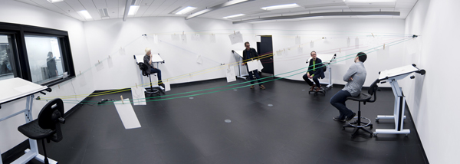
Fig.1 Neural String Network installed at the University of Salford MediaCityUK, March 2012.
The DecodeRecode project lasted 24 hours and involved over thirty partner institutions from around the world including artists, scientists, academics and students who collaborated on this live digital media performance. The MediaCityUK building foyer acted as the main hub receiving and sending content around the world between our international partners, using five high-resolution video wall displays, each with a specific input. The event included live interactive performances with sound, animation, drawing, poetry, video, motion graphics, virtual environments and collaborative screen sharing. A telematic workstation was installed behind the five large format video screens and consisted of a cluster of MacPro computers controlling an array of outputs exchanged over a range of Internet protocols including web based applications, video streaming, file sharing and email. A key aspect of the project was the ‘open-source/ open-content’ approach to creating, responding and contributing to an international pool of shared content between all the project participants. By signing up to this shared ‘Dropbox’ folder, participants were able to upload their work (be it images, animations, sounds, text or code) to the shared folder, but also take other content out, which they could then use/ respond to/ add to or change any way they desired before returning it to the DecodeRecode Dropbox folder. This global pool of content was established with the agreement that; what you put in someone else could take out; nothing was ever completed; everything was in a creative state of flux - as an international networked celebration of the Alan Turing centenary. Our students worked in the telematic workstation, sourcing local content form Turing’s Manchester and collaborated live with the international partners throughout the project. Themes included; biological systems, artificial life, coding, recoding, decoding and Alan Turing’s life story, resulting in a live mash-up media jam performance over 24 hours.
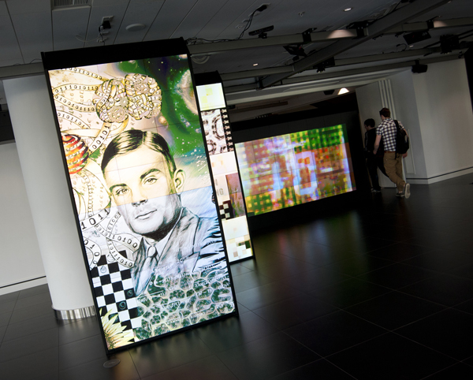
Fig.2 DecodeRecode at MediaCityUK, celebrating 100 years of Alan Turing, March 2012.
The fundamental task and research question behind the Neural String Network was to help students better understand the power and significance of shared collaborative telematics arts practice in the eventual DecodeRecode project. Preparing them to interact and respond creatively and reject intellectual property in favour open-content. In a localised analogue form the students were able to quickly understand the concept behind the open-source model of the project in a very ‘hands-on’ approach and experience the creative potential of an interactive collaborative drawing ‘machine’.
The underlying conceptual background of both DecodeRecode and the consequent Neural String Network projects originates from the Telematic Art events and happenings of the mid to late 1980s. These networked art exchange projects involved groups of artists located around the world engaged in the dispersed authorship of collaborative artworks in a continual transient state of creative fluidity, produced using a range of telematic communication devices ranging from fax machines to private timesharing networks. My own involvement as an artistic contributor and instigator of some of these early telematics events included ‘Le Palais Idéal’ in collaboration with Roy Ascott in 1988, ‘Text Bombs & Videotape’ at the Watershed Media Centre Bristol in 1991 and the ‘Globe Show’ at Oldham Art Galley in 1990. DecodeRecode and the Neural String Network introduced the students to these origins of social networking that have since become embed in every day contemporary practices, often overlooked by our current student generation. The essential lessons here are rooted in Roland Barthes’s essay ‘The Death of the Author’ (Barthes 1967), manifesting that the creation of meaning lies as much in the mind of the viewer as it does with the artists, whereby the viewer and creator become one in the same in an on-going state of creative flux.
As an undergraduate Fine Art student in 1987 at the Newport School of Fine Art I had the opportunity to work with, then head of School, Roy Ascott who was pioneering the field of telematics arts. During this time Ascott had recently presented the seminal project ‘La Plissure du Texte: A Planetary Fairy Tale’ in 1983, alluding to Barthes’s ‘The Pleasure of the Text’, a further discourse on authorship, semantic layering, and the creative role of the reader as the writer of the text (Barthes 1975). Ascott’s visionary telematic ideas of global computer networked art practice as a cybernetic model of consciousness (Ascott 2003) made a life long impression on me, and this collective consciousness discourse prevails again in the underpinning concept of the Neural String Network experiment as a dynamic system of firing synapses and neurones in the form of strings and pulleys. Other influential projects by Roy Ascott include ‘Digital Body Exchange’ from 1987, a telamatic image exchange between global collaborators engaging in a Surrealist/ Dadaist Exquisite Corpse game of consequences, which again shares close parallels with the experiments carried out using the Neural String Network, discussed later in this paper.

Historical Context
In developing the original concept for the Neural String Network I was mindful of another lasting memory that predates my introduction to Roy Ascott and Telematic Art. A vivid memory that has constantly haunted me since and might also account for the welcoming embrace I later had for Ascott’s cybernetic vision of networked art in the future. On a trip to Dublin in 1984 I stumbled across ‘The Bad Ass Café’ where I was served by a waiter who took my order and placed it in a little wooden cup hanging from a wire above my table, he continued to pull a cord, which fired the wooden cup containing my order across the café on a cable to the kitchen, thereby allowing him to continue taking orders in what was a very busy café. I then realised that every table in the café was connected in the same way and sat back to drink my coffee and contemplate the neural system in the ceiling above me in true Joycean style.
At the time of writing this paper, I traced my steps back to this experience and made further research into the system used in The Bad Ass Café in Dublin. The network of cables and pulleys in the café dates back to the late nineteenth century, and were used in shops, department stores, offices and factories around the world, generally referred to as ‘Cash Railways’ using a range of techniques, mostly developed in North America. Varying from ‘Cash Balls’ invented in 1881, which conveyed cash in hollow wooden balls, running along inclined tracks between sales point to cashier (Buxton 2003) to ‘Cash Lifts’ consisting of a car running vertically between two steel guide wires that could be raised by pulling on a cord and descended under gravity, allowing a counter to be served above or below the floor of the cash office (Buxton 2003) and the most widely used ‘Wire Line Carriers’, similar to the one I experienced in Dublin, patented in the USA by William S. Lamson in 1882 of The Lamson Carrier Company Boston, Massachusetts. Lamson was the best-known manufacturer of the Cash Railway system and was established in Britain as the Lamson Store Service Company in 1888 with distribution rights to Europe, Africa, Australia, New Zealand and the Middle East (Buxton 2003). Apart from those in Museums and the occasional quirky café, Cash Railways have all but disappeared from use, a concept replaced by ‘chip and pin’ cashiers of late. But it is no surprise the Neural String Network, like many contemporary media art works, is once again drawing from the media art archaeology of the late nineteenth century (Huhtamo 2011) alongside the inventions of the Kinetoscope, the Horseless Carriage and Pepper’s Ghost, to name but a few.
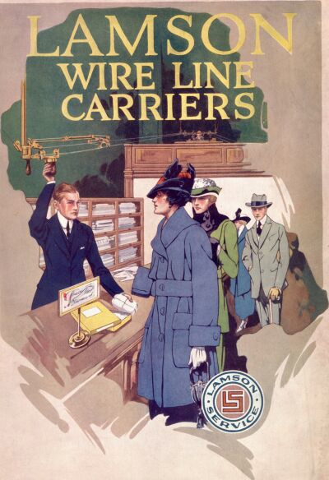
Fig.3 Lamson Wire Line Carriers, Cover of a Lamson brochure, ca. 1917
In identifying the historical context for the Neural String Network it would be impossible to ignore the radical ground breaking experiments of the Surrealists in the early 1930’s with the ‘Exquisite Corpse’ involving André Breton, Paul Eluard, Tristan Tzara and Benjamin Peret (Caws 2001). Based on an old French parlour game involving several players, each player would write a phrase on a sheet of paper and fold it to conceal the larger part of the phrase, passing it on to the next person for their contribution and so on. The surrealist game got its name from the results of one of the first experiments, ‘Le cadavre/ exquis/ boira/ le vin/ nouveau’ (The exquisite corpse will drink the young wine). Led by André Breton the group later adapted the game to drawing a figure by assigning a section of the body to each player (Caws 2001), revealing the familiar surrealist metaphoric outcomes. The most striking similarity here with the Neural String Network is characterized by the Surrealist poet Nicolas Calas who referred to the game as an ‘unconscious reality in the personality of the group’ (Adamowicz 1998), hinting at the notion of a collective networked consciousness engaged in ‘open-content’ creative practice, a process that Max Ernst called ‘mental contagion’ proposing that poetry must be made by all and not by one (Adamowicz 1998).

Experiments with Students
The first improvised prototype development of the Neural Sting Network was set up at the University of Salford in the School of Art and Design undergraduate studios in February 2012, during a workshop session with first year BA Graphic Design students. The two-hour workshop was repeated on three occasions with groups of 25 students, each of which were divided into five teams of 5 students - arrived at, purely by the size of each group. All the students were then asked to draw a network diagram connecting five points together with each other. The task lasted 20 minutes and the students quickly identified a pentagram within a pentagon as the optimum network design. The student teams were then distributed around the studio at five separate tables. Provide with a ball of string each team were asked to connect themselves to all the other tables by looping the string between convenient points close by, such as the leg of a chair or the handle of a window etc. The basic network was complete and the students were tasked with playing an Exquisite Corpse game of consequences by pegging their drawings to the looped string and pulling on the line to pass their drawing onto the next team for their contribution. To be expected the exercise produced some fascinating and ambiguous outcomes. But what was more surprising were the large amount of drawings produced in the space of the two hours, following the only rule, that if you receive a drawing you must immediately stop the current drawing and pass it on to continue with the one you have received. Given the freedom to explore the string network, the students quickly understood the analogy and playfully mimicked social networking protocols by sending simple written messages such as ‘be my friend’, ‘poke you’ and ‘join my group’.
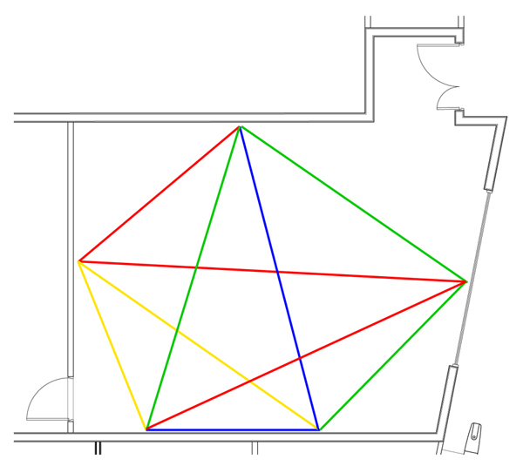
Fig.4 Neural String Network design for the Multi-Function Project Room at MediaCityUK
From these initial prototype experiments the first public installation of the Neural String Network was presented in the Multi-Function Project Room at the University of Salford MediaCity in March 2012. The installation consisted of five drawing table ‘nodes’ positioned around the project room, measuring eight by eight metres square. Each node was linked to the other four via pulleys and colour coded washing lines, making it possible to peg a sheet of A4 paper to a line and winch it across to any one of the other nodes. The network system used 10 string connections between the five drawing tables, creating the pentagram within a pentagon neural network design. During the installation in March 2012 students, researchers and staff were invited to use the Neural String Network at their convenience. Other programmed workshops/ performances included both undergraduate and postgraduate students. Through feedback and focus groups the majority of student discussions fixated on the open-content model of the project and the development of collaborative drawing exercises on the theme of the centenary celebration of Alan Turing. Each participating student was given a single word drawn from the Turing theme, such as ‘machine’, ‘brain’, ‘code’ and ‘apple’ that were interpreted and communicated as a collective Turing narrative. The initial networking analogy and playfulness in the first experiments continued to be discussed throughout.
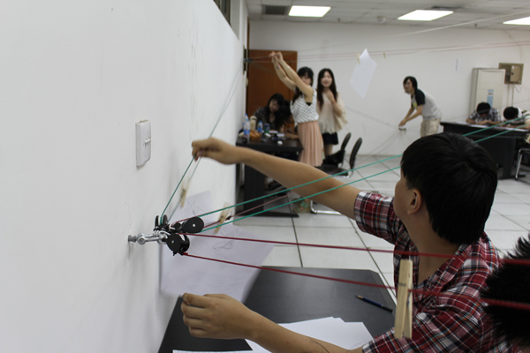
Fig.5 Neural String Network installed at the College of Fine Arts Shanghai University, July 2012.
The second installation of the Neural String Network took place at the College of Fine Arts Shanghai University in July 2012. As Visiting Professor at Shanghai University I installed the Neural String Network for the duration of my visit from July 1st to 16th, to conduct a series of workshops with the undergraduate BA Digital Art and Design students. This provided a more focused and reflective opportunity to work with the students for the entirety of the visit on a number of experiments and activities exploring materials, time, rules and communication. The workshop began with the network design task and the string network was set up in an empty classroom in exactly the same way as it was before in the Multi-Function Project Room at MediaCityUK Salford. This time I was working with four groups of ten students, two to a table/ node. One of the particular advantages of working with the String Neural Network in this context was crossing the language barrier, the students quickly understood the concept and what was required by the very presence and experience of the installation, and it was very straightforward to set them off to work as a team independently. The first exercise commenced by introducing a single word to each node, whereby they were instructed to read the word and start drawing the first association that came to mind, and then respond to an image in the same way when one was received. Surprisingly to me the initial results read like storyboards or pictograms, not dissimilar from Chinese words/ characters, revealing a narrative structure – which is perhaps culturally to be expected.
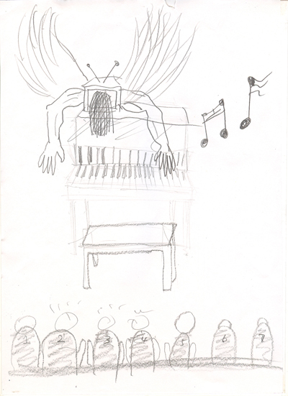
Fig.6 Initial drawing outcomes from student exercises at Shanghai University, July 2012.
In the second phase the students were introduced to the principles of telematics arts and the writings and work of Roy Ascott, through a complementary seminar programme delivered on occasions through out the visit as a running discourse. The emphasis was on advocating the ideas of a networked collective consciousness and that the students’ participation and collaboration represented the workings of the conscious mind through the exploration of subconscious associations and creative outcomes. On this basis the students were intermittently provided with freestyle opportunities to explore the Neural String Network without any prompting, simply to explore their collective inner mind and spontaneous creative response. This always led to group feedback sessions at the end of each experiment were I would take the entire group through all the outcomes of the exercise and often ask who contributed to each of the drawings. The students appeared to enjoy this part of the project most, which caused a lot of amusement when the drawings were finally displayed to them and their collective thoughts had come to bear. This also provided me with the opportunity to stress the importance and significance of considering the collaborative opportunity to evoke cause and effect approaches when reflecting on the results so far.
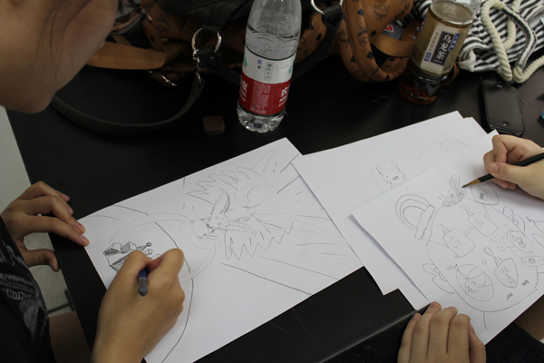
Fig.7 Students participating in the Neural String Network at Shanghai University, July 2012.
The final phase of the project aimed to present a Neural String Network performance to fellow students and staff of the College of Fine Arts on the last evening of the workshop. Preparations began by introducing the students to the work of the Surrealists in the 1930s with the Exquisite Corpse and asking them to consider a surrealist approach by relaxing and attempting to empty their mind of any preconceived intensions, to simply react and improvise on the first thought that comes to mind when an image is received in an attempt to delve deeper into their subconscious. Further exercises introduced five different colour ranges in order for the student to identify all nodes and participants of the network, making it possible to identify a complete image when all five colours had contributed to it. Paper sizes and materials such as charcoal and pastels were also experimented with and kept the students’ momentum going. Prior to the final performance event I presented a final plenary lecture, which took the students through the entire development of the project, from the initial set up experiments at MediaCityUK in Salford, an introduction to the DecodeRecode project, a historical account of Cash Trains and the work of Roy Ascott to the final outcomes of the project in Shanghai. The presentation included a selection of their drawings and in summary a cybernetic analogy of the Neural String network as a dynamic system of firing synapses and neurons of a collective mind, thereby encourage the students to respond quicker and on impulse in preparation for the public performance. Approximately 20 members of staff from the college joined us for the final event, including ceramicists, historians, painters and architects. The concept was quickly grasped and well received by all, opening up a dialogue between the staff and students on the subject of the drawings created over the two weeks, which were presented on the walls of the room where the Neural String Network was installed.
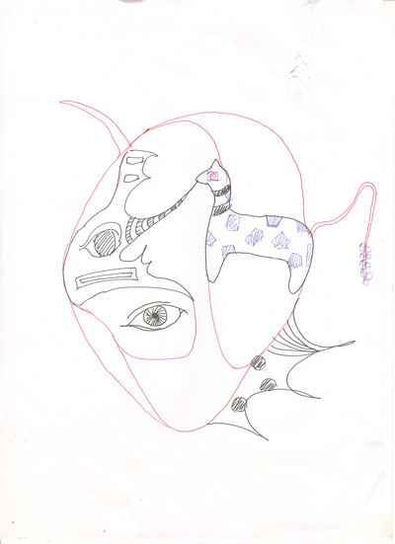
Fig.8 Drawing following the second phase of the workshop at Shanghai University, July 2012.

Outcomes and Conclusions
The Neural String Network is essentially a dynamic system of interaction or an analogue computational machine. When it is complete with participants and drawing materials this device becomes ready to programme or task with commands and therefore affords both the roles of creative collaborator and creative developer or programmer. To completely understand the potential of this system both the input and output must be experienced and tested when we consider the complexity and potential of the system as a whole. Through current experiments I have adopted the role of ‘programmer’ by preparing participants to take part and inputting tasks to process and complete. The fundamental aim of these exercises is to help us better understand the full potential and significance of shared collaborative practice, networked creativity, collective consciousness and specifically how this affects the telematics arts and global social networking platforms of the future. As social network protocols have become increasingly more ubiquitous and pervasive, and intellectual property rights have become more stringent, the current generation of art and design undergraduates have on the whole embraced and accepted these systems and protocols without question. Whilst it is difficult to measure the long-term effect of the Neural String Network experiments with these students, judging by their level of engagement, enthusiasm and feedback it will certainly be a point of reflection during their development and future engagement with telematic systems. It is hoped that the physically experienced analogy of interconnected synapses and neurons firing across a collective consciousness will have a significant contribution to their creative processes and communities in the future.
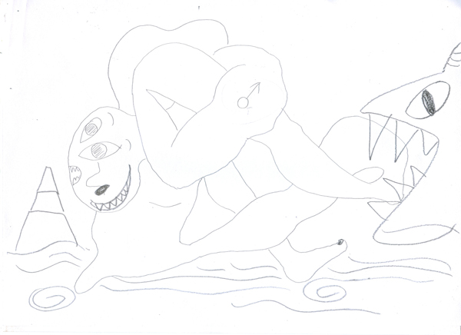
Fig.9 Final drawing example from student exercises at Shanghai University, July 2012.
The workshop at the College of Fine Arts Shanghai University concluded with two proposal developments that could be taken forward during future visits to Shanghai University. Taking a speculative approach to the architecture of the college, I proposed a large-scale Neural String Network installation for the outdoor atrium space of the building. The string network could stretch across the 300-meter square atrium courtyard space, linking up the four walls of the six-storey college building that surrounds it, connecting various departments by entering through the windows of the studios and floors that occupy the space. Given the volume of the atrium it would also be possible to increase the scale and complexity of the neural network by increasing the number of nodes, offering both multidisciplinary and public engagement, depending on who happens to stop by a particular node and make a contribution. The second future development proposal was arrived at through discussions concerning participation at the ‘Experimental Mobile Applications Workshop’ at Shanghai University in November 2012, organised by the ‘Shanghai Creative Designers Association’ and the ‘Creative Centre of Public Art and Virtual Lab’. The proposed application would be a convergence of the Neural String Network concept with the iPad capabilities that include the accelerometer, wireless networking and touchscreen drawing. By using a local wireless network it would be possible to exchange a montage of digital drawings and images between any number of participants. By using the same principles as the Neural String Network new multiple modes of interaction could be introduced whilst keeping the principles of collaborative creative practice at the forefront.
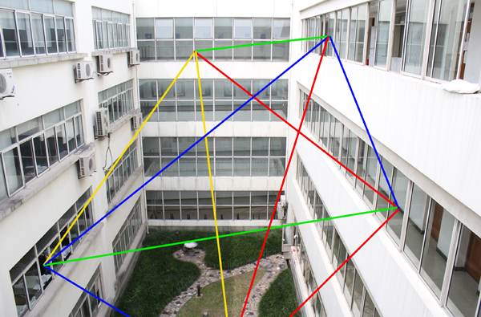
Fig.10 Proposed network design for the atrium space at the College of Fine Arts Shanghai University.

References
Adamowicz, E. (1998) Surrealist collage in text and image: dissecting the exquisite corpse, Cambridge University Press, Cambridge.
Ascott, R. (2003) Art and Telematics: Towards a Networked Consciousness (1984). In Edward A. Shanken (Ed.) Telematic Embrace (pp. 185-200), University of California Press, Berkeley.
Barthes, R. (1977) Death of the Author in Image Music Text, Essays selected and translated by Stephen Heath, Fontana Press, London.
Barthes, R. (1975) The Pleasure of the Text, Translated by Richard Miller, Hill and Wang, New York.
Buxton, A. (2003) Cash Carriers in Shops, Shire Library, Oxford.
Caws, M. A. (2001) Surrealist painters and poets an anthology, The MIT Press, Cambridge, Massachusetts.
Huhtamo, E. (2011) Dismantling the Fairy Engine: Media Archaeology as Topos Study. In Erkki Huhtamo & Jussi Parikka (Ed’s.) Media Archaeology (pp. 27-47), University of California Press, Berkeley.

