International conference on engineering and product design education
2 & 3 september 2010, Norwegian University of Science and TEchnology, Trondheim, Norway

Help! Engaging students in an immersive simulation to increase empathy when designing emergency products
Cathy GRUNDY, Andrew BLAKE.
¹University of Brighton, University of Sussex
²University of Brighton.
abstract
In a creative exploration with second year students at the University of Sussex, we attempted to investigate how we can improve our understanding of being in a panic situation in order to design emergency products empathically. In this case we investigated the scenario of being inside a burning environment and we imagined being in the role of an untrained person having to use a typical product for the first time. The potential for human error increases when using equipment under duress and in circumstances where timing is critical, these issues will be especially important. This investigation used the Creativity Zone, a flexible multimedia space, to create an immersive environment that simulated the effect of flames surrounding the subject. The motivation was to allow student’s to interact with the simulation as if they were experiencing the real event directly. The project revolved around designing the interface to make its use intuitive; so that upon first encounter visual clues enabled successful interaction with it. Examples included a fire extinguisher, a defibrillator, an emergency radio and an airplane exit. Theoretical ideas were included based on studies in perception and more information was available through a web site designed to provide an on-line gallery. This was created with help from a CETL bid; the url is www.visble.org.uk. The students were also asked to consider Semiotic thinking in their solution. The project is part of the assessment for a course called Advanced Studies in Form, based on the study of perception.
Keywords: Scenarios, Creativity, Empathy, Usability, Affordance, Semiotics

1 Introduction
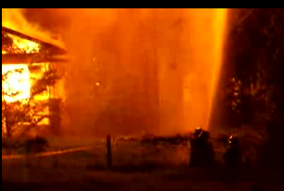
Figure 1: Screen shot from Fire video

Empathy with a user and an understanding of their needs and behaviors can be critical to ensuring an effective product design process. How different circumstances, human characteristics, personality traits and experience influence interaction with an object are sophisticated concepts. While a context can be studied theoretically or described, the ability to react and respond to tasks conducted within it can nevertheless be hard to predict exactly. It is also difficult to relate to such events personally and to put oneself in the place of the other within the situation [1]. This grasp of other people’s realities is probably one of the most difficult things to teach students. Full ethnographic studies are an excellent way to understand the behavior of others, however, they are usually too time consuming or expensive for most design activity within a college; this can sometimes lead to lack of awareness of the design requirements. In this particular case we wished to review how we can improve interaction with products in a critical situation or emergency; something that is difficult for most of us to comprehend without direct experience.

Usability for Different Emotional States
Anxiety and panic are negative emotions that affect our ability to process information and can inhibit performance of procedural tasks [2]. According to Easterbrook [3]: “Emotion reduces utilization of cues. In some tasks this can be an advantage (for example elimination of irrelevant cues); more often, however, such reduction inhibits performance.” Although stress can help us to focus on simple fight or flight reactions; operating an interface requires a higher level of cognitive activity that will be impeded by stress. Thus, in redesigning the interface of an emergency product, a key objective is to simplify the task and to reduce visual complexity and the number of cues available. It is possible to provide visual emphasis to help indicate important components and perhaps lead a viewer through a set of controls in a sequential manner, where necessary. Studies in perception and visual communication can help us to design clearer interfaces with reduced visual ‘noise’.

Perception studies:
A research project, funded by InQbate through the CETL fund led to the creation of an on-line visual gallery based on meeting desired goals for interaction with an artefact. This took the form of a web site structured according to the goals and was designed as a supportive teaching tool to share experiences. It show cased particular design layouts and discussed how they might promote beauty and usability and includes ideas based on studies in perception. Students in earlier sessions had done quizzes and quick design activities inspired by a series of Flash movies introducing the ideas. The movies encouraged independent exploration of principles like affordance, clarity, creating emphasis and flow. The movies have since been developed into downloadable elements of the teaching material for the web site. A paper describing activities and feedback for the Flash movies was submitted to EPDE 09 [4] The url is http://www.visable.org.uk The content is also helpful in designing the emergency products so that they might be used more intuitively.

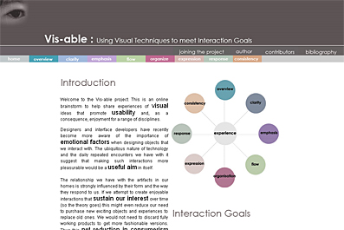
Figure 2: Screen shot from Visable on-line gallery
Four particular techniques were considered particularly helpful, in this instance. Methods for instigating Clarity, Emphasis; visual hierarchies that create Flow; and Expression are the categories as they are defined as Interaction Goals on the web-site. These are briefly described.

Clarity:
How do we make an artefact clear and readable? This can be described as an aim to create ‘clarity’ in its form and purpose. Attractive objects often obey simple aesthetic laws that can also be used to help us to simplify what we see. The world around us is a complex place, full of a multitude of objects projecting different, often conflicting messages that seem to be vying for our attention and mental 'space'. Often the key to an elegant design is to avoid over loading our sensory mechanisms. We need to use visual techniques that optimize our Cognitive Load to help.
Figure 3: Graph of Cognitive Load
Cognitive Load is the amount of effort it requires for our perceptive mechanisms to absorb and process sensory information. Psychologists have proved that there is an optimum Cognitive Load for a human being to maintain the right level of interaction with an interface. If there is too much going on, we are likely to become confused and bewildered.

Some of the techniques we can include to help are: Unity; Simplicity of form; Repetition and Harmony; Proportion and Order; Gestalt principles; Spreading the load across different media or senses; Hiding and revealing objects; White-space

Emphasis:
Sometimes we simply want to make something stand out. It may be that we wish to design an object that is particularly striking or to make elements of a composition more prominent. It is vital to be able to find the part of an interface or artifact that is most important to us. An obvious example is perhaps an emergency stop button on a product. It is also very useful when beginning any process of interaction, to know where to start. Artists use a technique called creating ‘emphasis’ to lead the eye to important parts of a picture or sculpture. Many web designers are also aware of using emphasis to draw attention to areas on a web page. Those that study communication are primed to create Visual Hierarchies, by increasing ‘Visual Weight’ and use other methods to create a focal point for the eye.
Techniques include: Visual Elements and the Physiology of the Eye; Visual Weightings including use of size, boldness, colour, texture, detail and tone; Contrast; Directional elements; Position; Movement; Gestalt principles of wholeness.

Flow:
In order to increase our level of engagement with any activity, it has been shown that having a sense of flow is important. When we are involved with painting, for example, or a process where we feel immersed in the event, time can pass quickly and we can be quite efficient and productive.
It is important to consider how the eye flows around an interface. Visual techniques can help to have a clear starting point or emphasis for a process and then lead the eye around, which can increase the perceptual flow. It is common sense that if we can see a series of required actions we need to follow that it will be easier for us to engage with them. We are consequently more likely to feel a sense of flow. Many of the techniques used to create emphasis can also be used to create hierarchies, of information to lead the eye. Techniques include: Visual Hierarchies using Visual elements and Weightings; Directionality; Visual Connections

Expression:
How can we make an artefact expressive of its meaning and function? Most design gurus agree that the available functions and uses of an interface should be made 'visible', and that a device or object should be explicit through its form and meaning. Alan Cooper (1) makes analogies between computers, products and people. This principle in human terms is similar to a person being friendly, helpful and forthcoming. We can ensure that the available interactions with an object are visible when they are needed and that we create clear affordances that suggest what the user should do through the form. Returning to our human analogy, however, sometimes elusive people are more fascinating! An 'elusive' interface that attempts to be intriguing to a user may keep some of its nature hidden in the initial stages of use. This works very well for game designs, and illustrates that all principles should be considered along a spectrum against contextual understandings. Techniques include: Affordance and Gibson’s theories of perception; Visibility; Constraints

2 method
The following describes the procedure that was carried out during the project. Initially a lecture was given in a separate area of the Creativity Zone to introduce the brief and the interaction principles being considered. The students were told what was going to happen in the space and pre-warned that they might consider the situation stressful, especially if they had previously been in a fire. Students were asked to work in groups of 3 and to record, through video and photographic means their reaction when attempting to use the equipment within the ‘burning’ space. We looked at a range of real Fire Extinguishers, a defibrillator, an emergency radio, and an airplane fire door was simulated as a projection of an image onto the dividing curtains. The brief ran as follows:

2.1 Brief:
“Imagine yourself in each of the following scenarios in turn within the Creativity Zone.
(N.b. We are not advocating that you become fire-fighters or deal with dangerous situations, always call emergency services where necessary!) Your task is to design a product that projects its use to the viewer using the visual techniques learned including: its nature & purpose, how it should be used.
You should use the theories and ideas discussed in lectures to make your product form communicate and meet these objectives. Present your ideas through sketches and renderings. Do not focus on the redesign the function or the ergonomics of the product directly You are not given credit for this.

Scenario 1:
Imagine the scene: you smell smoke and notice it is billowing out from the office next door. You panic as you rush in to see what is happening. A fire has broken out in the waste paper bin, but it might turn into a big fire if you don’t do something quickly. The bin is in the way of the exit and there are staff inside the room. There is a fire extinguisher, but is it the right kind? Do you know how to use it? Your pulse is racing, and beads of sweat appear on your forehead, you are panicking as you try and work out what to do…

Scenario 2:
You have managed to get yourself a seat next to the fire exit on the airplane as you set off on a family holiday (increased leg room!). The only problem is that there really is an emergency landing and everyone is depending on you to be able to open the door and operate the emergency slide. Do you know what to do? You wish you had studied the safety card now don’t you?

Scenario 3:
In a tube train, there has been a breakdown and smoke is coming from somewhere. A passenger has collapsed and needs a defibrillator. There is one hanging up available, but do you know how to use it?

Design Work:
You should re-design of one of the products of your choice to make it more intuitive and more usable in these panic situations. Try and use the following design method to pursue Interaction Goals.
a. Clarity
Ensure that the design as a whole is not over cluttered, ensuring that it is easy to understand and interpret the interface
b. Create layers of communication with Visual Elements (See website on ‘Flow’)
Use different visual elements and their relative weightings to make different parts of the design stand out more than others. You can help people follow a series of actions by differentiating the series of controls in a sequence.
c. Affordance and Expression
Use the ability of an object to express through its design what you do with it. For example, a handle that looks like it needs to be turned. We can use clues in the form, texture and colour to promote this and make products more communicative. You can also use ‘Constraints’ to limit possible actions.
Semiotics
Semiotics, the study of signs can help us to introduce clues about the nature of a particular object. We could, for example, use the red, amber, green sequence associated with traffic lights to indicate a sequence of use. Alternatively we could illustrate that a fire extinguisher contains water with an metaphor of water droplets on its casing.

The study was introduced in the Creativity Zone, a state of the art facility that provides a very interesting and potentially inspiring space to teach design subjects. The environment can be considered analogous to a theatrical stage set, with the students and staff behaving like actors within it. We can therefore shape the environment to our own particular vision, providing the ideal opportunity to create immersive ‘experiences’. To simulate fire, we projected moving fire videos and burning house scenes on the walls surrounding the space. We also added them to the transparent curtains that can be added to divide up the room. Images of aircraft and other emergency exits were also added to walls and curtains. The students were then asked to video each other interacting with the products supplied and record their reactions to using the product and their problems with it.

3. findings
On the whole the group were highly successful at including creative ideas for affordance or constraints within the product form. Figure 5 shows a redesign for the cone of the C02 extinguisher with spikes or textures that suggest that it should be held elsewhere. Often this can be very cold and inexperienced users can accidently get burned by it if they reach out and hold it during deployment.
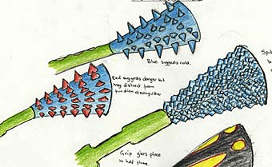
Figure 5: Cones for C02 extinguishers that constrain the user
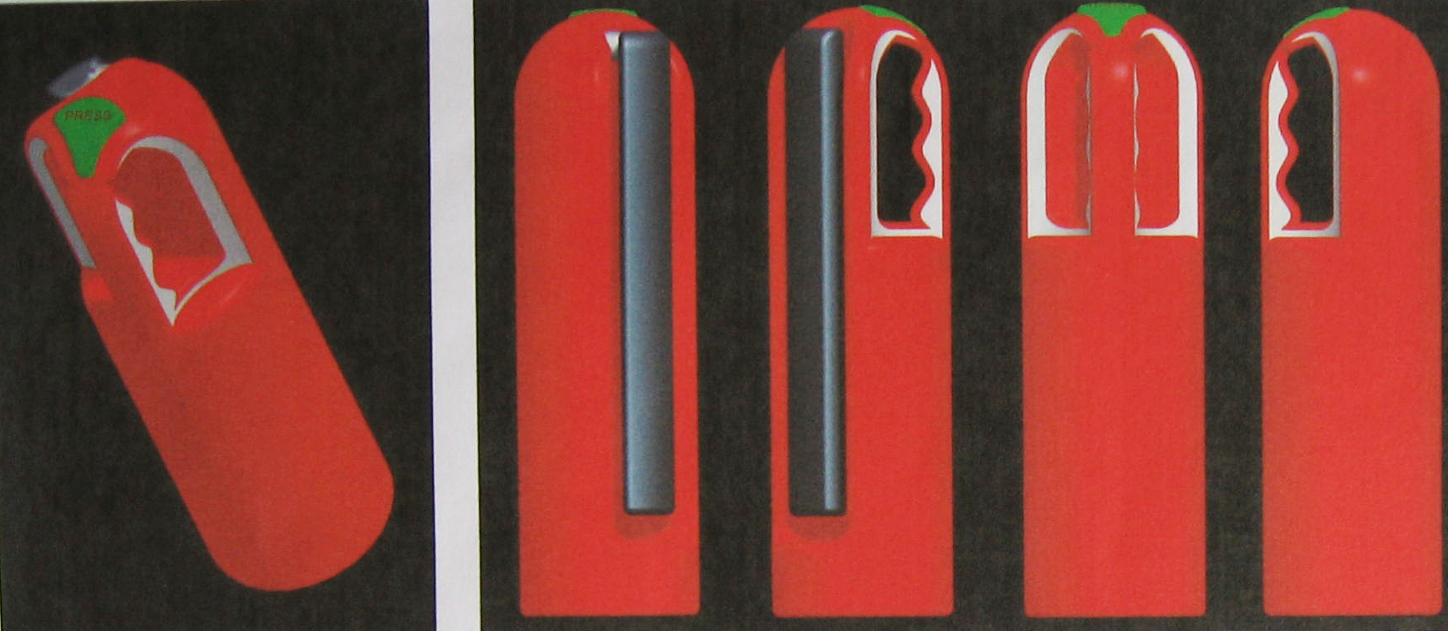
Figure 6: Texture and colour changes to afford where to hold and deploy the extinguisher.

The example shown in Figure 6 indicated where it should be held and where it should be activated. Figure 7 illustrates how constraints and affordance are used to indicate clearly the first stage of removing the pin before use.
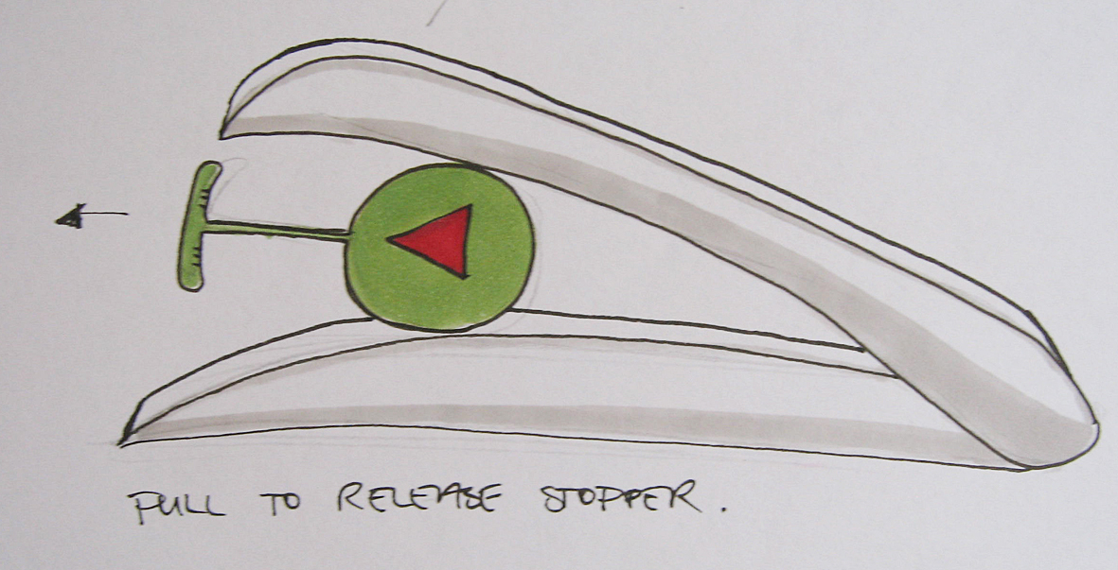
Figure 7: Affordance and Constraint
The students included visual hierarchies effectively. This can be seen most effectively in the defibrillator design shown in Figure 8, where they used size and texture to create a hierarchy and also typical colours associated with traffic lights.
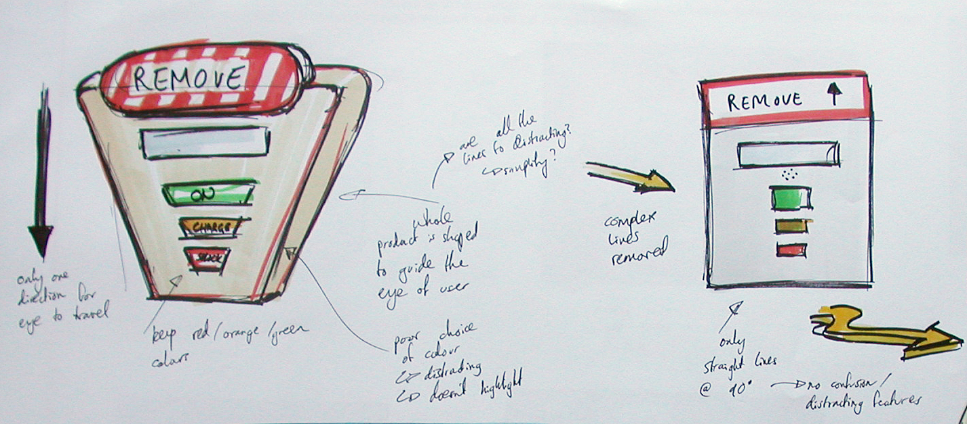
Figure 8: Defibrillator design

The results of the project were generally of high quality, with evidence of understanding the problems to be addressed. Most students agreed that having the flames around them, added to their awareness of the issues involved and particularly going through the actions as though they were using the object for real. The level of anxiety experienced by students varied greatly. One student, who was prone to panic-attacks already, had to leave due to anxious feelings. Most did not feel that concerned but reported tiredness as though they had been in a traumatic situation. They all thought that it had helped them to consider the anxiety others might experience, however.

Conclusions
In interviews with students following the experience, they said that the process had helped them to identify with the problem. It was therefore concluded that the event was successful in its aim to focus design thinking. It also reinforces the idea that simulating and acting out scenarios for any design context can help with increasing empathy. It was also mentioned that the addition of sound might make the experience more convincing for some, but this also might induce further panic for others. Overall, it was difficult to genuinely ascertain the degree to which the scenario enactment had actually helped the product design; a control group without the simulation might have helped with this. In the main, despite different levels of immersion experienced, all the students agreed that it was a really good way to introduce a project because it had focused their attention and motivated them.

References
[1]
[2] Darke, Shane, Effects of Anxiety on Inferential Reasoning Task Performance, in Journal of
personality and social psychology Vol 55, ISS 3, 1988, pp499
[3] Easterbrook, J.A. The effect of emotion on cue utilization and the organization of behaviour, in Psychological Review. Vol 66(3), May 1959, 183-201.
[4] Grundy, C., Blake, A.,
[5] Cooper, Alan, Reiman, Robert. About Face: The Essentials of Interaction Design, Indiana, USA,
Wiley publishing, 2003)

