Relative soil/wall stiffness effects on retaining walls propped at the crest

M. Diakoumi
School of Environment & Technology, University of Brighton; M.Diakoumi@brighton.ac.uk

W. Powrie
School of Civil Engineering & the Environment, University of Southampton; wp@soton.ac.uk

KEYWORDS: retaining wall; mobilised strength; wall flexibility; soil stiffness; design.

ABSTRACT: Review of the different methods used in current engineering practice and codes of practice for the design of retaining walls has indicated that complex and time consuming analysis is often required to model the soil behaviour. Alternatively, empirical or simple methods based on linear elasticity can be used, but their limitations are significant. A calculation procedure is developed for retaining walls propped near the crest, with reference to Eurocode 7 (BS EN 1997-1:2004), which can be used to address safety and serviceability requirements in design and takes account of both the real nature of soil behaviour and the flexibility of the wall. The results of the calculation are compared with those derived from a conventional limit equilibrium analysis and are used to develop look-up charts which can be used in design to take account of bending moment reduction due to wall flexibility effects.

1 INTRODUCTION

Codes of practice for the design of retaining walls recommend limit equilibrium calculations with the soil strength being reduced by a factor of safety, F_{s}, to ensure that the wall is remote from the Ultimate Limit State (ULS). Guidelines to avoid the Serviceability Limit State (SLS) are fewer and less clear than for the ultimate state, since deformations are often assumed to be a secondary problem and are predicted by calculations based on elasticity theory. However, in reality soil is not a linear isotropic elastic material but its stiffness depends on both stress and strain; hence, in some cases past experience and recorded behaviour of retaining walls is used as guidance in design, but this empirical knowledge can only be applied to similar and comparable cases. Alternatively, project specific rigorous soil-structure interaction analysis may be carried out by using sophisticated numerical analysis software. However, the number of parameters required for the development of the soil model, the calibration of the values and investigation of their sensitivity, the cost and user expertise required restrict significantly the practicality of these methods.
Previous research (Rowe, 1952) has shown that wall flexibility will reduce the bending moments in embedded retaining walls propped at the crest, but this is not always considered in design. Therefore, the development of a practical and reasonably accurate design method that can reliably determine the factor of safety against ultimate limit failure in the ground and the likely in-service behaviour of walls propped at the crest, taking into account both the real nature of the soil behaviour and wall flexibility would be a useful tool in design.

2 MOBILISED STRENGTH DESIGN (MSD) METHOD

2.1 Background

Bolton, Powrie & Symons (1989, 1990) introduced a new design approach based on the concept of idealising the soil behaviour by means of simplified kinematically admissible strain fields. Following Bolton & Powrie (1988), a geostructural mechanism for stiff walls in clays was used to
relate the rigid body rotation of the wall to the maximum shear strain in the adjacent soil and hence to the ground movements. The shear strain in the adjacent soil was related to the mobilised strength required for equilibrium. The underlying assumption of the method was that uniform, rigid body rotations of the wall resulted in uniform strains and hence a uniform mobilised strength in the surrounding soil. The soil and wall deformations under working conditions are then estimated from the equilibrium calculation. The effective stress distributions on either side of a stiff wall were assumed to be approximately linear with depth, and the ground movements due to wall bending were neglected. Osman & Bolton (2004) developed the method further under the term mobilisable strength design (MSD) method.

2.2 Application of the MSD method to flexible walls propped at the crest

According to the simplified geostructural mechanism, the maximum wall deflection will occur at the toe of a rigid wall propped at the crest. However, flexible walls deform in a more complicated way and the maximum wall deflection will probably be close to dredge level. The application of the MSD method to flexible walls propped at the crest is discussed in this paper.
For flexible walls, further kinematically admissible strain fields may be added to better represent the soil behaviour. The active and passive soil zones are subdivided into a number of triangles as shown in Figure 1, where h is the retained height and d the embedment depth of the wall. The soil is divided into four zones behind and two zones in front of the wall for the analysis presented in this paper. In principle, the soil could be divided into more zones to achieve a smoother deflected shape. The triangles are free to slide on vertical and horizontal surfaces, which are assumed to be frictionless, and can be attached to the surrounding rigid zones through zero extension lines. Zero extension lines are at 45° to the principal axes of strain, assuming the angle of dilation is equal to zero. The mobilised shear strength and the shear strain are assumed to be uniform within each triangle. The use of additional kinematically admissible strain fields permits the incorporation of different mobilised shear strengths corresponding to the different mobilised strains in each zone of the soil surrounding the retaining wall. Strains are then related to the wall deformations by a geostructural mechanism. The strain increment within a triangle should be consistent with the relative rotation of the triangle and then the total strain is estimated by superimposing the strain increments of an individual triangle and all those larger than it. The rotation of a triangle is related to the wall displacement by means of a geometrical relationship.

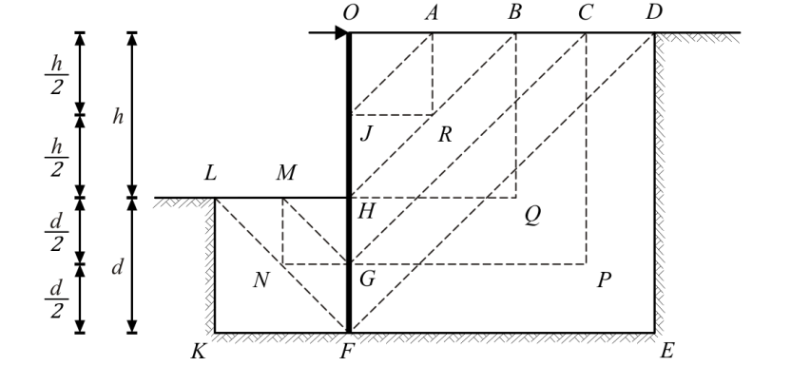

Figure 1: Admissible strain fields for a flexible retaining wall propped at the crest.

Wall movement is assumed to take place in four successive stages as shown in Figure 2. The first stage consists of the movements of triangles ODF behind and HFL in front of the wall. According to the geostructural mechanism (Bolton & Powrie, 1988), taking compression positive the stain increment, δγ₄, within triangle DEF can be related to the rotation of triangle ODF, δθ₄:

δγ₄ = 2 δθ₄ (1)

Triangle LFK in front of the wall will be compressed and the maximum shear strain increment
within it, δγ₅, is related to the rotation of triangle ODF by equation (2).

δγ₅ = 2 δθ₄ (h + d) / d (2)

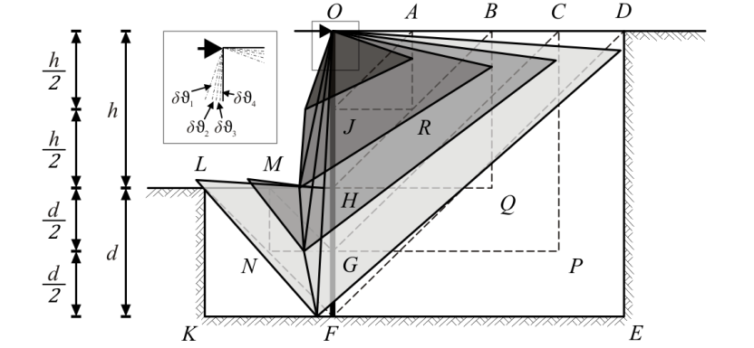

Figure 2: Wall rotation in four successive stages.

The second stage of wall movement consists of the rotations of triangle OCG behind and HGM in front of the wall. The corresponding maximum shear strain increments δγ₃ within CPG and δγ₆ within MGN are given by equations (3) and (4) respectively, where δθ₃ is the rotation of triangle OCG.

δγ₃ = 2 δθ₃ (3)

δγ₆ = 2 δθ₃ (h + d / 2) / (d / 2) (4)

Similarly, the third and fourth stage of wall movement consist of the rotation δθ₂ of triangle OBH and δθ₁ of OAJ behind the wall, resulting in maximum shear strain increments δγ₂ within BQH and δγ₁ within ARJ of:

δγ₂ = 2 δθ₂ (5)

δγ₁ = 2 δθ₁ (6)

The total shear strain in each triangle is assumed to be the sum of the incremental shear strains associated with this triangle during each stage. Therefore, for triangles DEF, CPG, BQH and ARJ behind the wall the total shear strains γ₄, γ₃, γ₂ and γ₁ are given by Equations (7), (8), (9) and (10) respectively:

γ₄ = δγ₄ = 2 δθ₄ (7)

γ₃ =δγ₄ + δγ₃ = 2 (δθ₄ + δθ₃) (8)

γ₂ = δγ₄ + δγ₃ + δγ₂ = 2 (δθ₄ + δθ₃ + δθ₂) (9)

γ₁ = δγ₄ + δγ₃ + δγ₂ + δγ₁ = 2 (δθ₄ + δθ₃ + δθ₂ + δθ₁) (10)

For triangles LFK and MGN in front of the wall, the total shear strains γ₅ and γ₆ are given by Equations (11) and (12) respectively. The smaller triangle MGN in front of the wall will first be sheared by δγ₅ = 2 δθ₄ (h + d) / d, due to the rotation of triangle HFL during the first stage. An additional amount of shear strain will then develop within triangle MGN during the second stage.

γ₅ = δγ₅ = 2 δθ₄ (h + d) / d (11)

γ₆ = δγ₅ + δγ₆ = 2 δθ₄ (h + d) / d + 2 δθ₃ (h + d / 2) / (d / 2) (12)

3 MODELLING OF SOIL BEHAVIOUR
3.1 Hyperbolic stress-strain relationship

A soil model that takes account of the soil inelasticity whose input parameters are easily determined is adopted in this paper since it is consistent with the objective of achieving a practical and reasonably accurate solution.
The hyperbolic equation introduced by Duncan & Chang (1970) to approximate the non-linear, inelastic and stress dependent behaviour of soils is transformed as shown in equation (13) to relate the shear stress t to shear strain γ assuming zero volumetric strain.

t = (γ / 3) / (a + b γ / 1.5) (13)

In Equation (13) the parameters a and b are related to the initial shear modulus G_{i}, Poisson’s ratio v and shear stresses at failure, τ_{f} , by equations (14) and (15) respectively:

a = 1 / [2 G_{i} (1 + v)] (14)

b = 1 / (2 τ_{f} ) (15)

The simplicity of the relationship derives from the relatively straightforward determination of the required parameters from laboratory triaxial tests. Comparison between other stress-strain relationships (Jardine et al, 1986; Allman et al, 1992; Smith et al, 1992) and the transformed hyperbolic relationship as introduced here has shown close consistency (Diakoumi, 2007).

3.2 Mobilised strength

If the strain increments in a soil zone are known, the mobilized strength, φ׳_{mob}, can be estimated using a constitutive relationship measured in an element test on a representative sample of the soil (Bolton and Powrie, 1988). The rate of change of φ׳_{mob} with shear strain is a useful way of expressing both the development of strength and the stiffness at the same time and is adopted in this paper. The application of additional kinematically admissible strain fields, as described previously, enables the use of different values of φ׳_{mob} for the active and passive soil zone and for different depths from the crest.
From the geometry of Mohr circle of stress in Figure 3, φ'_{mob} is given by equation (16)

φ'_{mob} = sin⁻¹ [ t / s'] (16)

where t is the radius of the Mohr circle equal to 1/2 (σ₁' - σ₃') and s' is the average effective stress equal to 1/2 (σ₁' + σ₃') . From the above:

s = t + σ₃' (17)

From equations (13), (16) and (17):

φ'_{mob} = sin⁻¹ {γ / [3 a σ'₃ + γ (1 + 2 σ'₃ b)]} (18)

Equation (18) can be written in the simpler form
φ'_{mob} = sin⁻¹ [γ / (A + B γ)] (19)

where A = 3 a σ'₃, B = (1 + 2 σ'₃ b) and a, b are constants of the hyperbolic relationship as defined previously. If G = G* z, where G* is the rate of increase of shear modulus G with depth, γ_{s} is the soil’s unit weight, γ_{w} is the water’s unit weight and φ' is the angle of shearing resistance at failure, it can be shown (Diakoumi, 2007):

A = 1.5 / (1+ v) · [(γ_{s} – γ_{w}) / G*] (20)

B = (1 + 2 σ₃' b) = 1+ (1- sin φ') / sin φ' (21)

From the above, the shear strain can be related to the mobilised strength, if parameters A and B are determined from laboratory triaxial tests.

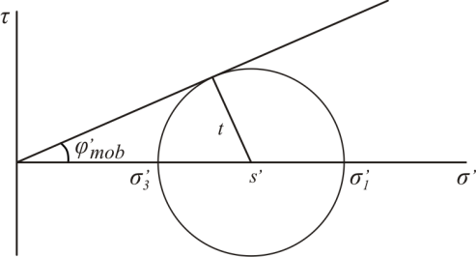

Figure 3: The Mohr circle of stress.

4 WALL FLEXURAL RIGIDITY ANALYSIS

It has been shown (Diakoumi, 2007) that the flexural rigidity of a beam can be represented with satisfactory accuracy by a number of rotational springs concentrated on different discrete points, i, with rotational stiffness equal to E I divided by half the lengths of the adjacent sections, for beams with different boundary conditions subject to uniform and triangular loads. The behaviour of a retaining wall propped at the crest is likely to resemble the behaviour of a simply supported or cantilever beam; hence, the discretised flexural rigidity approach can be applied.

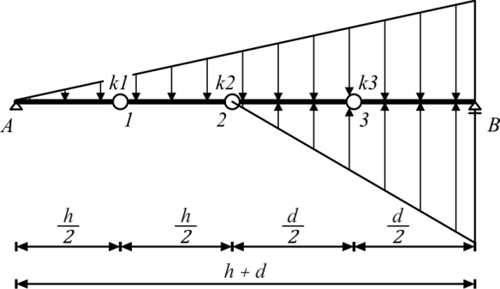

Figure 4: Discretisation of wall into four rigid parts connected by rotational springs.

In Figure 4, the continuous curvature of the wall is idealised into a number of rotations at discrete points, corresponding to the triangles in the active and passive soil zones as shown in Fig. 1. The
flexural rigidity of the beam, E I, is modelled by rotational springs of stiffness k_{i}. If M_{i} is the bending moment and θ_{i} the rotation at the i_{th} discrete point, then k_{i} = M_{i} / θ_{i}. From the geometry, the rotation, θ_{i}, can be related to wall rotations δθ_{i}. Setting m equal to the ratio of the retained height h
to the overall wall length H, and the wall flexibility ρ=H⁴/EI, as defined by Rowe (1952), the normalised bending moment at the i_{th} point, M_{i} / (γ_{s} H³) can be determined.
For example, the spring rotational stiffness at point 1, k₁, is given by equation (22). The normalized bending moment at point 1, M_{i} / (γ_{s} H³), can then be calculated by equation (23).

k₁ = E I / (h/4 + h/4) = 2 E I / h (22)

M₁ / (γ_{s} H³) = k₁ θ₁ /(γ_{s} H³) = (2 E I)(2 δθ₁)/ (h γ_{s} H³) = 4 δθ₁ / (m γ_{s} ρ) (23)

From the above, the normalised bending moments can be expressed in terms of δθ_{i}, m and the dimensionless quantity γ_{s} ρ.

5 ULS AND SLS CALCULATIONS

By taking the moments about the crest, the retained height ratio m at ULS can be determined if the soil strength at failure, φ', is known. According to MSD, for a wall with a retained height ratio m determined from the ULS calculations, wall rotation about the crest will mobilise different amounts of soil strength, φ'_{mobi}, in each soil zone. Equation (19) is used to relate the mobilised soil strength φ'_{mobi} to the shear strain γ_{i} developed in each soil zone. The shear strain γ_{i} can be related to the wall rotations δθ_{i} by equations (7) to (12). The active and passive earth pressure coefficients, K_{ai} and K_{pi}, will be different in each soil zone because the mobilised strengths φ'_{mobi} are different and may be calculated according to Eurocode 7 (BS EN 1997-1:2004). Here, pragmatically rather than with any rigorous justification, full wall friction (φ΄= δ) has been assumed.
After a small wall rotation into the excavation, the stresses are redistributed and a new equilibrium condition is reached. The active and passive pressures, σ_{hi}, behind and in front of the retaining wall are assumed to be different but linear in each soil zone and depend on δθ_{i} , φ' and γ_{s} / G*. From the horizontal equilibrium and taking the moments about the crest

∑R_{h} = 0 (24)

∑M_{c} = 0 (25)

where ∑R_{h} is the sum of horizontal forces acting on the wall and ∑M_{c} the bending moments at the crest. The normalised bending moments M_{i} / (γ_{s} H³) can be calculated from the stress distribution and will depend on δθ_{i}, φ' and γ_{s} / G*. Substitution of these values into the equations derived from the flexural rigidity analysis (i.e. eq. 23) in combination with eq. (24) and (25) gives a system of five unknowns: δθ₁, δθ₂, δθ₃, δθ₄ and F. The solution of this system requires the determination of parameters A, B and the dimensionless quantity γ_{s} ρ. Parameter B depends on φ' and can be easily obtained from element tests on soil samples. Parameter A depends on the dimensionless quantity γ_{s} / G*, and may again be determined from element tests.
To explore the rotations, normalised bending moments and prop load of a retaining wall propped at the crest for a range of wall flexibility numbers embedded in a variety of soil conditions, the system of five unknowns is solved numerically using the Wolfram Mathematica version 6 software for values of φ' from 20° to 40°; values of log (γ_{s} ρ) from -3 to 2, and values of log [(γ_{s} – γ_{w}) / G*] from -4 to -1, assuming full wall friction (δ = φ').

6 COMPARISON BETWEEN THE MSD METHOD AND EUROCODE 7 (BS EN 1997-1:2004)

For comparison, the in service maximum bending moments, M_{max} , and prop load, F, obtained from the MSD method are divided by the respective values M_{max,EC7} and F_{EC7} calculated according to Eurocode 7 (BS EN 1997-1:2004). Conditions of pore water pressures corresponding to an approximate state of linear seepage from an original ground water table at the ground level are assumed. The ratios of M_{max} /M_{max,EC7} and F /F_{EC7} are plotted in Figures 5 and 6 for different values of wall flexibility and soil stiffness, assuming a shear strength at failure representative of clays (φ'=20°). In Table 1 the values of parameter A are listed together with the corresponding values of the shear modulus, G, with depth z for a value of v equal to 0.5, and γ_{s} and γ_{w} equal to 20kN/m³ and 10kN/m³ respectively. A single value of v is adopted to maintain consistency with Duncan & Chang’s (1970) analysis. The typical wall flexibility values (Log [γ_{s} ρ]) for a rigid, diaphragm, sheet pile and soft retaining wall with a total length of 20m and γ_{s} equal to 20 kN/m³ are shown in Table 2. The rigid and soft walls are included to represent extreme cases.

Table 1: Soil stiffness values.
Log (A) | A | G (kN/m²)
-4 | 10⁻⁴ | 10⁵·z
-3 | 10⁻³ | 10⁴·z
-2 | 10⁻² | 10³·z
-1 | 10⁻¹ | 10²·z

Table 2: Wall flexibility values for different types of retaining walls.

 | Rigid | Diaphragm | Sheet pile | Soft
EI (kNm²/m) | 2.33·10⁹ | 2.33·10⁶ | 7.8·10⁴ | 3.2·10⁴
ρ (m³/kN) | 6.96·10⁻⁵ | 6.96·10⁻² | 2.05 | 5
Log [γ_{s}·ρ] | -2.86 | 0.14 | 1.6 | 2.0

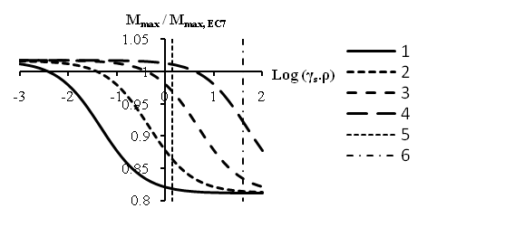
A=10⁻⁴
A=10⁻³
A=10⁻²
Diaphragm
Sheet pile
A=10⁻¹
Figure 5: Comparison between MSD and Eurocode 7 maximum bending moments for different values of soil stiffness and wall flexibility when φ'=20° and the original ground water table is at ground level.

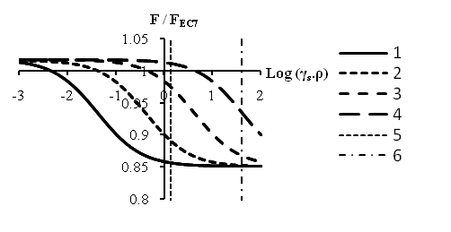
A=10⁻⁴
A=10⁻³
A=10⁻²
Diaphragm
Sheet pile
A=10⁻¹
Figure 6: Comparison between MSD and Eurocode 7 prop loads at the crest for different values of soil stiffness and wall flexibility when φ'=20° and the original ground water table is at ground level.

In Figures 5 and 6 the origin of axes is at (0, 1). The x-x’ axis represents the case when the maximum bending moments and prop loads calculated according to the MSD method is equal to the respective magnitudes calculated according to Eurocode 7 (BS EN 1997-1:2004). For the parts of the curves above the x-x’ axis, Eurocode 7 (BS EN 1997-1:2004) might underpredict, whilst for the parts of the curves below the x-x’ axis might overpredict the maximum bending moments and prop loads compared to MSD method. The figures show that as the wall flexibility or the soil stiffness increases, the maximum bending moments and prop loads reduce below their limit equilibrium values. The pattern of the reduction is found to be similar for different values of φ′ (Diakoumi, 2007). It should be noted that very high or low values of wall flexibility or soil stiffness might not be realistic, but are included to represent extreme conditions. For wall flexibility values that may be typical of a diaphragm or sheet pile wall, a reduction in both the maximum bending moments and prop load is shown in Figures 5 and 6.

7 CONCLUSIONS

New kinematically admissible soil displacement fields have been introduced to enable the MSD method to be applied to flexible retaining walls propped at the crest. Wall flexure is idealised by a simple mechanism and a modified hyperbolic relationship is used to associate the mobilised shear strain with the mobilised shear strength. The ratios of the MSD maximum bending moments and prop loads to those calculated according to the ultimate limit state (ULS) calculations in Eurocode 7 (BS EN 1997-1:2004) were plotted against wall flexibility and soil stiffness. For types of walls commonly selected in engineering practice, the maximum bending moments and prop loads were found to reduce below their limit equilibrium values calculated according to Eurocode 7 (BS EN 1997-1:2004). The amount of the reduction for a given wall stiffness depends on the soil stiffness.
The main advantage of the proposed method is the straight forward way of relating the mobilised soil strength to the wall and soil behaviour under working conditions taking into account both the soil stiffness and wall flexibility. Therefore, it is an improvement to linear elastic soil models or empirical techniques and may serve as a practical design tool.

acknowledgementS
The research described in this paper was sponsored by Corus Group and the School of Civil Engineering and the Environment, University of Southampton.

references
Allman, M. A. & Atkinson, J. H. (1992). Mechanical properties of reconstituted Bothkennar soil. Geotechnique, 42, No. 2, 289-301.
Bolton, M. D. & Powrie, W. (1988). Behaviour of diaphragm walls in clay prior to collapse. Geotechnique, 38, No. 2, 167-189.
Bolton, M. D., Powrie, W. & Symons, I. F. (1989, 1990). The design of stiff in-situ walls retaining overconsolidated clay part 1: Short term behaviour, Ground Engineering, 22(8), 44-47 & Ground Engineering, 22(9), 34-40.
Bolton, M. D., Powrie, W. & Symons, I. F. (1990). The design of stiff in-situ walls retaining overconsolidated clay part 2: Long term behaviour, Ground Engineering, 23(2), 22-28.
British Standards Institution, (2004). Eurocode 7: Geotechnical design-Part 1: General rules. BS EN 1997- 1:2004, British Standards Institution, London, UK.
Diakoumi, M. (2007). Relative Soil/Wall Stiffness Effects on Retaining Walls Propped at the Crest. Ph.D. thesis, University of Southampton.
Duncan, M. J. & Chang, C. Y. (1970). Nonlinear analysis of stress and strain in soils. ASCE Journal of Soil Mechanics and Foundations Engineering Division, Proceedings of ASCE, Vol. 96, SM 5, 1629-1653.
Jardine, R. J., Potts, D. M., Fourie A. B. & Burland, J. B. (1986). Studies of the influence of non-linear stress-strain characteristics in soil-structure interaction. Geotechnique, 36, No. 3, 377-396.
Osman, A. S. & Bolton, M. D. (2004). A new design method for retaining walls in clay. Can. Geotechnical Journal, 41, 451-466.
Rowe, P. W. (1952). Anchored sheet pile walls. Proceedings of the institution of Civil Engineers, Pt 1, 1, 27-70.
Smith, P. R., Jardine, R. J. & Hight, D. W. (1992). The yielding of Bothkennar clay. Geotechnique, 42, No. 2, 257-274.

