Programme for the TEAMS RIG Tailoring Group meeting, Thursday, November 26th, 6.00-7.30pm
Early tailored clothes for women, 1800-1875
By invitation. Please stick to 10 minutes
Chair: Dr. Hannah Rumball, Univ. of Brighton

6.00pm Chair: Hannah Rumball: Intro: Reminder of the Aims of this session in the context of our RIG project.

6.05 - 6.15: Dr. Cally Blackman (Univ. of the Arts), From Riding Habit to Walking dress in the mid to late 18th century.

6.15 - 6.25: Dr. Clare Rose, V&A Education, ‘Ready to Wear Clothing in The National Archives.’

6.25 - 6.35: Dr. Sarah Johnson, Independent Scholar NY, ‘Tailoring for women in the USA, 1754- 1869.’

6.35 - 6.45: Dr. Liz Tregenza, Colchester Museum, ’Sharing Two Images from the Colchester Museum Collection;’

6.45 – 6.55: Dr. Hannah Rumball, Univ. of Brighton, ‘How waterproof were Ulsters?: Analysing the waterproof claims of Ladies c 19th ulsters.’

6.55 - 7.30: DISCUSSION: Chair - Hannah Rumball
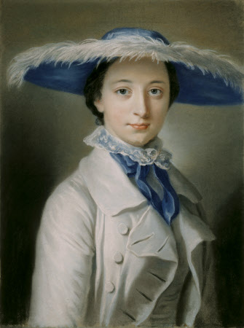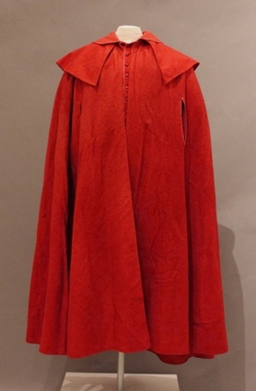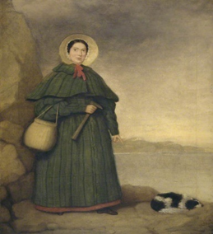
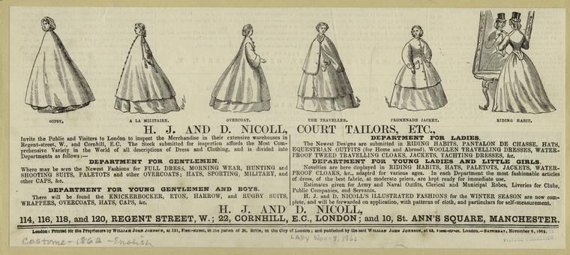
Images: No 1: Miss Caroline Vernon, 1770, Attingham Park NT; No 2 Cloak, 1790- 1810, Lichfield Hist Soc. Pasadena; No 3 Mary Anning, Fossil hunter, c1838-39, Lyme Regis Mus; No 4: H.J. and D. Nicholl, Nov. 862, Women’s Ready- to-Wear, NYPLDig.Coll no 803559. (LT Nov. 16th 2020)

